**Reading Emails Aloud Guidance**

The Disabilities and Dyslexia Service (DDS) at London Met recognises that some students may find it more difficult to visually read information, such as emails, which are received. As a large amount of information is communicated to students through your University Email Account, the guidance below can advise on how you can set up your computer to read the text in your emails out to you.

All students can access their University Email Account through [WebMail](https://student.londonmet.ac.uk/webmail/) with your University Username and Password. [Office365](https://www.office.com/) is the current University Email Platform.

**Web Browser**

In order to enable the “Read Aloud” function, you will need to use the Google Chrome Web Browser.

If you do not have it installed, Google Chrome can be downloaded for [PC](https://www.google.com/intl/en_uk/chrome/dr/download/?brand=YTUH&gclid=EAIaIQobChMI5470gYD1_wIVxfDjBx0oBww1EAAYASAAEgIIN_D_BwE&gclsrc=aw.ds) and [Mac](https://support.google.com/chrome/answer/95346?hl=en-GB&co=GENIE.Platform%3DDesktop#zippy=%2Cmac)

**ClaroRead Extension**

To facilitate the “Read Aloud” process, you then need to download the [ClaroRead Extension for Google Chrome](https://chrome.google.com/webstore/detail/claroread-chrome/ifgehbglgmidafhhdcopacejknmcmhcd).

**Step by Step Guide**

1. Download the [ClaroRead Extension for Google Chrome](https://chrome.google.com/webstore/detail/claroread-chrome/ifgehbglgmidafhhdcopacejknmcmhcd) onto your Google Chrome Web Browser. This can be done by clicking the “Add to Chrome” button.

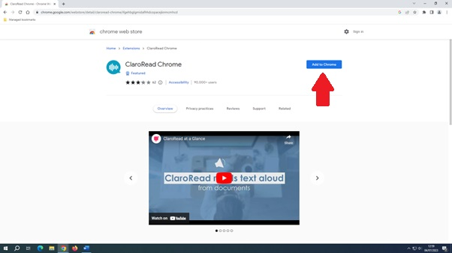

1. When prompted, click “add extension”.

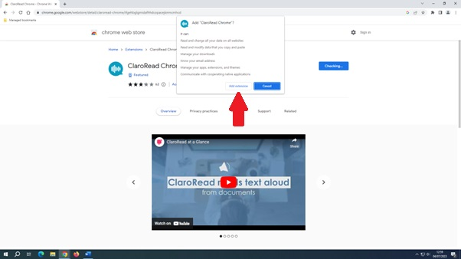

1. Once downloaded, a ClaroRead Toolbar (which can be moved around the screen) will appear. This has a range of functions including:

* Play
* Stop
* Curser (to start the playback at a certain part of the text)
* Settings (the cog icon)
* Spell Checker

Step 3


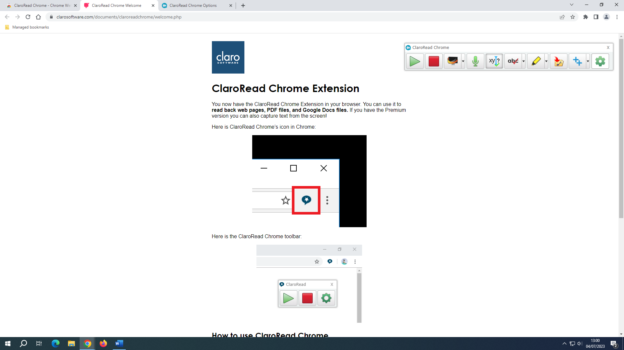

1. By clicking on the “cog” icon, you can change many of the settings such as:

* Speed of the speaker
* Text highlighting as the content is read out (so that you can follow along)

Step 4


1. When you go to your email, select the text that you wish to be read aloud, right click and click “speak selected text”

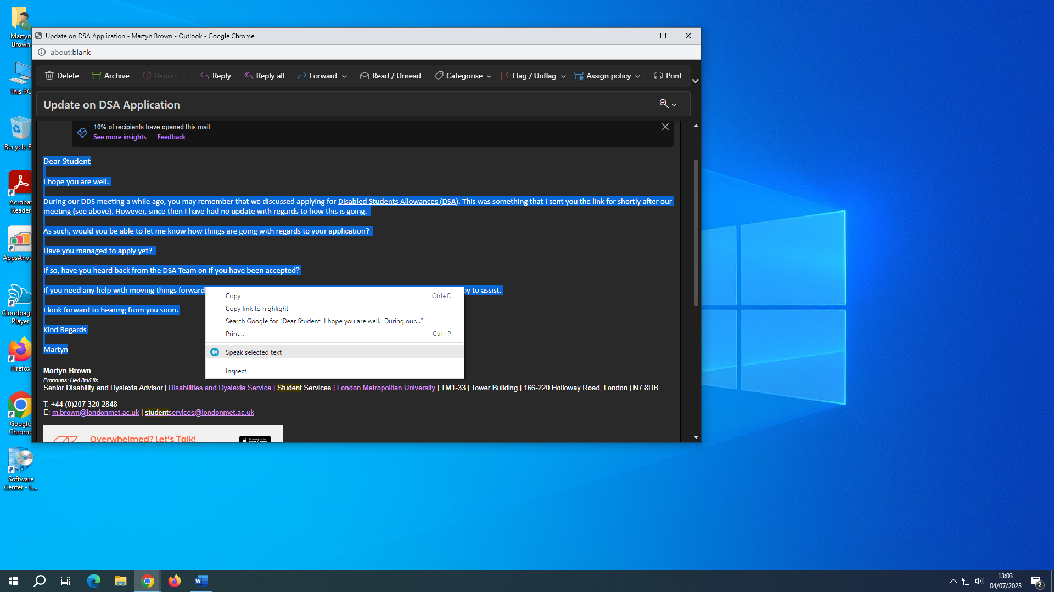



1. Don’t worry if you close the toolbar, you can access the settings menu by clicking on the Extensions button in the top right of the task bar (Puzzle Piece), clicking on the three dots, clicking on “manage extension” and then choosing “extension options”. That will take you to the settings page.

