**Reading Emails Aloud Guidance**

The Disabilities and Dyslexia Service (DDS) at London Met recognises that some students may find it more difficult to visually read information, such as emails, which are received. As a large amount of information is communicated to students through your University Email Account, the guidance below can advise on how you can set up your computer to read the text in your emails out to you.

All students can access their University Email Account through [WebMail](https://student.londonmet.ac.uk/webmail/) with your University Username and Password. [Office365](https://www.office.com/) is the current University Email Platform.

**Step by Step Guide**

1. Select the email that you want to read in Office365 - Outlook

Step 1


1. Double click on the email to open it in a new window

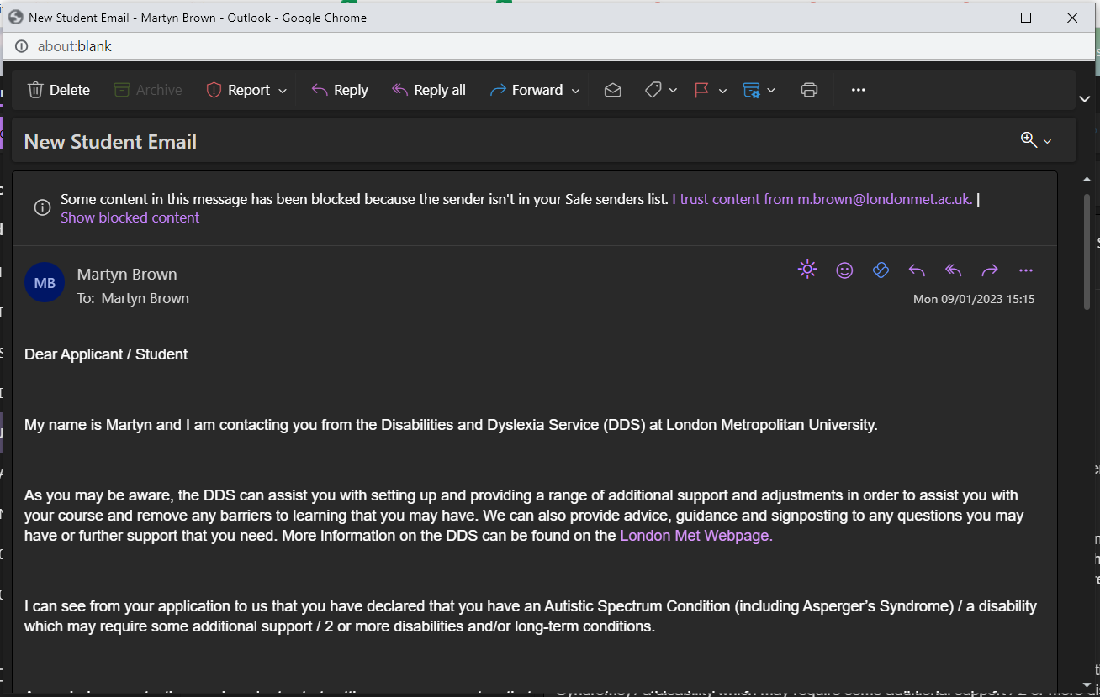

1. Click on the three dots on the far right side of the toolbar at the top and select “immersive reader”

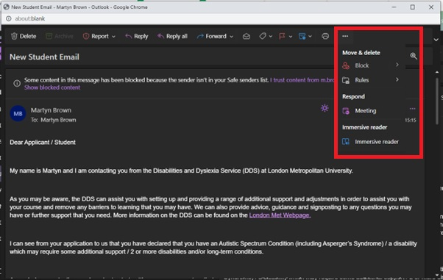

1. Immersive reader will then open in a new window. You will notice that the lines are now also more well spaced.

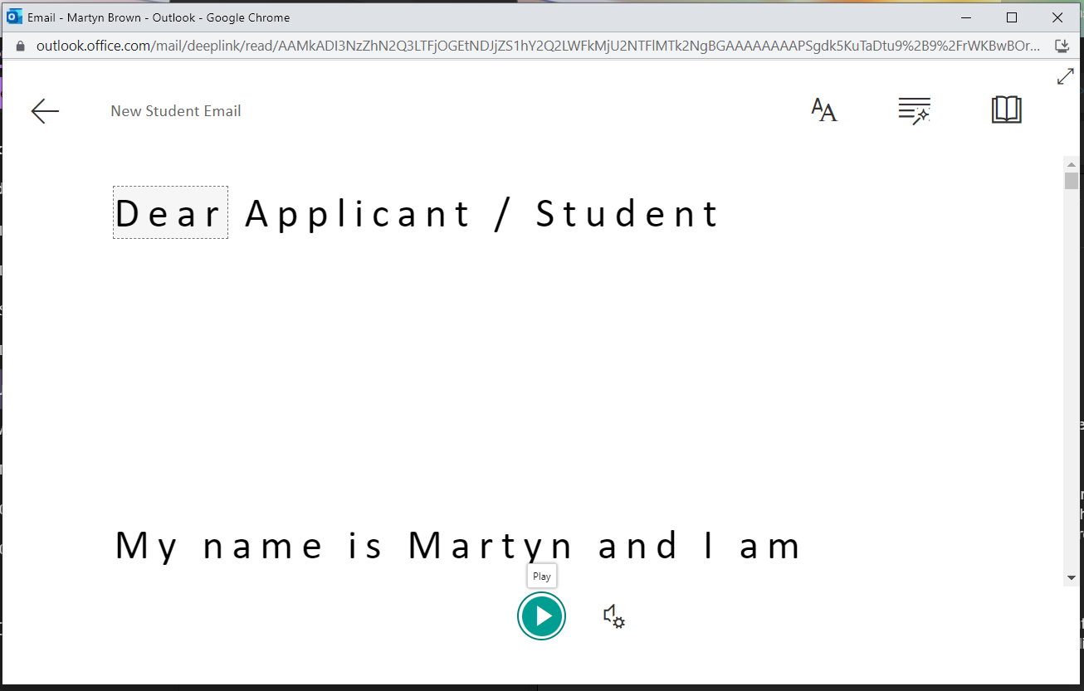

1. For emails to be read out loud, press the play button at the bottom of the screen. As the text is read aloud, the words will be highlighted as it goes. Pause then stops it.

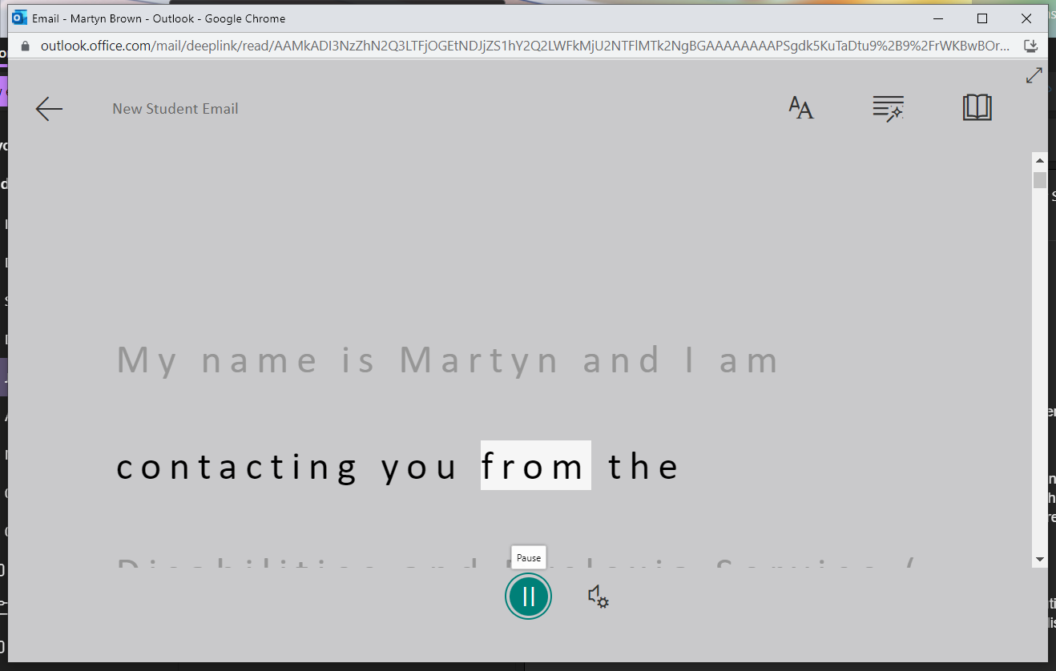

1. By clicking on the “speaker and cog” button, which is next to the play button, you can change the type of voice and speed that it goes.

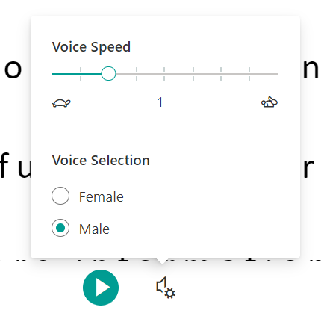

1. At the top of the immersive reader, there are a range of buttons which allows you to further change the settings on the immersive reader to make all content accessible to your requirements

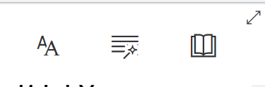

1. Options for settings include “line focus” which darkens the screen and allows you to focus on one line at a time, enlarging/shrinking the font, changing the font, increasing/decreasing the line spacing and changing the background colour.

