Activating Closed Captions in Microsoft PowerPoint for Students and Staff who are D/deaf or Hearing Impaired

# Disabilities and Dyslexia Service (DDS)

Version:1.1

Date: 01.03.2023

# Introduction

At [London Metropolitan University](https://www.londonmet.ac.uk/), we are committed to ensuring that all students, regardless of disability, have an equitable and inclusive experience in all aspects of university life.

Across the university, we have a number of students who identify as D/deaf and/or Hearing Impaired and as such, accessing audible content may be a barrier to them depending on the impact of their hearing difficulties. In line with the [Equality Act (2010)](https://www.legislation.gov.uk/ukpga/2010/15/contents), the university has a duty to make anticipatory and reasonable adjustments to students in order to remove any barriers as a result of a disability in order to ensure that they are able to access all areas of the university. A disability is categorised as a condition or impairment which lasts or is expected to last for 12 months or longer and has a significant impact on day to day life. As such, many hearing impairments including partial or total D/deafness can be included in this.

The [Disabilities and Dyslexia Service (DDS)](https://student.londonmet.ac.uk/life-at-london-met/student-services/disabilities-and-dyslexia-service-dds/individual-examination-arrangements-on-campus-exams/) has therefore put together this guidance document to assist everyone working at the university on how to activate and use Closed Captions (subtitles) within Microsoft PowerPoint in order to aid the learning and teaching of students – including those who are D/deaf and/or Hearing Impaired. This will therefore allow these students (along with others who may benefit from this inclusive practice) to follow along with spoken and audio content via a written format and therefore reduce the barriers being faced to accessing materials.

The DDS actively encourages all staff to engage with this guidance to make their sessions more accessible.

# Setting Up and Using Closed Captions in Microsoft PowerPoint

While some individuals may have additional support mechanisms in place to assist them such as Hearing Aids, Loop Systems, BSL Interpreters and Notetakers, the presence of Closed Captions is an easy, accessible and enabling tool which can increase the accessibility of many sessions both face to face and remotely for a variety of individuals including those who are D/deaf or Hearing Impaired.

Please note that while the university does have Panopto in place for the recording and live streaming of class sessions, Panopto only allows for Closed Captions to be added after the recording is complete at present. As such, it does not allow for individuals needing closed captions to follow along with sessions in real time. Additionally, some Online Learning Platforms such as BlackBoard Collaborate also does not have a function for live Closed Captions. As such, the use of Microsoft PowerPoint for Closed Captions is key.

Please ensure that you follow the [Panopto Guidance](https://learntechsupport.londonmet.ac.uk/kb/panopto-student_support/) for ensuring that Closed Captions are added to all video recordings to ensure accessibility.

### Accessing Microsoft Office and PowerPoint

All university PC’s and machine’s should have the most recent full Microsoft Office suite (including PowerPoint) installed as standard and therefore it is ready to use. However, if for any reason there is no access to PowerPoint then this can be accessed for free using a university username and password via [Software for Students](https://student.londonmet.ac.uk/it-resources/software-for-students/).

Any issues with Microsoft Office or being able to access it should be raised with [IT Services](https://student.londonmet.ac.uk/it-resources/it-help-and-support/) in the first instance.

### Activating and Using Closed Captions in Microsoft PowerPoint

1. Open Microsoft PowerPoint or your prepared presentation.
2. Go to the “Slide Show” tab at the top of the main window

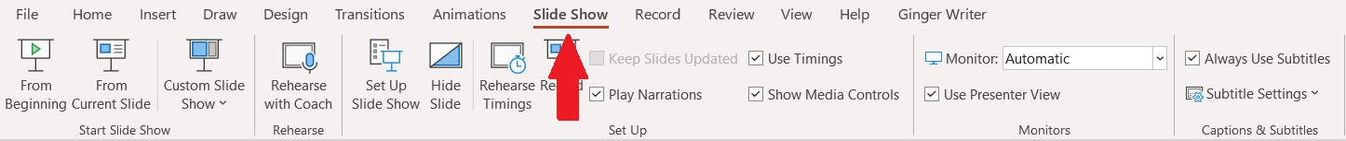

1. Go to “Captions and Subtitles” on the Right Hand Side

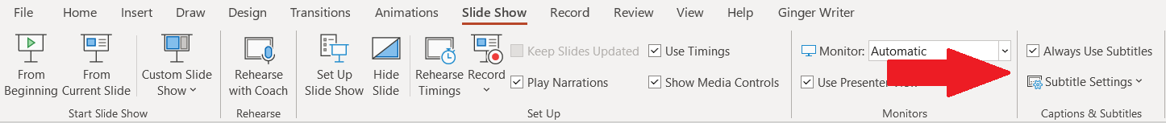

1. Ensure that “Always Use Subtitles” is ticked – this will turn on Closed Captions when in presentation mode

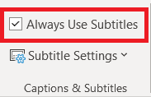

1. Select the “Subtitle Settings” drop down menu to programme the recommended settings. It is recommended that you check that the correct microphone is being used and that the Closed Captions are “Above Slide”. This will ensure that no material on your slides are being covered up by the captions and that they are easy to see by not being at the bottom of the screen where other people or objects may obstruct the view.

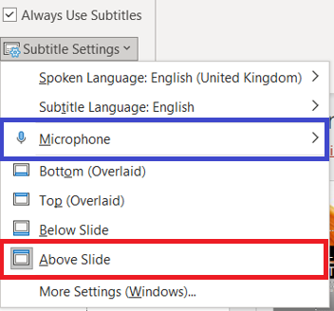

1. 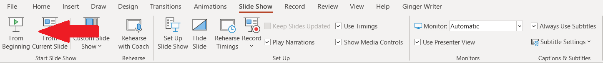Enter presentation mode by clicking on “From Beginning” under the “Slide Show” tab. Once you speak, the captions should automatically appear with a great deal of accuracy. Please ensure that you stand at or near to the lectern/microphone to ensure that best pick up and quality is received. This will ensure that the captions are most accurate.

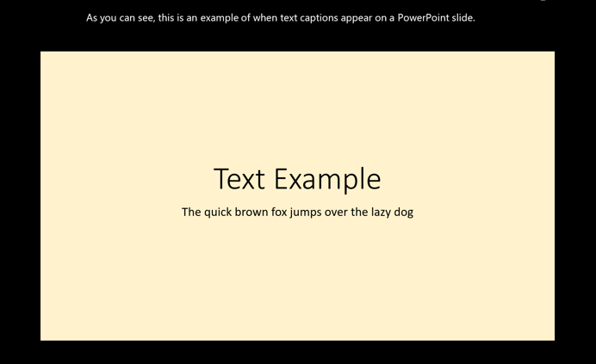

1. If you are not presenting but are still speaking, make sure that a blank slide is on screen as this will allow for the Closed Captions to continue.



Should you have any questions with how to use Closed Captions in Microsoft PowerPoint or would like to discuss using them further then please email [studentservices@londonmet.ac.uk](mailto:studentservices@londonmet.ac.uk)

# Key Resources

[RNID – Royal National Institute of the Deaf](https://rnid.org.uk/)

[Live Captions in MS Teams](https://support.microsoft.com/en-us/office/use-live-captions-in-a-teams-meeting-4be2d304-f675-4b57-8347-cbd000a21260)

[Adding Closed Captions to PowerPoint Playback](https://support.microsoft.com/en-us/office/add-closed-captions-or-subtitles-to-media-in-powerpoint-df091537-fb22-4507-898f-2358ddc0df18#:~:text=In%20PowerPoint%2C%20in%20the%20Normal,files%20and%20then%20click%20Insert.)

[Real Time Captions in PowerPoint](https://support.microsoft.com/en-us/office/present-with-real-time-automatic-captions-or-subtitles-in-powerpoint-68d20e49-aec3-456a-939d-34a79e8ddd5f)

[Closed Captions in Google Chrome](https://support.google.com/chrome/answer/10538231?hl=en-GB)