

Research Degrees

RD2 Research Student Progress Review
Please read all the instructions:
- Students must complete the relevant sections each year as they progress, First RD2 submission, Second RD2 submission etc.
- Students must complete all of sections one, two, three, four and five.
- If you have any confidential issues, comments, queries or suggestions you would like to raise about any aspect of your research degree programme, please contact the Chair of your school-based RSPG.
- Students, supervisors and readers must read the University's Research Degree Regulations and Code of Good Research Practice before completing this form. Information can also be found in the Handbook for Research Students and Supervisors in the Doctoral Studies section of WebLearn.
Contents

RD2 Submission 2
Section One – Your Details 2
Section Two - Supervision 5
Section Three – Programme of Research 6
Section Four – Researcher Development 8
Section Five – Feedback and Reflection 10
Section Six – Written Work to be Submitted with RD2 Form 11
Student Declaration 12
Section Seven – Supervisors’ Comments and Feedback 13
Recommendation by the Supervisors 13
Section Eight – Independent Reader’s Comments and Feedback 15
Recommendation by the Independent Reader 16
Research Student Progress Group Decision 17

Students, please update the contents field > right click > update field > update entire table

RD2 Submission

Section One – Your Details
Student Number |  |  | Date of First Enrolment
Name |  |  | Email
Title of Thesis
Supervisors’ Names
Have there been any changes to the supervisory team | ☐ No  ☐ Yes, please describe below
Year of study | Choose an item.  Other: | Mode of Study |  |  | Choose an item.
Intermissions
(Time and duration)
Please indicate your stage of study  (select one) |  | ☐ preparation  ☐ data collection and analysis  ☐ interpretation and thesis preparation  ☐ writing up only  ☐ submitting thesis (see below)  ☐ other (please name):
If you have started data collection, please provide the date of research ethics approval. |  | Choose an item. Choose an item.  ☒ N/A
If you are submitting the thesis for examination within 4 months of the RD2 submission date you do not need to complete the remainder of the form.  Please have supervisor sign for confirmation. |  | Supervisor signature confirming projected submission date for thesis:
If unforeseen circumstances prevent you from submitting on time or at all, please detail here and notify your supervisors and the RSPG chair. If the reasons are deemed valid, a late submission (up to two weeks late) or deferral will be arranged.
Supervisor support for late submission or deferral of submission: |  | Please sign:
RSPG chair support for late submission or deferral of submission: |  | Please sign:

Section Two - Supervision
If you have any concerns regarding supervision, please contact your supervisors in the first instance if appropriate. If you do not feel able to do this, please contact either the chair of your school-based RSPG, the PGR Coordinator or the Research Lead in your School.
Please indicate how many times you have met with your supervisors since your last report to the RSPG; i.e. in the last 6 months or 12 months (delete as appropriate). Meetings may include contact in person, by correspondence, telephone, email or video call; please distinguish between these types.

Section Three – Programme of Research
Please state briefly your research aims, objectives, and questions or hypotheses
Please provide a brief description of the progress you have made with your research project since your last report to the RSPG; i.e., over the past 6 or 12 months (delete as appropriate) (approx. 500 words).
Please identify any challenges or problems encountered for which additional support, training, or guidance might be required.
Please provide an updated outline of your anticipated timetable for completing your thesis
When do you plan to submit the thesis? | Choose an item. Choose an item.

Section Four – Researcher Development
Research students are expected to develop their personal, professional, and research competencies, skills, and knowledge throughout their period of study at London Met. They should discuss their training needs with their lead supervisor and identify which activities are appropriate and necessary for their programme of research, and personal and career development. This should take place regularly each year, so that the student proactively manages their professional development.
The London Met Research Student Training Programme offers a range of courses across four domains: Knowledge and Intellectual Abilities; Personal Effectiveness; Research Governance and Organisation; Engagement, Influence, and Impact. These courses are available face-to-face and on-line.

Section Four A: Looking back
Please tick below which of the following researcher development activities you have engaged with since your last submission to an RSPG. Please give the date and a brief description of the activity.
☐ | London Met Postgraduate Research Training Sessions
Description
☐ | On-line courses which you have undertaken
Description
☐ | Taught Masters modules which you have undertaken
Description
☐ | Relevant conferences which you have attended
Description
☐ | Relevant conferences at which you have presented
Description
☐ | Relevant journal articles, publications, or other artefacts which you have submitted, published, performed, or exhibited
Description
☐ | Any other researcher development opportunities in which you have participated
Description
☒ | if you have not engaged in any of these activities, please indicate the reason(s) why you have not done so. Lack of engagement with researcher development may be a risk to successful completion of your research programme
Description

Section Four B: Looking forward
Take an audit of your skills and capacities and identify three areas where you need to address the gaps in your professional development, from now until your next RSPG submission. We suggest that you look at the Vitae Researcher Development Framework for reference (check out the link and the diagram at the bottom of this section).
The kind of areas you would like to address could be, for example: critical thinking and analysis, project management, networking, etc. You may want to discuss with your supervisors how to approach it and think about resources available to you. We suggest revisiting the PGR Training Programme repository on Weblearn, looking for training available elsewhere (e.g. School of Advanced Study), or thinking of a conference you could attend/present at or a journal article you can submit in the next year.
Please mention the three areas and briefly describe the planned actions to address the gaps, including the type of training/ activity and when this will be completed (i.e. what/ why / when).
Researcher Development area 1
Researcher Development area 2
Researcher Development area 3

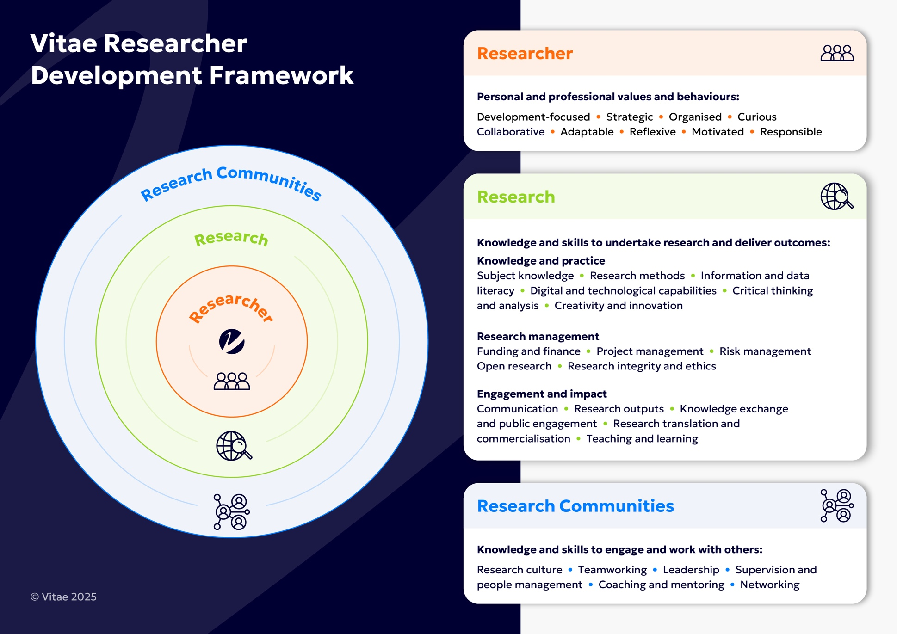
Figure 1. The Vitae Researcher Development Framework

Section Five – Feedback and Reflection
Please copy and paste the feedback from Turnitin from your last submission (if applicable) below
Please provide a short reflective statement upon the feedback from the last RD1/RD2 submission and any actions arising (500 words max).

Section Six – Written Work to be Submitted with RD2 Form
The progress review is not intended to add to a student’s workload. The RSPG wants to see ‘work-in-progress’. Students should only submit written material that will benefit the preparation of the thesis, or form part of the thesis. It should be of sufficient length and quality to facilitate an assessment of progress.
You should submit a draft chapter or report on data analysis (or part thereof) of at least 4000 words. It must be work that has not been submitted previously to an RSPG – discuss with your supervisor what the best submission might be. Please follow the Guidance for Research Students on appending your written work to this form to upload to Turnitin in the Doctoral Studies site in WebLearn as a single document.
Please complete this section to help the Reader by explaining where your submission fits within your thesis, what else the chapter will cover (or what further analysis you are planning), and where it sits within your programme of work. It will also help us if you can include a table of contents, indicating which chapters have been written/drafted.
Work submitted here is for assessment and is subject to normal rules of academic standards and honesty; your submission via Turnitin is subject to a similarity check. You may use Turnitin to check your work prior to submission.
Please insert work below:

INSERT WRITTEN WORK HERE
(please use Ariel 11pt font of similar)

Student Declaration
To submit your work to the RSPG, please sign and date the following:
☐ I confirm that I have read the Academic Regulations prior to submission
☐ I confirm that I have read the Code of Good Research Practice
☐ I confirm that this submission is all my own work
Student’s Signature |  | Date

Section Seven – Supervisors’ Comments and Feedback
Please note that these comments will be sent to the student following the RSPG meeting and/or available via Turnitin
Please comment conjointly on the student's progress in respect of their programme of research and make a recommendation regarding progress. Your comments and suggestions will provide formative feedback to the student.
Please offer supportive, constructive, and sensitive comments on the work, including whether it is of an appropriate standard for a student in stage 1 (preparation), stage 2 (data collection and analysis), or stage 3 (interpretation and thesis preparation) of their registration. Suggestions may be included for possible modifications; additional references; and/or potential improvements in design / conduct / presentation / language, which will help the student to strengthen their work. Supervisors should confer in making, wherever possible, a unanimous recommendation.
An independent reader will also make an independent recommendation.
What stage does the work submitted indicate where the students are at: |  | Choose an item.
Please put your feedback and recommendation as a text comment in the Turnitin feedback studio (blue pen symbol on the right side).
The section below shows you the wording you should use for the recommendation.

Recommendation by the Supervisors

We recommend / do not recommend (delete as appropriate) that progress is approved
Supervisor’s name |  |  | Date
Supervisor’s name |  |  | Date

Section Eight – Independent Reader’s Comments and Feedback
Please note that these comments will be sent to the student and their supervisor following the RSPG meeting and/or available via Turnitin
Please comment on the student's progress in respect of their programme of research and make a recommendation regarding progress. Your comments and suggestions will provide formative feedback to the student.
Please offer supportive, constructive and sensitive comments on the written material provided, including whether it is of an appropriate standard for a student in stage 1 (preparation), stage 2 (data collection and analysis), or stage 3 (interpretation and thesis preparation) of their registration. Suggestions may be included for possible modifications; additional references; and/or potential improvements in design / conduct / presentation / language, which will help the student to strengthen their work. If you do not feel you have sufficient information on which to base your recommendation, please notify the Research and Postgraduate Office <research@londonmet.ac.uk>.
The supervisors will also make an independent recommendation.
What stage does the work submitted indicate where the students are at: |  | Choose an item.
Please put your feedback and recommendation as a text comment in the Turnitin feedback studio (blue pen symbol on the right side).
The section below shows you the wording you should use for the recommendation.

Recommendation by the Independent Reader
We recommend / do not recommend (delete as appropriate) that progress is approved
Reader’s name |  |  | Date

Research Student Progress Group Decision
(OFFICE USE ONLY)
The section below shows the options available. The decisions are recorded in the minutes of the RSPG meeting.
☐ Progress approved

☐ Refer (to be considered at the next RSPG or at another specified date) |  | Reason:  Date:
☐ Withdraw |  | Reason:
☐ Chair’s Action |  | Action to be taken:
RSPG Chair |  |  | Date

