Sources for the research of black workers and trade unions in the TUC library collections
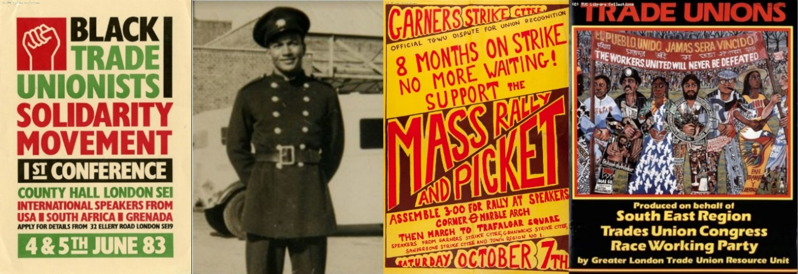

Taken from TUC Library website Britain at Work
Original text written by Wilf Sullivan, TUC Race Equality Officer, illustrations from TUC Library

Introduction
The contribution of black workers in the trade union and labour movement is largely undocumented and mainly seen in the context of post-war immigration. However the years between the two World Wars were particularly important for the development of black self-organisation in the UK trade union movement.
The inter-war period saw major race disturbances in both mainland Britain and in its colonial outposts. During 1919, there were disturbances in port areas of Britain with large concentrations of black people. Perhaps the most serious of the disturbances in the UK occurred in Cardiff during the summer of 1919. Local white men attacked black men in the docks area forcing the local black community to barricade themselves in their homes for several days.
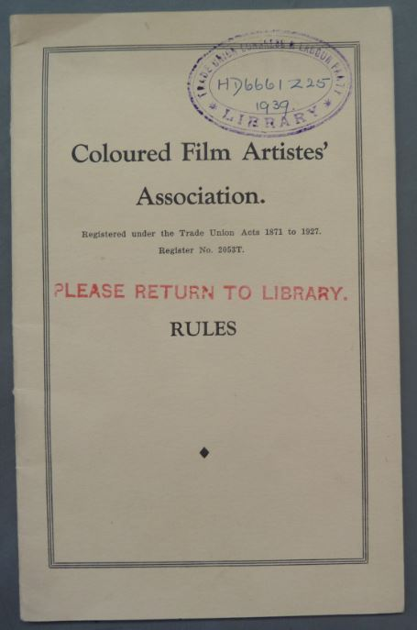

In 1936, black workers in Cardiff formed the Coloured Seamen's Union, bringing together Africans, West Indians, Arabs and Malays to fight against the operation of the colour bar on the Cardiff Docks. This move to develop their own black self-organised structures within the context of the labour market was as a direct consequence of the failure of trade unions to effectively take up the specific issues facing black workers at that particular workplace. The period also witnessed the formation of the first independent black self-organised trade union in the UK. The Coloured Film Artistes' Association (CFAA) was established at Elstree studios as a means of attempting to improve the terms and conditions of work for black actors and extras at the site.

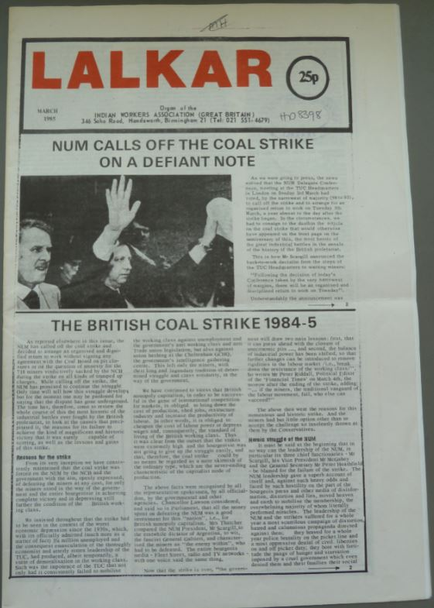
LALKAR – periodical of the Indian Workers Association (GB)
Asian workers were also active in creating black self-organisation with strong links with the trade union movement. They formed the Indian Workers Association (IWA) in Coventry in 1938. Many other local branches were formed in subsequent years in areas with a high concentration of Indian workers, eg Leicester and Southall. Many IWA members had been activists in India and brought with them a strong tradition of militant struggle. The IWA always encouraged trade union activity, but initially its main focus was concentrated on the issue of Indian independence from British rule - this was achieved in 1947. As a result of this and the fact that there was a big increase in the number of Indians coming to live and work in Britain after World War Two, the IWA focused more on the trade union and anti-racist struggle in Britain. By the 1950s, the various Associations had combined to become the Indian Workers Association (Great Britain). After unifying these local groups, the IWA (GB) quickly became one of the most important Punjabi associations in Britain, with strong connections to the trade union movement and closely involved with both anti-racist and immigration legislation.

The post-war period
As in other European countries the United Kingdom actively recruited migrant workers to rebuild the economy after the war. Initially, Britain recruited Polish ex-servicemen and European Voluntary Workers (EVW) from refugee camps and from Italy. The Trades Union Congress (TUC), and especially the miners' union, however, insisted on strict conditions, arguing that EVWs could be employed only if there was no British labour available.

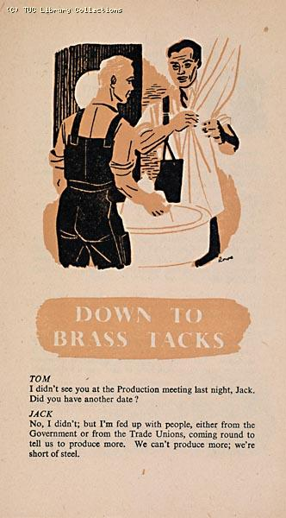
This TUC leaflet about industrial production covers a range of post-war issues including Joint Production Committees, the American Loan, shortages of food and raw materials, immigration.
However, labour migration came from ex-colonies as well: West Indies, India, and Pakistan - the Commonwealth. According to the British Nationality Act of 1948 all subjects of the crown had the right to enter Britain. These workers, through their Commonwealth citizenship, had the right to live and work in Britain without restrictions. Indeed, they had the same political and legal rights as the British citizens (e.g. voting rights in local and national elections). This colonial status was thus very different from the 'guest workers' in other European countries. But although they had the same rights in theory, the Commonwealth workers took subordinate positions in employment compared to white British workers and were over-represented in low-paid, insecure jobs.
Trade unionism was a natural means of organisation for these migrants, developed from their direct experience and tradition of organising in trade unions (sometimes illegally) under British colonial rule. Trade unions in the English speaking colonies emerged after the First World War, as a form of organised resistance to some of the economic and social excesses of British colonial rule. The link between the anti-colonial struggle and trade unionism was strengthened by the involvement of many trade union delegates at the 5th Pan African Congress held in Manchester in 1945. The Congress was held a month after the World Federation of Trade Unions conference in Paris and this enabled black trade unionists from the colonies and from the UK to participate.
This experience of trade union organising in Africa, the Caribbean and India accompanied post war immigration to the UK. A tradition of collective organising was part of the black worker experience, so joining a trade union was a natural step to take when entering the UK labour force.

However, despite black workers joining trade unions in large numbers, they were not welcomed by the UK trade union movement or the TUC. While the immigrant workers did not constitute a threat to the jobs of British workers because of acute labour shortages following the war, the TUC argued during the 1950's and 1960's that black workers did not integrate with white workers. This helped to stereotype black migrant workers as "problem" and "other". Even though during the 1969 TUC Congress, rank-and-file trade union members challenged the immigration controls and supported government's plans in calling for positive action to combat discrimination, the TUC General Council prevented the motion receiving majority support, thereby opposing government plans for anti-discrimination legislation.
During this period, the UK trade unions' position can be categorized as 'racist exclusive'. Some trade unions' preference was to, first, keep migrant workers out of the labour market, second, (since that wasn't possible) keep them out of the union, and third, since many became union members, exclude them from the entitled union benefits. In addition, during the 1950s there were a number of race riots, or attacks on immigrants by white youths and the Oswald Mosley's Union Movement. This culminated in the riots in Nottingham and London's Notting Hill in 1958 where black people were attacked in the streets and in their houses.

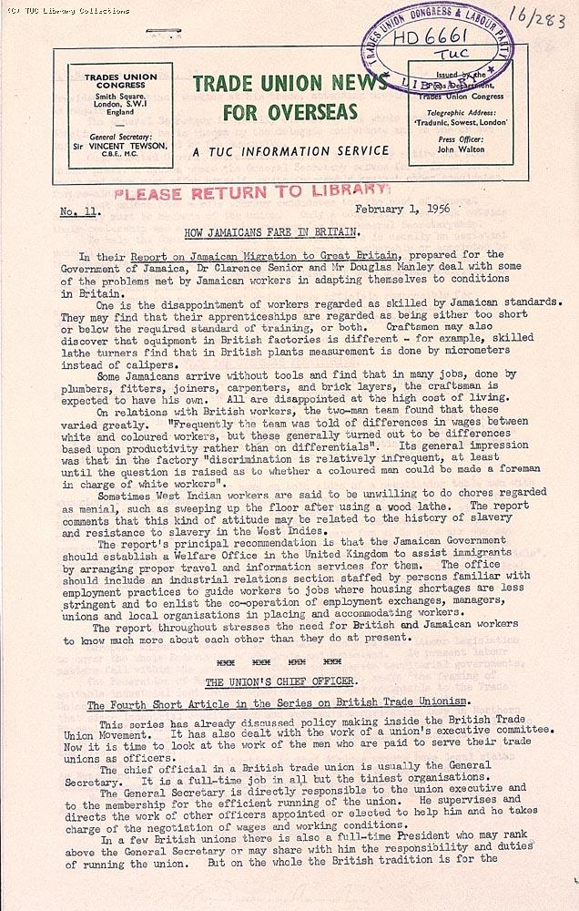
This article in the TUC bulletin 'Trade Union News for Overseas' of 1 February 1956 is entitled "How Jamaicans fare in Britain" and deals with the racial discrimination and other problems faced by immigrants from Jamaica and elsewhere in the Caribbean area.

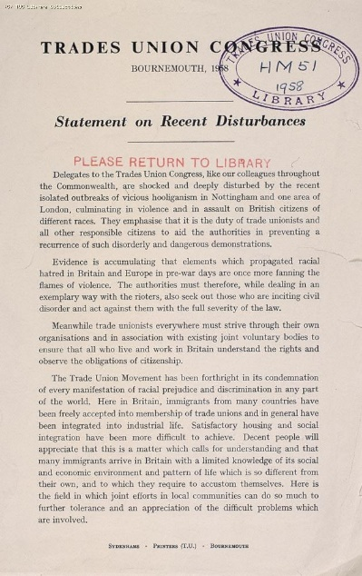
This statement was circulated to delegates attending the 1958 TUC Congress in Bournemouth. It condemns the riots and racist attacks which had taken place in Nottingham and Notting Hill Gate, London.
We continue to acquire recent publications on issues such as
- equal pay and hours
- parental leave and childcare
- discrimination at work and employment rights
- older women
- women in unions
- health
- black and ethnic minority women.

Recent acquisitions can be seen on the online catalogue, but the majority of older documents are only accessible via a card catalogue in the Library.

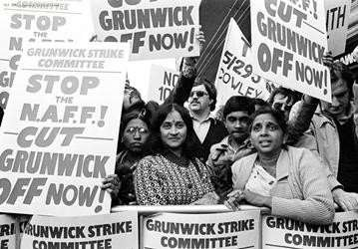

The press cuttings collection includes files on individuals, organisations and industries and is an invaluable source. For example, a search on the online cuttings database on the (see below) for women reveals 40 folders of cuttings 1913 -1979 covering strikes, equal pay and the marriage bar.

Special Collections deposited in the Library include the records of the Workers’ Educational Association, including its Women’s Advisory Committee, the Labour Research Department, with documents written by women activists such as Margaret Cole, Barbara Drake and Ellen Wilkinson, and the Mary Macarthur Holiday Trust which provided holidays and rest-breaks for working women. The Library also holds the papers of individuals e.g. Gertrude Tuckwell 1861-1951, Margaret Bondfield 1873-1953, Marjorie Nicholson 1914- 1999, Dorothy Elliott 1895-1980, Yvonne Kapp 1903-1999 and Mary Macarthur 1880-1921. The Tuckwell Collection includes printed and manuscript documents from 1890-1921 covering issues relating to women’s political and employment rights, anti-sweating campaigns, union organisation, health and safety, suffrage campaigns and issues relating to women and World War 1. The Bondfield papers include her diary of a visit to Russia in 1920 and documents relating to the International Congress of Working Women 1921 and the International Federation of Working Women 1922-1925. Catalogues of the WEA, LRD, Tuckwell and Nicholson collections can be searched online from Collections webpage.

Online resources include:
- Winning Equal Pay on the Union History website equal pay pages show filmed interviews with women who fought for and won equal pay, hundreds of digitised images and documents, plus contributions from historians and other experts.
- The Union Makes Us Strong on the Union History website info page provides digitised photographs and documents relating to women’s history in its Timeline and has a fully searchable database of the Trades Union Congress Annual Reports 1868-1968. The website also has a whole section dedicated to the famous 1888 strike of women match workers in London.
- The Workers War on the Union History website workers war page
- Britain at Work: voices from the workplace 1945-1995 on the Union History website Britain at Work page present images and documents, as well as oral testimony from women who worked on the Home Front during the Second World War and later in the period of Reconstruction.

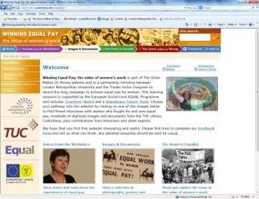
Visitors should note that the TUC Archive, including correspondence files and committee minutes has been deposited in the Modern Records Centre at the University of Warwick.
The TUC Library Collections are accessible in the university’s Special Collections Reading Room. The collections are available by appointment only for external visitors. See Access details on the Special Collections page of the University website for details.

TUC Library Collections, London Metropolitan University, The Wash Houses, Old Castle Street, London E1 7NT (entrance via 16 Goulston St).
Tel: 020 7320 3516 // Email: tuclib@londonmet.ac.uk
TUC Library Collections web page
The Union Makes Us Strong : TUC History Online
The Workers War: Home Front Recalled
Winning Equal Pay: The Value of Women’s Work

July 2019

