Researching lesbian, gay, bisexual and transgender (LGBT) issues in the TUC library collections.
The TUC Library Collections transferred to the London Metropolitan University in 1996. The holdings include not only union publications and documents relating to working conditions and industrial relations in the UK and overseas, but also material collected from the various campaigns and policy areas with which the TUC and its affiliated unions have been involved. Visit us to view original material that documents the history of:
- LGBT issues
- Equality and diversity legislation
- Anti-discrimination campaigns
- International LGBT campaigns
- Strikes, demonstrations and social movements

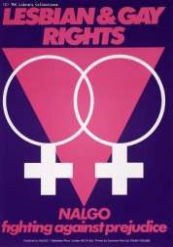
The TUC Library Collections are accessible in the university’s Special Collections Reading Room. The collections are available by appointment only for external visitors. See Access details on the Special Collections page of the University website for details.

TUC Library Collections, London Metropolitan University, The Wash Houses, Old Castle Street, London E1 7NT (entrance via 16 Goulston St).
Tel: 020 7320 3516 // Email: tuclib@londonmet.ac.uk
TUC Library Collections web page
The Union Makes Us Strong : TUC History Online
The Workers War: Home Front Recalled
Winning Equal Pay: The Value of Women’s Work
April 2018
