Researching housing, construction and city panning in the TUC library collections

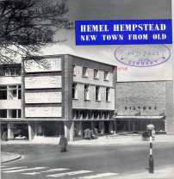
The TUC Library Collections transferred to the London Metropolitan University in 1996. The holdings include not only union publications and documents relating to working conditions and industrial relations in the UK and overseas, but also material collected from the various campaigns and policy areas in which the TUC has been involved since its foundation in 1868. Visit us to read original documents from the beginning of the 20th century on:
- Garden cities and New Towns
- Housing policies and programmes
- Regional planning and development
- Housing design
- Trade unions and working conditions in the construction industry
- Urban planning

The TUC Library Collections are accessible in the university’s Special Collections Reading Room. The collections are available by appointment only for external visitors. See Access details on the Special Collections page of the University website for details.

TUC Library Collections, London Metropolitan University, The Wash Houses, Old Castle Street, London E1 7NT (entrance via 16 Goulston St).
Tel: 020 7320 3516 // Email: tuclib@londonmet.ac.uk
TUC Library Collections web page
The Union Makes Us Strong : TUC History Online
The Workers War: Home Front Recalled
Winning Equal Pay: The Value of Women’s Work

April 2018

