Sources for the study of the European labour movement in the TUC collections
The TUC Library Collections, established in 1922, transferred to the London Metropolitan University in 1996. The core areas of the Library are reference and historical works on the trade union movement, union publications from the UK and overseas, documents relating to working conditions and industrial relations in various industries and countries, and material collected from the various campaigns and policy areas in which the TUC has been involved since its foundation in 1868. Most overseas material dates from the foundation of the International Federation of Trade Unions in 1913, although there is some earlier material. The collection of information from international and overseas political and labour movements expanded with the establishment of the TUC International Committee in 1921.

The Collections hold the printed publications of the TUC, its affiliated unions, and overseas organisations with which it has been in contact plus pamphlet collections from the Labour Party, Communist Party and other relevant political groups and campaigns. Also held are the publications of various international organisations such as the International Labour Organisation and its regional organisations from 1918, material from and about trade union internationals (IFTU, ICFTU, WFTU, WCL) and their trade secretariats from 1913, plus papers from the Communist International, Red International of Labour Unions, etc.

The Library also holds relevant publications from pan-European organisations from the Marshall Aid period onwards e.g. the European Productivity Agency, the OEEC/OECD, and official, union and pressure group material on the concept of European Union from the early 1950s to today. There are good holdings of material from the European TUC and European Industry Committees and on current issues such as migrant workers and European Works Councils.

There are separate files for each country - covering trade unions, labour law, labour market issues, and political, economic and constitutional history. These files include documents from unions, political parties, pressure and campaign group, official papers relating to political and labour activities, conferences, reports from British visitors, statistical series, economic surveys, etc. There are small special collections on specific periods/events e.g., the Russian Revolution, Spanish Civil War, documents from both World Wars including material produced by resistance or exiled groups, and the post WW2 reconstruction of unions in Central Europe. The collections from France and Germany are particularly strong. Before 1920, runs of overseas periodicals are often incomplete, but there are good runs of key titles from the main trade union centres in each country, e.g., La Voix du Peuple 1922-1940 and La Vie Ouvriere 1934 -1993 from the Confederation Generale du Travail in France. The TUC continues to deposit material from overseas trade unions.

The collection of press cuttings dating from c.1910-1970 includes files on individual countries and is an invaluable source. For example, a search on the online cuttings database on the Collections web page (see below) for France reveals 26 folders of cuttings 1916-1966 covering e.g., the CGT, the French Communist Party, the United Front, the Bedaux system.
Special Collections deposited in the Library include the International Federation of Workers’ Educational Associations Archive and papers of individuals, e.g. Gertrude Tuckwell 1861-1951 [which has documents from international women’s congresses from 1904, women’s working conditions in factories and sweatshops overseas and includes a report on a visit to a French match factory from 1898] and Margaret Bondfield 1873-1953 [including her diary and other papers from a visit to Russia in 1920 and documents relating to the International Congress of Working Women 1921 and the International Federation of Working Women 1922-1925].

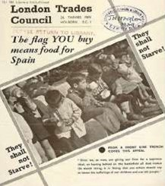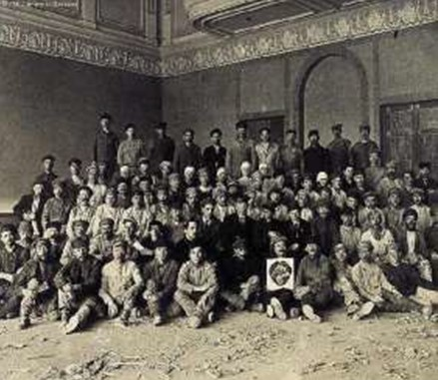

The TUC Library Collections are accessible in the university’s Special Collections Reading Room. The collections are available by appointment only for external visitors. See Access details on the Special Collections page of the University website for details.
TUC Library Collections, London Metropolitan University, The Wash Houses, Old Castle Street, London E1 7NT (entrance via 16 Goulston St).
Tel: 020 7320 3516 // Email: tuclib@londonmet.ac.uk

TUC Library Collections web page www.londonmet.ac.uk/libraries/tuc
The Union Makes Us Strong : TUC History Online at www.unionhistory.info
The Workers War: Home Front Recalled at www.unionhistory.info/workerswar
Winning Equal Pay: The Value of Women’s Work at www.unionhistory.info/equalpay
April 2018

