Help searching the Archive of the Irish in Britain Digitised Collections

You can access the digitised Archive of the Irish in Britain from this web page

When you click on the link to search the collection you will come to a screen with lots of years listed:

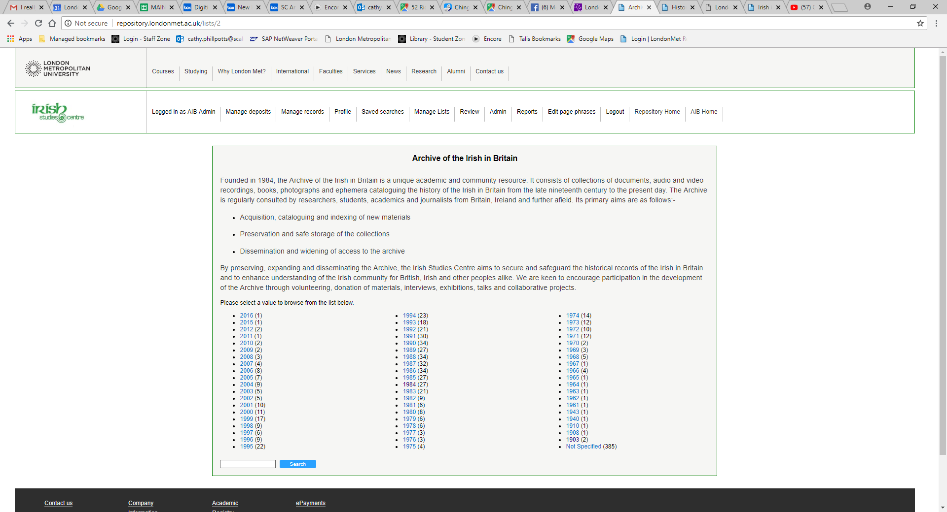

You can either:
- choose a year and click on it to see all the digitised content that was originally published in that year (“Not specified” means that the original publication did not have a date).
or,
- type some keywords into the search box at the bottom left of the screen and then click on search.

You will then see the catalogue record(s) for your year or topic. To access the digitised material, move your mouse over the title on the catalogue record and click on the title when the text becomes underlined on the screen.

You will then see more details about the item including a link to the digitised version; which you may download for private research or study.

Some items also have a transcript of the text – which can be useful if the original is difficult to read, or, if you are using a “screen-reader” to access content. You may also download the transcript for private research or study.

If you have any questions or need further help, please email specialcollections@londonmet.ac.uk.

