HOW TO INSTALL MICROSOFT TEAMS ON A CHROMEBOOK

This guide will walk you through how to install Microsoft teams your Chromebook.

- To begin, open your Chromebook and power it on and sign into your Chromebook. You should be presented with a screen like this one:
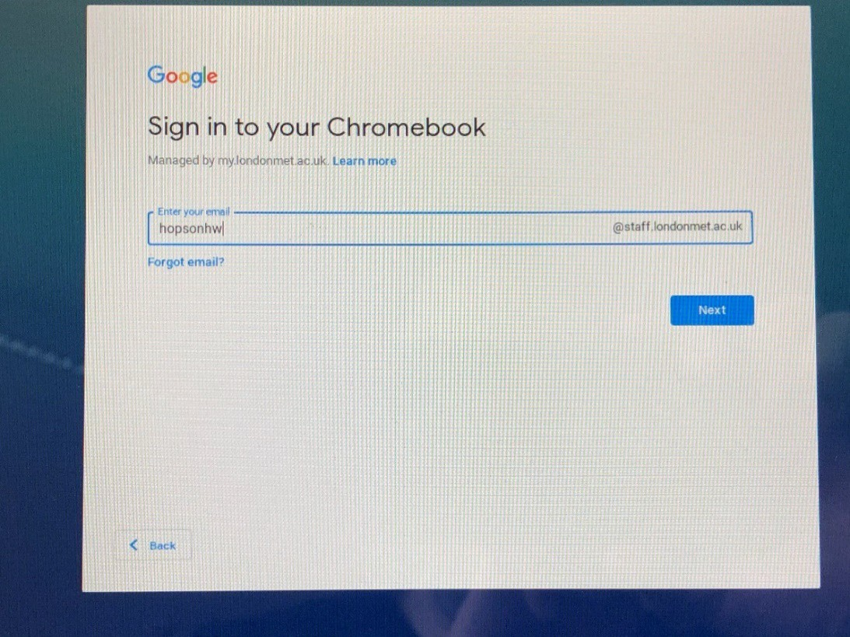
- Now enter your password in the box on this screen and click Next:

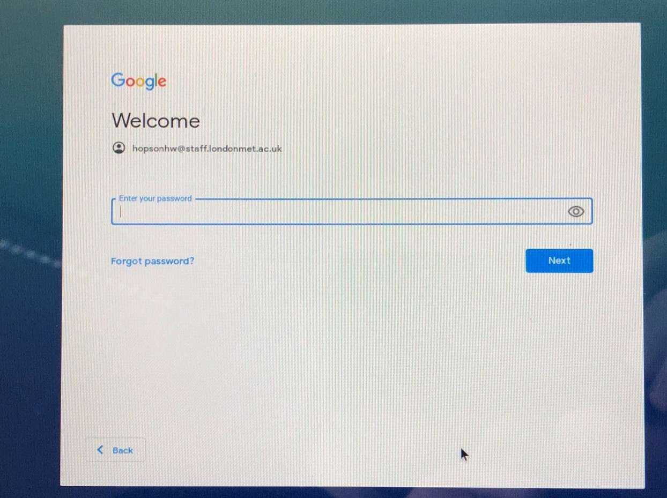

At this point you should now be signed into home network and into your Chromebook laptop.
- Click on Play Store on the Chromebook, see the image below.
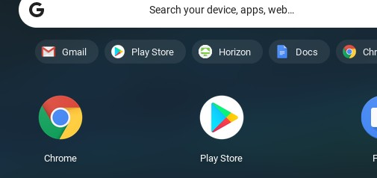

- Type Microsoft Teams on the search box

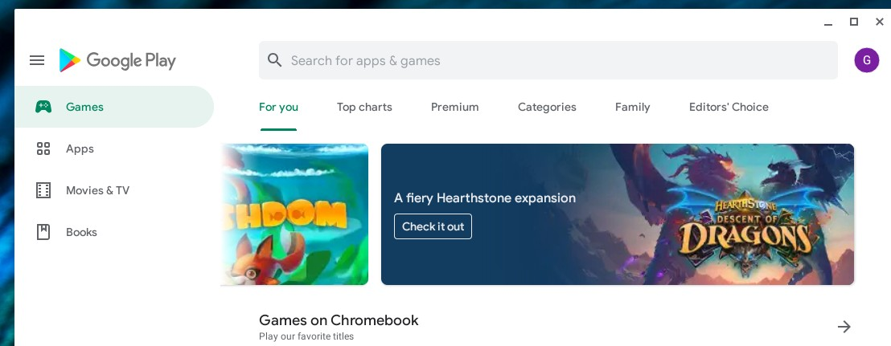

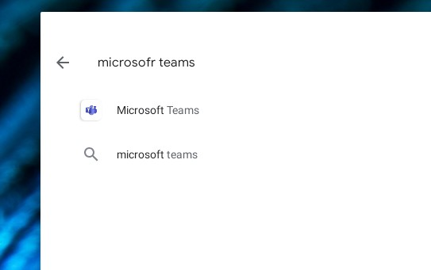
- Click on the icon Microsoft Teams

- Click Install for the application to be installed on the Chromebook
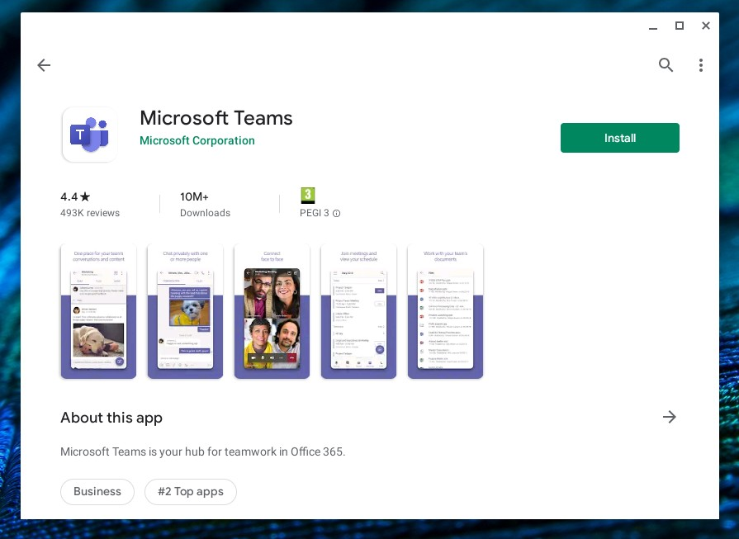

- Once application installed click to open and sign in
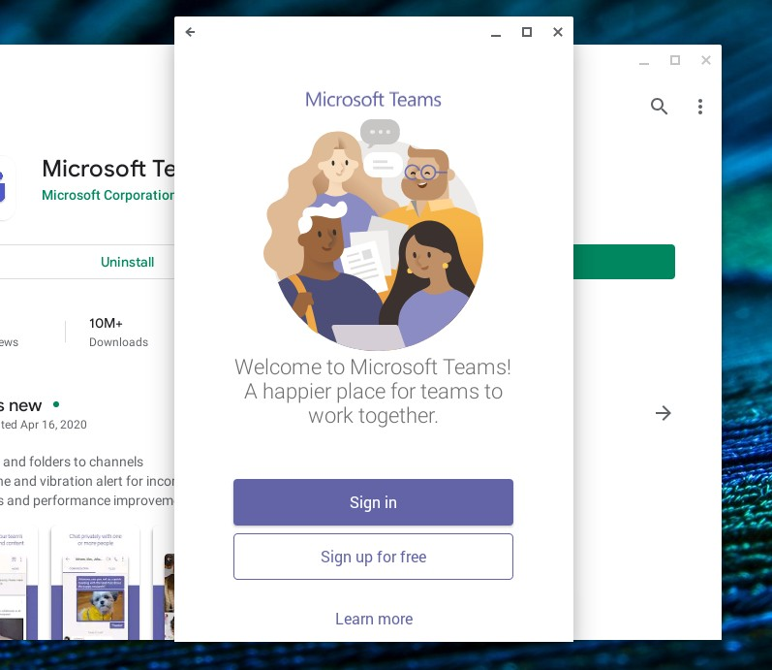

- Sign in by using the format “username@staff.londonmet.ac.uk”

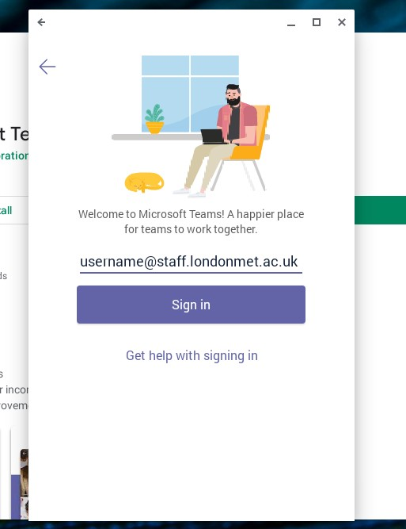

- Enter your university password.

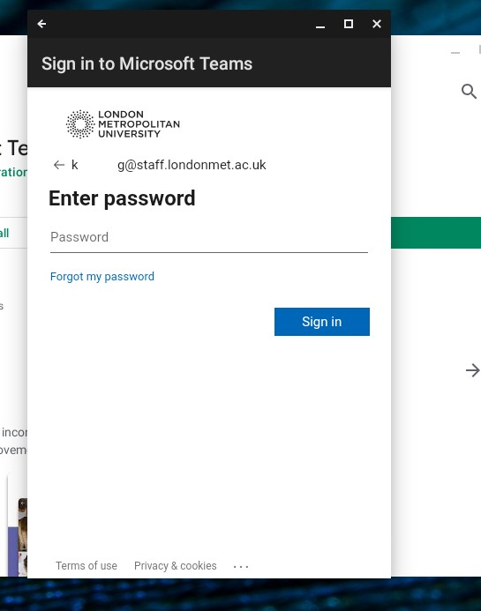

- Click next and finally click Got it and you are ready to use the app.

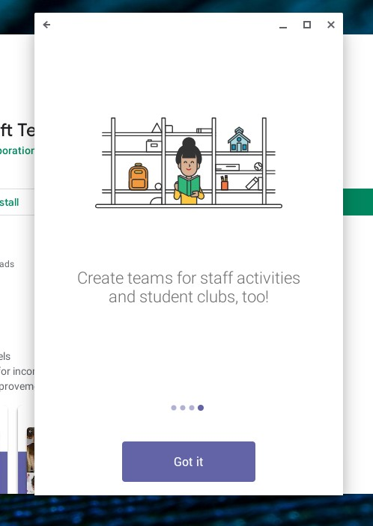

- On the bottom of the screen you can change between Chat, Teams, Assignments and Calls.

- Alternatively, you can open a browser and type “teams.microsoft.com”
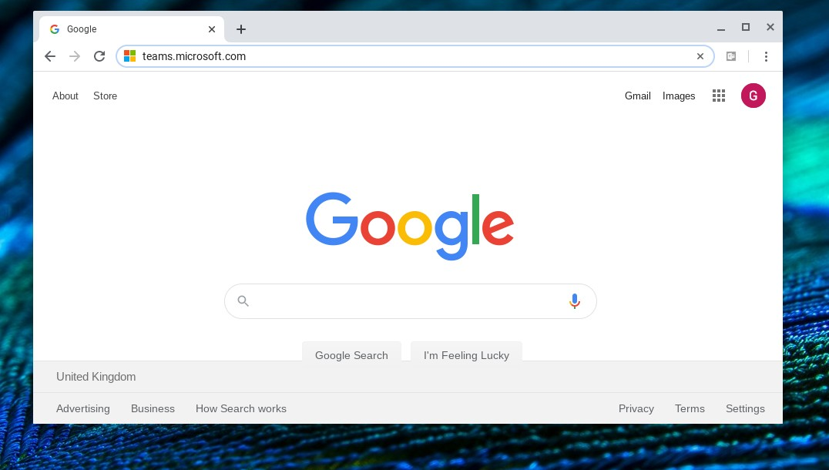
- Sign in using your university credentials “username@staff.londonmet.ac.uk”

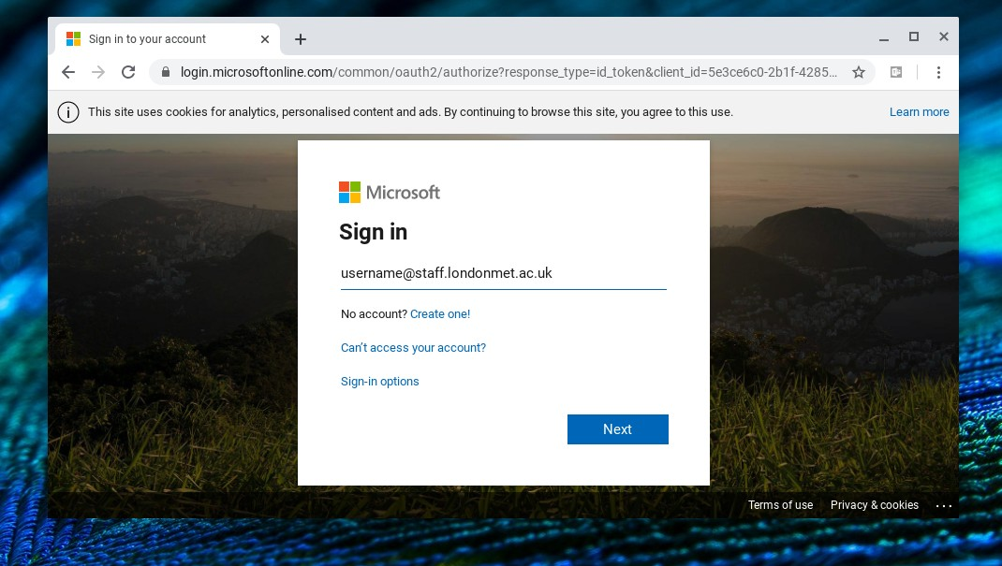

- Enter your password

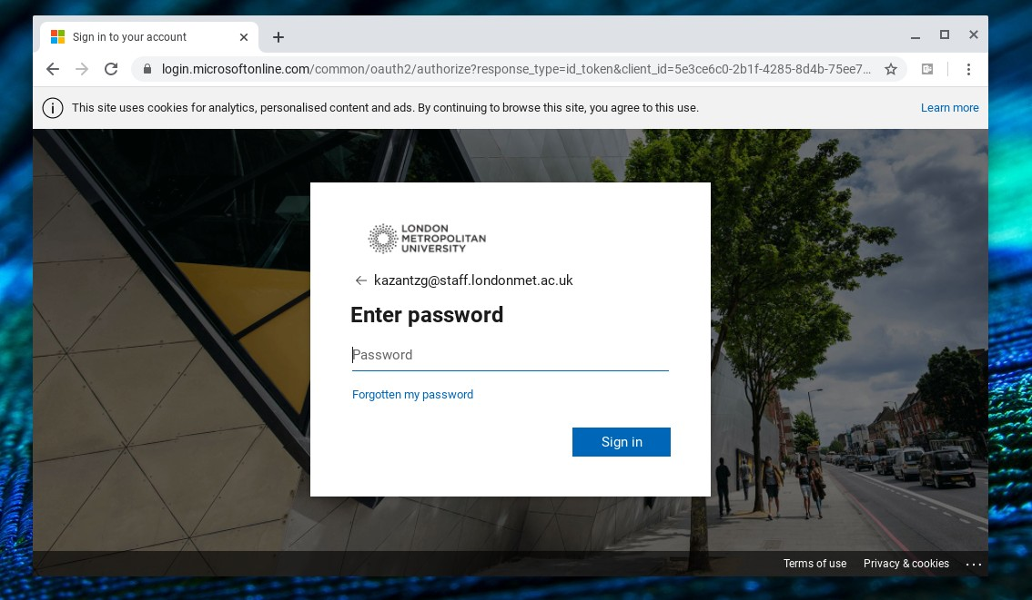

- You are now logged in and are ready to use teams.
