- The first time you open an Adobe program on a machine you will get this login box

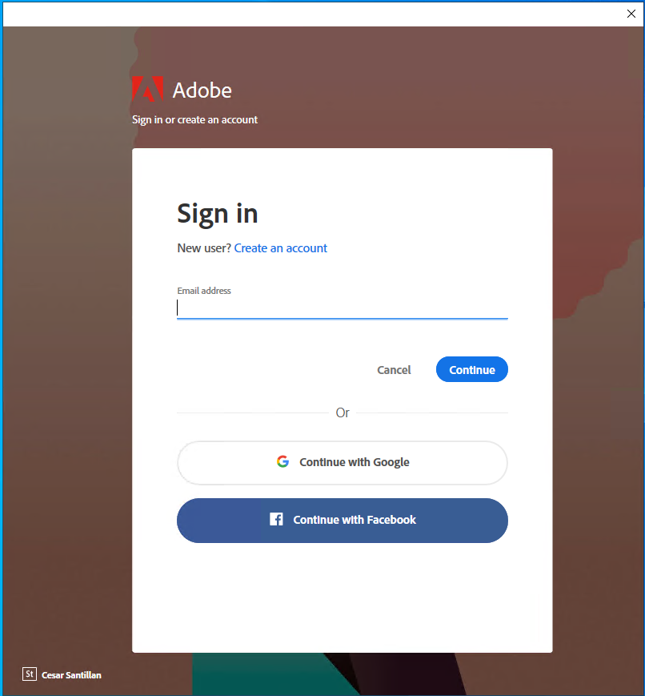

Enter your @staff.londonmet.ac.uk or @my.londonmet.ac.uk email

You should then get logged into your account and be able to start using the application.

- You may be taken to the account selection screen:

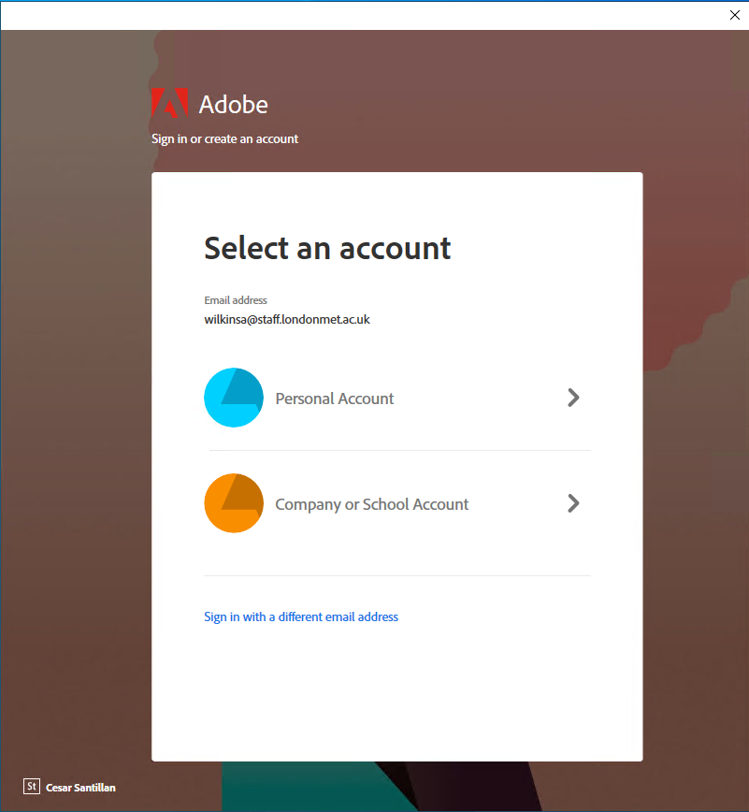

Select “Company or School Account”

- You may then get logged in or you may be presented with the below box:
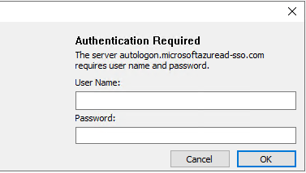

If this appears then enter your usual user name and password.
You will then get this wondow:

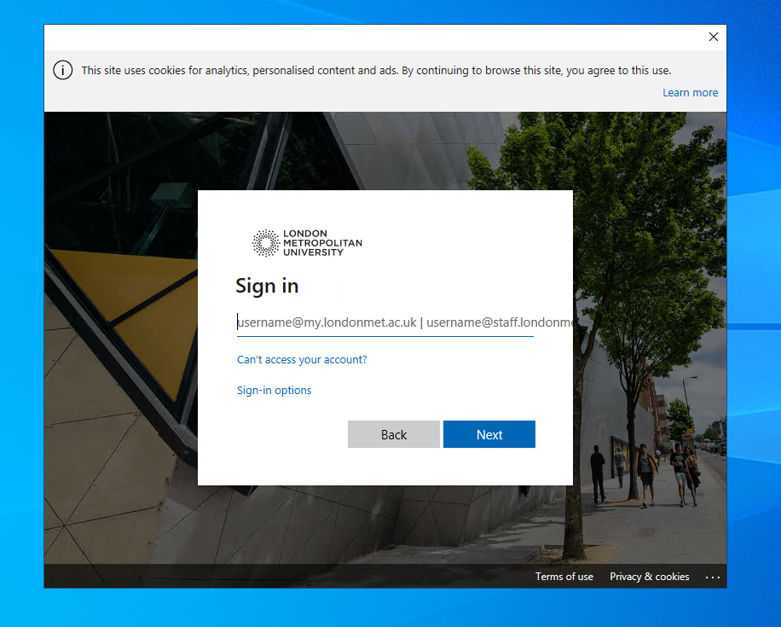

Enter your @staff.londonmet.ac.uk or @my.londonmet.ac.uk email

- You will then be prompted for your password:

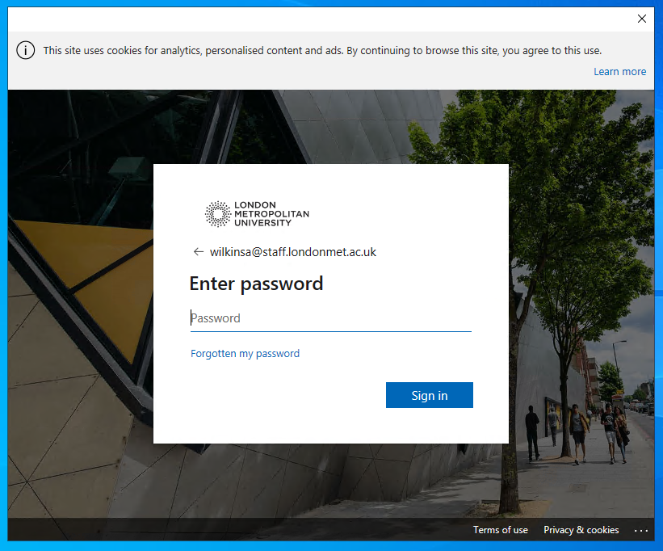

- You may be asked to select a profile. Please make sure you select the first one which starts “jisc”

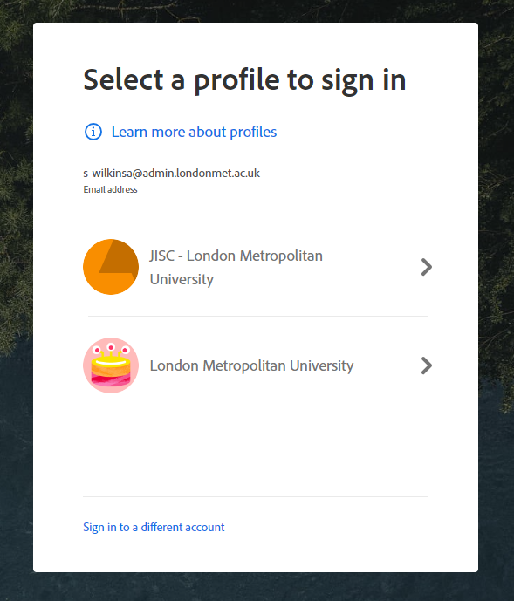

- Finally you will be presented with the stay signed in query:

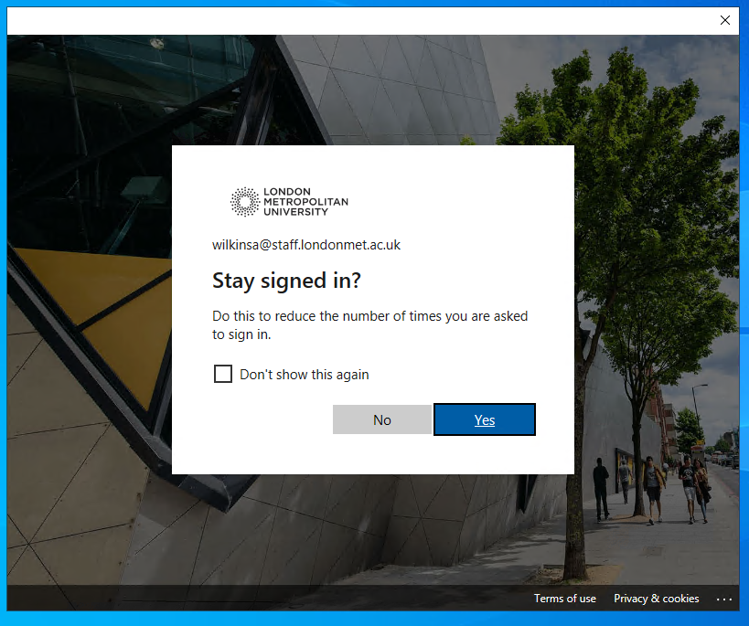

If you select “don’t show this again” this screen won’t appear on future logins.

- You should now be logged in to the Adobe software

