Eduroam Wifi Access: Guidelines for Students and Staff

Author: Holly Bowskill
Version: 1.0
Date: 28th March 2023
+44 (0)20 7133 2716

h.bowskill@londonmet.ac.uk
How to set up and use the eduroam Wi-Fi
Staff and students can access the University's free Wi-Fi network by connecting to eduroam. You'll only need to set this up once and you'll stay connected to the network around London Met and in thousands of participating locations in 70 countries worldwide.

How to set up eduroam

Setting up eduroam takes a few moments but it's well worth the effort in terms of the time it will save you in the long run.
- Make sure you’re online, for e.g. using a wired connection or your mobile data. If you need to, you can speak to Techsmart for a guest wifi account to allow you to set up your eduroam access
- Make sure you’re in an area where eduroam is available i.e. on campus
- Follow the instructions for your operating system:

Desktops and laptops
- Linux
- macOS
- Windows

Phones and tablets

Android

Chrome OS

iOS

Windows Phone

We also have generic instructions that can help you configure other devices.

Having problems?

If you're experiencing difficulties setting up or accessing your Wi-Fi connection, working through our troubleshooting tips may help you to resolve or diagnose the problem.

Wi-Fi troubleshooting >

Eduroam Visitors

If you're a visitor to the University from another organisation that offers eduroam
You will need to set up eduroam access at your home institution before you arrive in London Met.

If you're a short-term visitor to a University Department or College
You can request guest wifi access by:
- visiting the TechSmart desks in the libraries
- using IT help chat
- asking the member of staff you are visiting to make a request via the IT self service portal (this can be done in advance)

Phones and Tablets

Android

How to set up eduroam on a mobile device running Android
Before you begin, make sure you are in a location where the eduroam wireless network is available.
These instructions were written using a Google Pixel running Android 13.
Users with Android 10, Android 11, and later (including any Android device purchased in the last 3 years), should now use the ‘geteduroam’ application, downloadable from the Play Store, as the primary method of configuring eduroam.
The eduroam CAT instructions are still available if your device is unable to connect using the geteduroam application. Only use the eduroam CAT if you’re unsuccessful using geteduroam, if you are running Android 7 and older, or if you have a legacy Android device (4+ years old).

Step 1
Removing existing ‘eduroam CAT’ app and associated configuration files
If you have not previously configured eduroam on your Android 13 device, please skip to step 2 for configuration instructions using the new ‘geteduroam’ app.
All versions of Android: Remember to remove any existing eduroam configuration before any attempt to reconfigure using a different method (e.g. remove any profiles installed using the eduroam CAT before attempting to use geteduroam). This includes removing any manual configuration you may have previously set up.
Note: All the following steps require an internet connection. This can be done using a mobile network (3G/4G/5G).
If you do not have mobile internet access you can contact Techsmart for temporary guest wifi access. Do not complete the ‘geteduroam’ set up whilst existing ‘eduroam CAT’ configuration still exists on your device).

Step 2
Install the ‘geteduroam’ app.
Open 'Play Store' from your Apps list and search for 'geteduroam'.
Select ‘Install’.

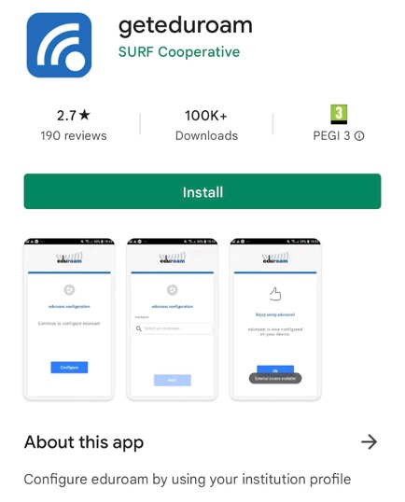

Step 3
Select ‘open’ once the app has completed the installation. If prompted ‘allow geteduroam to send notifications?’ select ‘Allow’.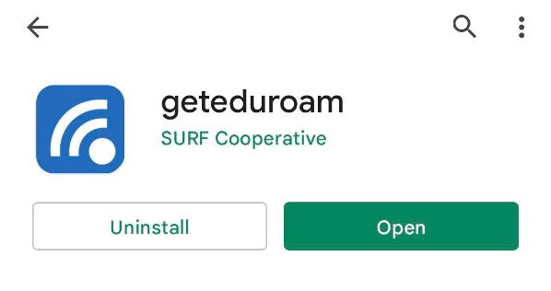

Step 4
In the ‘select an institution’ search box type ‘London Metropolitan University’.
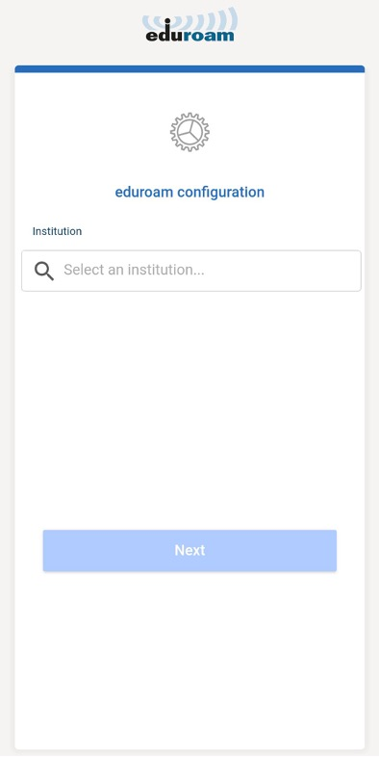

Step 5
Select ‘London Metropolitan University’ from the drop-down list, select the appropriate profile ‘staff’ or ‘student’ and click ‘next.
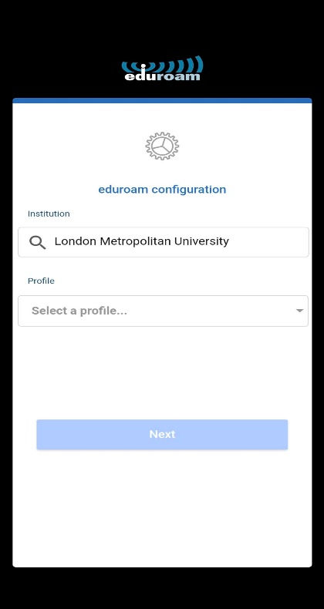

Step 6
Enter your London Met ‘username’ and ‘password’ in the following format:
Student: username@my.londonmet.ac.uk
Staff: username@staff.londonmet.ac.uk
Then select ‘Connect to Network’.
When prompted to ‘save this network?’ click ‘Save’ on the bottom right hand corner of the screen.
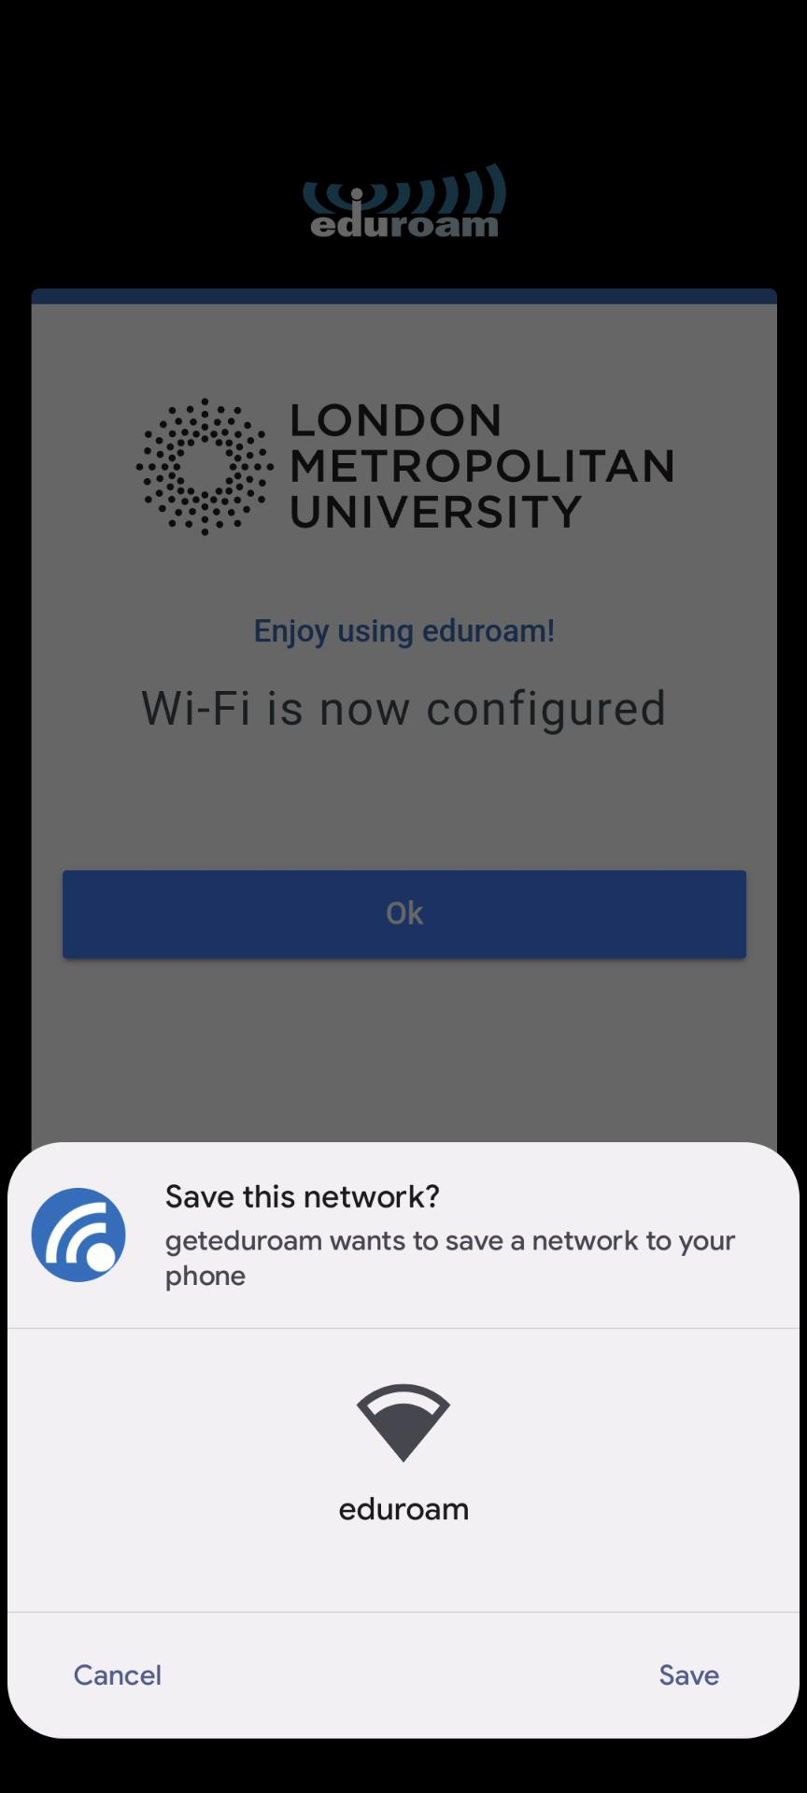

Step 7
Once you have successfully entered your username and password, the following message will appear.
Select ‘Ok’ and close the app ( but DO NOT DELETE) to complete the configuration process. You must keep the app running on your phone to maintain a connection to the eduroam network.
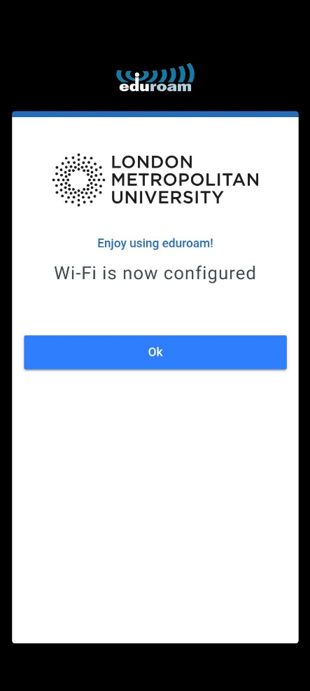

Your device should now be connected to eduroam. You can verify this by navigating to your network settings > Wi-Fi.
step_7.1.jpg
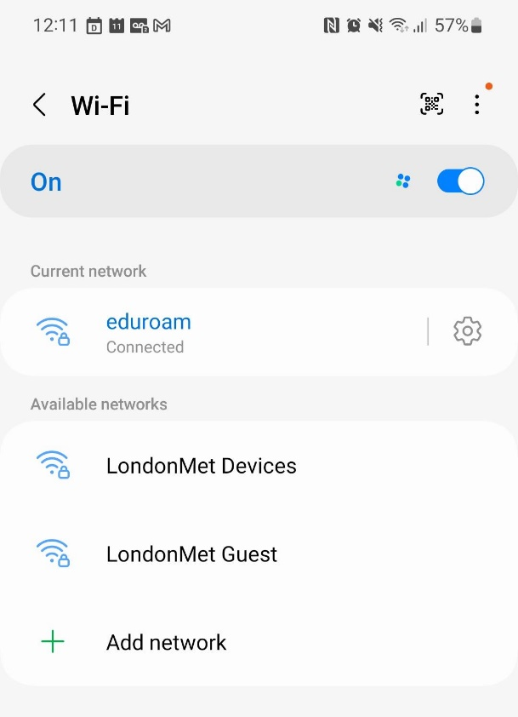
Select the cog next to ‘eduroam’ and toggle the ‘Auto reconnect’ setting to ensure your device automatically connects to eduroam whenever an access point is in range.
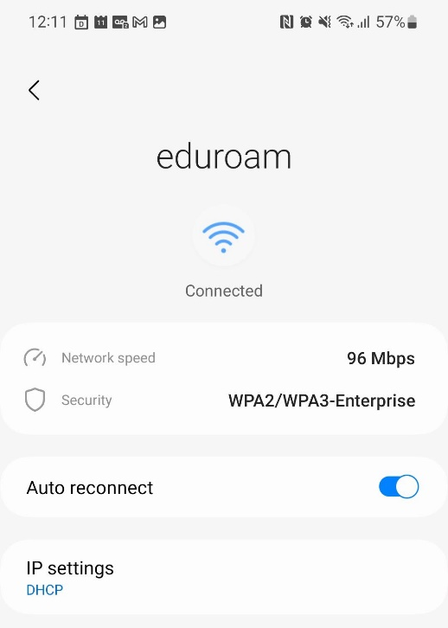

Your device should now automatically connect to the University's Wireless Service via eduroam whenever an access point is in range.
If it doesn't work, double check the above steps – particularly making sure your username and password are correct. You can also try to configure your Android device manually.
If you're still unable to connect, please look through troubleshooting or contact Techsmart

How to manually configure eduroam on an Android device
We recommend that you manually configure eduroam on an Android device only if you're unable to use the eduroam CAT tool - note that Android 11 may not work with the eduroam CAT, an alternative app is available from Play Store called "geteduroam" (remove existing eduroam configuration first).
Manually configuring eduroam on Android devices can be complicated and prone to error because of the variations between different versions of Android. The 'eduroam CAT' app simplifies this process, and we recommend using it wherever possible (Android version 10 and lower, it may fail for some Android 11 devices). However, if for some reason this process fails, then you can follow the manual instructions below.
Before you begin, make sure:
- you're in a location where the eduroam wireless network is available
- you have created a network access token for this device on the UIS token page.
- you have removed existing eduroam configuration first by forgetting the eduroam wireless network settings (if you have any).
These instructions were written using a OnePlus 5T running Android 8.

Important notes for devices running Android 11
From version 11 onwards the identity certificate presented by an authentication server (such as that used on eduroam) must be validated by your device. In previous versions it was possible to select "Do not validate" or similar in the eduroam settings (this is a security risk), this is no longer possible.
If you have set your eduroam connection up without certificate validation then you will find that you are unable to connect once upgraded to Android 11. You will need to 'forget' and reconfigure your eduroam settings.
We believe that the "eduroam CAT" may not work for all Android 11 devices, there is a new app called "geteduroam" (we will be fully documenting this when we have been able to test it). We recommend trying the new "geteduroam" app (which should be similar in process to the eduroam CAT) or if this doesn't work for you then please use the instructions below to manually configure your eduroam connection. Always remove existing configuration before attempting a new method (go to your wireless networks and 'forget' eduroam).

- Before you start, remove any current configuration for eduroam. Go to Settings then Wi-Fi. Press and hold on eduroam. If the option to Forget network or similar appears, then select it and continue. If the option to 'Forget network' does not appear you can still continue.
- Make sure you are connected to the internet (for example, via a mobile network or by connecting to the University's UniOfCam Wi-Fi network.
- Open your Settings dialogue.
- Select Wi-Fi.
- Select eduroam and enter the following settings options:
EAP method: select ‘PEAP’
Phase 2 authentication: select ‘MSCHAPV2
CA certificate: select ‘use system certificates’
Online certificate status: select ‘request certificate status’, or ‘request certificate’
Domain: type in londonmet.ac.uk
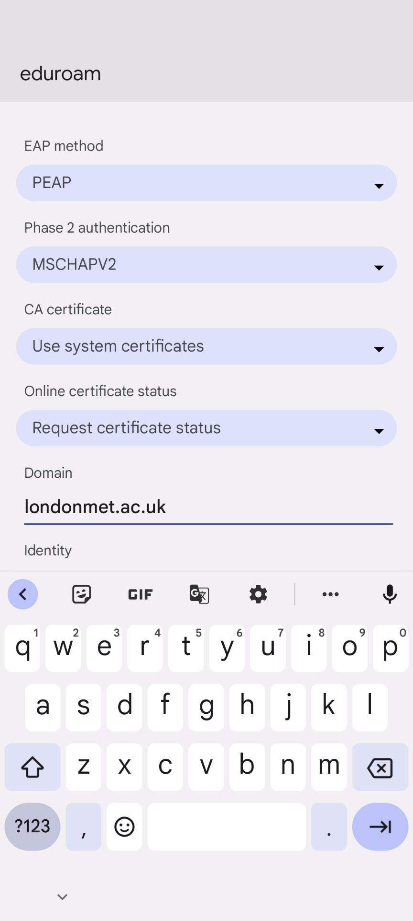
- Complete the other options as described below:
Identity: your username in the format:
Student: username@my.londonmet.ac.uk
Staff: username@staff.londonmet.ac.uk
Password: your London Met account password
- Select Connect.
Your device should now connect to eduroam. Your password will be saved.
If you still have problems connecting you can find further advice on www.eduroam.org , under ‘Eduroam tools’.

Mobile devices

iOS

How to set up eduroam on a mobile device running iOS (iPhone, iPad etc)
These instructions are for configuring eduroam for iOS devices such as iPhones and iPads.
Before you begin:
- make sure you're in a location where the eduroam wireless network is available
- If you’re using an older device Hogtie, make sure you’ve installed all updates
Then follow these steps:
Open the eduroam cat website. You will need mobile data (3G/4G/5G) to do this.
You’ll see this screen:
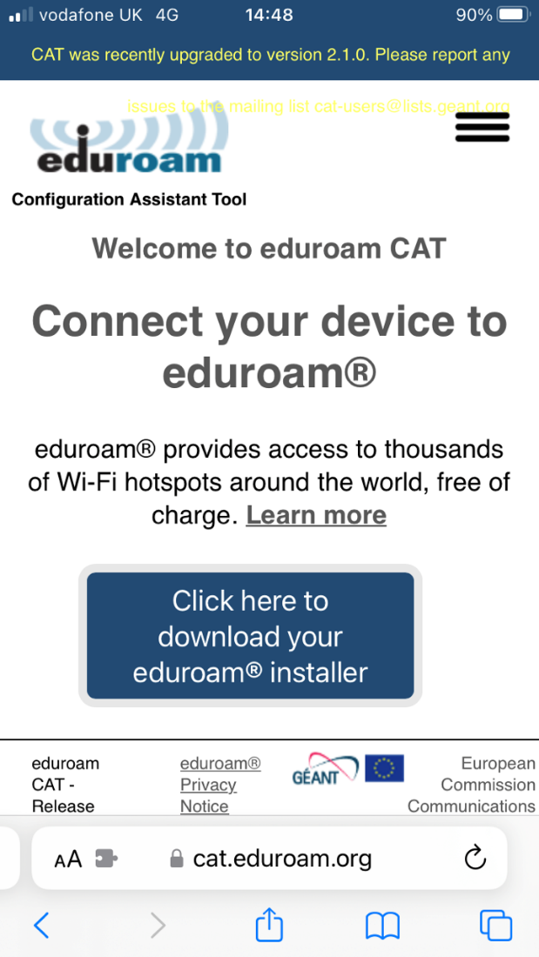
Click ‘click here to download your eduroam installer’.
You will then need to select ‘London Metropolitan University’ from the drop down menu:
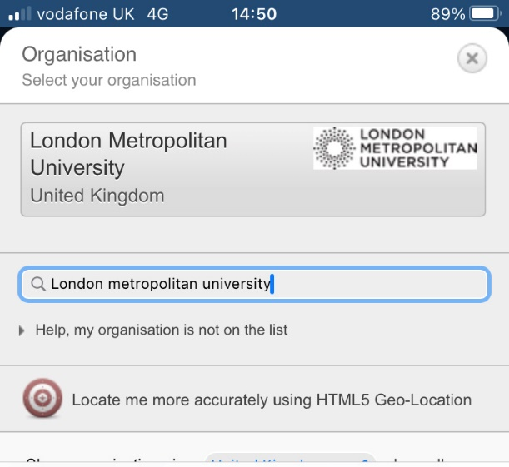
Then click on the London Metropolitan University logo above the drop down menu. You will then see this screen:
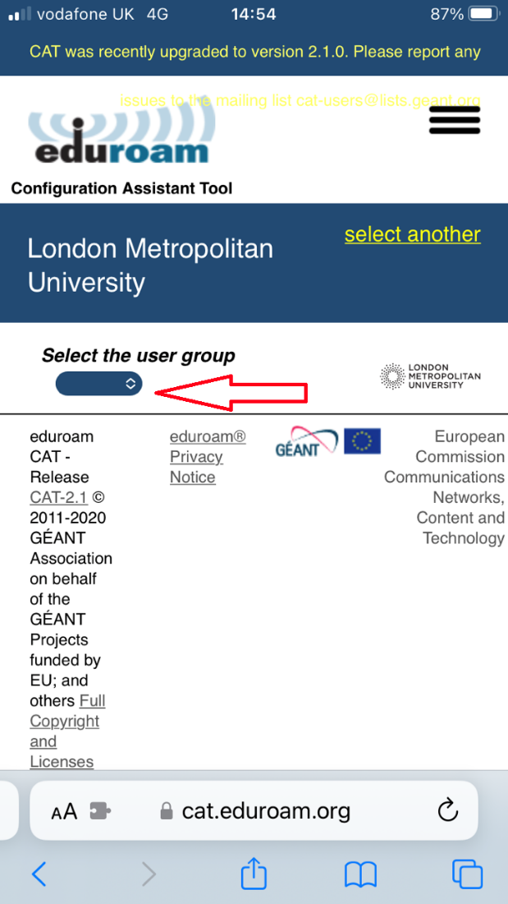
Click on the ‘select the user group’ box (highlighted by the red arrow in the image above) and select the appropriate user group:
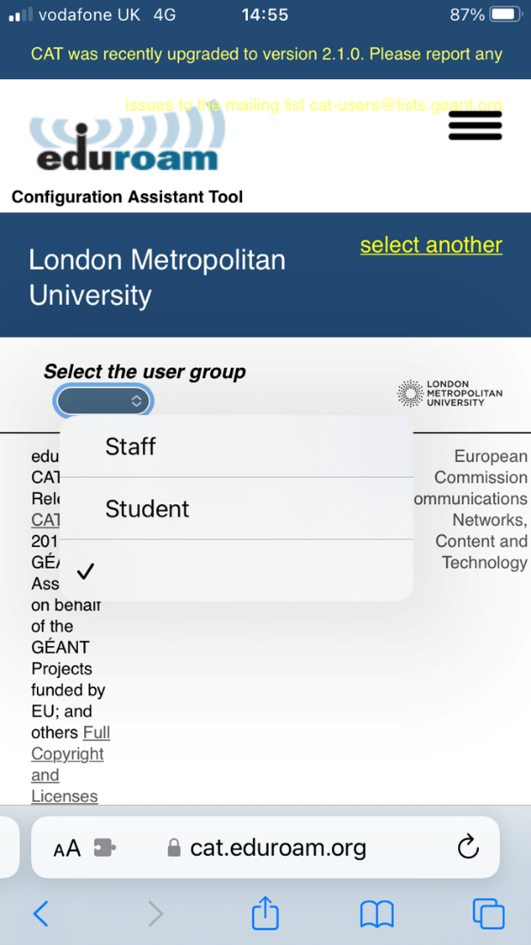
Click ‘download your installer for Apple device’:
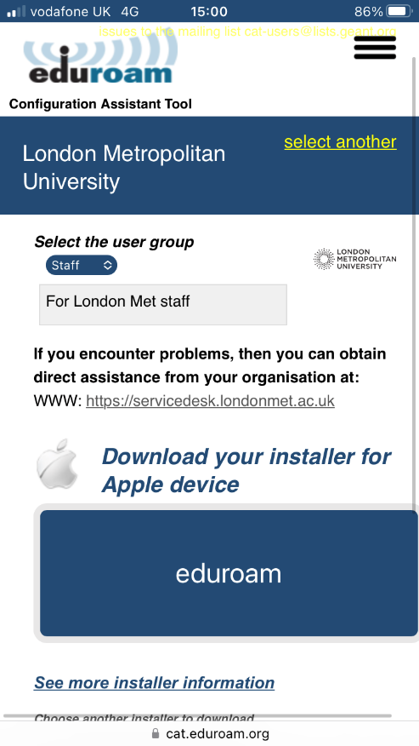

When prompted that ‘this website is trying to download a configuration profile’, click ‘Allow’:
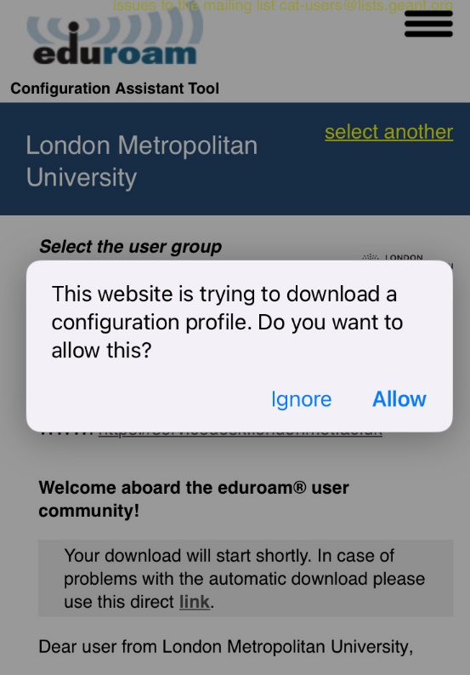
You will see the following screen:
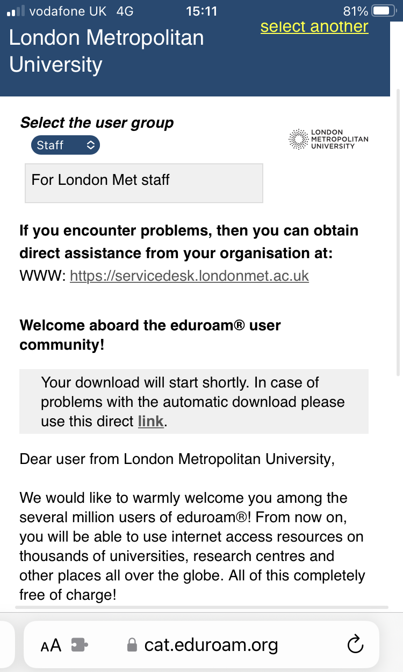
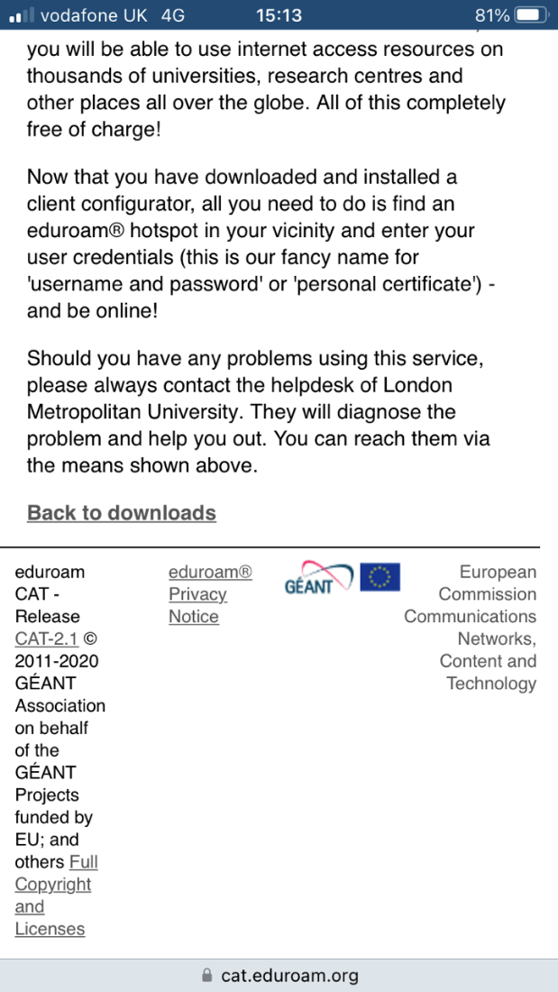

IMPORTANT: please read this screen carefully – your phone is now ready to connect to eduroam but you still need to manually connect your device to the network.
Follow these steps to connect to the eduroam network:
On your iOS device, go to the settings menu and select wireless and the, when it appears in the network list, select ‘eduroam’ from the list:
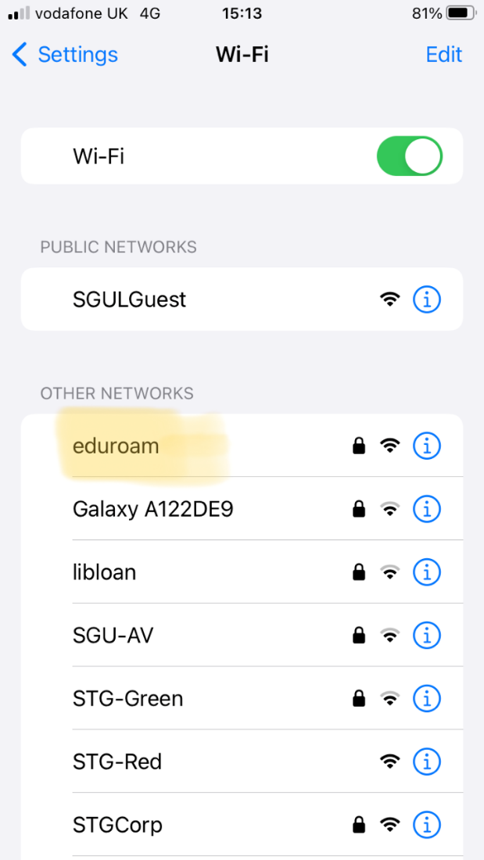

When prompted, enter your username in the following format:
Student: username@my.londonmet.ac.uk
Staff: username@staff.londonmet.ac.uk
And your password: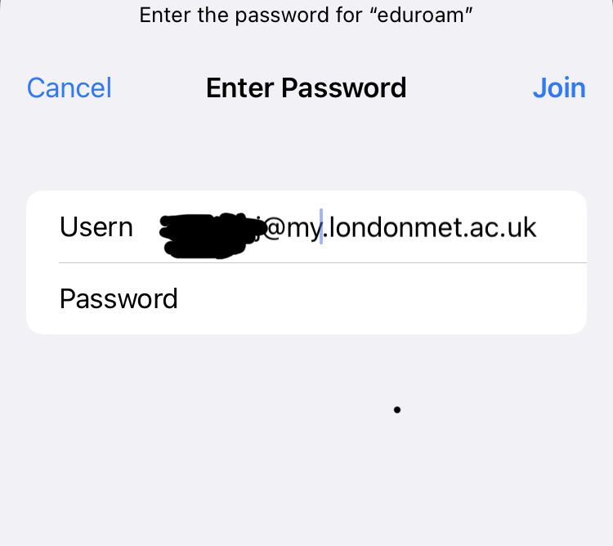
You will then see this screen:
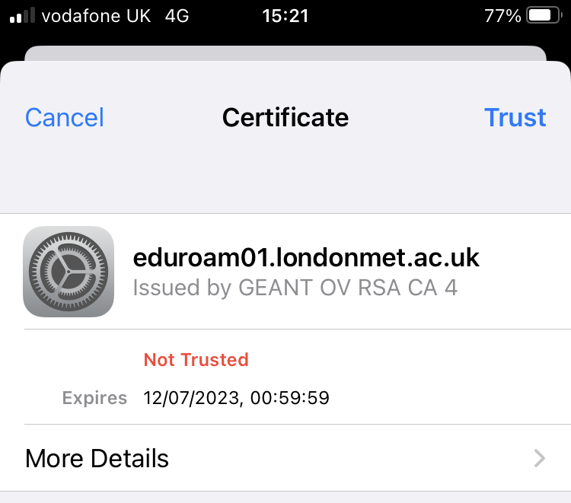
Click ‘Trust’ in the top right hand corner of the screen.
You will now be connected to the eduroam wifi network. You can check this by going back to the settings menu on your iOS device and selecting wifi:

How to set up eduroam on a MacBook
Before you begin:
- make sure you're in a location where the eduroam wireless network is available.
- If you’re using an older device Hogtie, make sure you’ve installed all updates.
Then follow these steps: Open the eduroam cat website. You will need mobile data (3G/4G/5G) to do this. You’ll see this screen:
Click ‘click here to download your eduroam installer’.
You will then need to select ‘London Metropolitan University’ from the drop down menu:
Then click on the London Metropolitan University logo above the drop down menu. You will then see this screen:
Click on the ‘select the user group’ box (highlighted by the red arrow in the image above) and select the appropriate user group:
Click ‘download your installer for Apple device’:

When prompted that ‘this website is trying to download a configuration profile’, click ‘Allow’:
You will see the following screen:

IMPORTANT: please read this screen carefully – your phone is now ready to connect to eduroam but you still need to manually connect your device to the network.
Follow these steps to connect to the eduroam network:
On your iOS device, go to the settings menu and select wireless and the, when it appears in the network list, select ‘eduroam’ from the list:

When prompted, enter your username in the following format:
Student: username@my.londonmet.ac.uk
Staff: username@staff.londonmet.ac.uk
And your password:
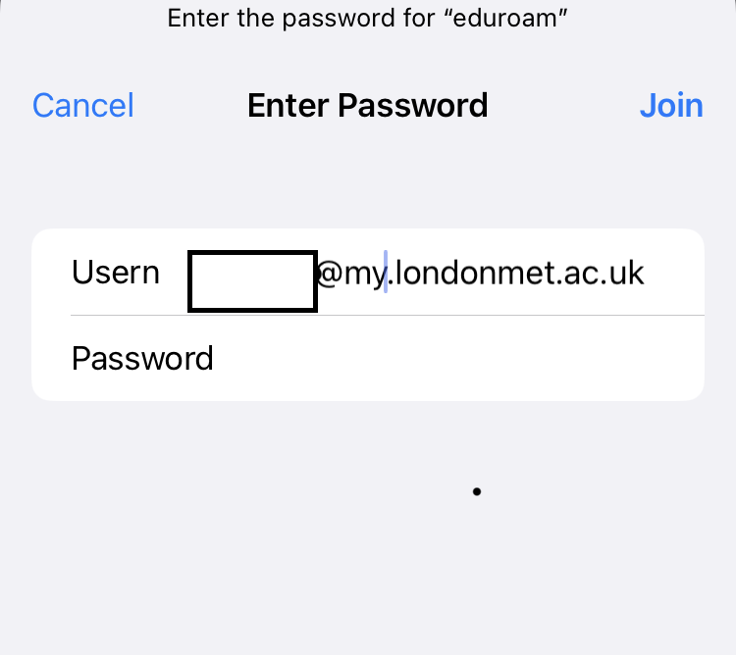
When connecting for the first time, you may then see this screen:
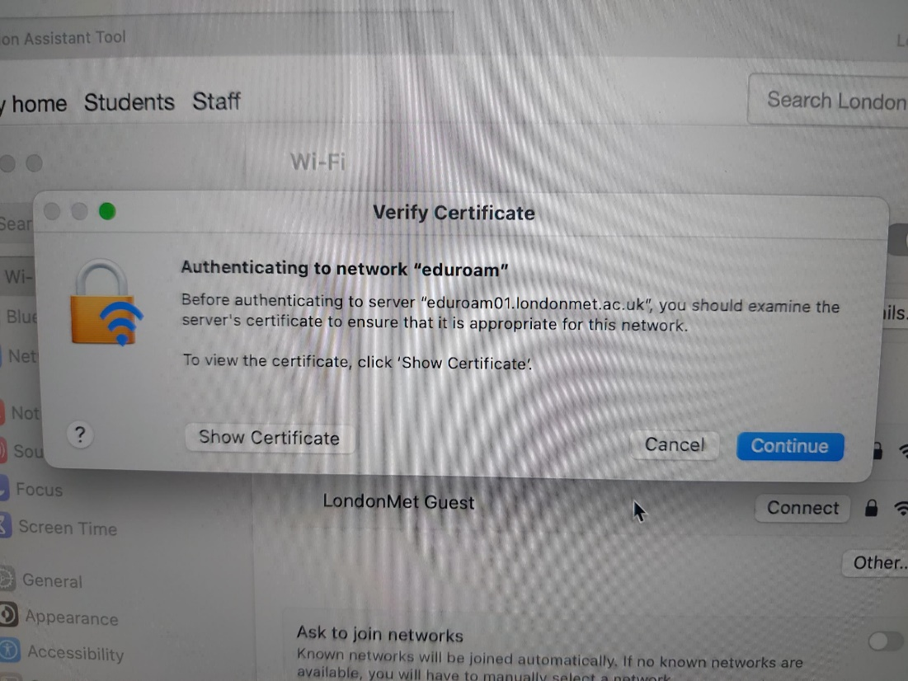
Select ‘continue’.
You may then receive a message saying that it was not possible to connect to eduroam. If this happens, try to connect again, select ‘continue’ on the above screen again and your connection should be successful.

Your device should now automatically connect to the University's Wireless Service via eduroam whenever an access point is in range. If it doesn't work, double check the above steps – particularly making sure your entered the user name and password correctly.

Need help?
If you're still unable to connect, please look through the troubleshooting page or contact Techsmart

Chrome OS

How to set up eduroam on a mobile device running Chrome OS
Before you begin, make sure you are in a location where the eduroam wireless network is available.
Connect to the internet – if you do not have a mobile internet connection you can contact Techsmart to request temporary guest wifi access.
Visit eduroam's Configuration Assistant Tool
Select "Click here to download your eduroam installer".

