

London Met's ITS team is pleased to introduce [AppsAnywhere](https://appsanywhere.londonmet.ac.uk/login), giving you access to all the software you need on-demand, anywhere, anytime. We've introduced this exciting new technology in response to student feedback.

## **1.What is AppsAnywhere**

[AppsAnywhere](https://appsanywhere.londonmet.ac.uk/login) is an online platform that allows you to access all university software whenever and wherever you need it.

Allows access to software from your own personal devices whether you’re on or off campus, making it easy to access specialist programs for your course.

AppsAnywhere is compatible with a host of devices and operating systems running Windows 7, Windows 10, Android, macOS, iOS and Linux.

## **2.How to use AppsAnywhere**

### **2.1. If you access AppsAnywhere on Campus, you can find in on the PC desktop.**

AppsAnywhere Icon



**Double click on the icon**, that will take you to the **AppsAnywhere** portal.

### **2.2. If you access AppsAnywhere from home:**

**Step 1**

Visit [AppsAnywhere](https://appsanywhere.londonmet.ac.uk/login)

**Step 2**

Log in with your **London Met username and password**.

A large screen in a room



**Step 3**

If it is the first time you have used the service, there will be a prompt about **validating your device**, and **downloading the AppAnywhere Client**. Both of these prompts are important to follow in order to use the software.

Click “It’s my first time using AppsAnywhere on this device. Let’s go.” if you haven’t used AppsAnywhere on your computer before.

AppaAnywhere welcome screen

The **AppsAnywhere** client installation will download automatically. Once complete, **run** the installer.

AppsAnywhere Welcome setup Wizard screen

An **AppsAnywhere client install** dialog box will appear. Click **Next** through the installation guide. When the installation is complete, click **Done** on the webpage.

Download Screen

Validation screen

AppsAnywhere Client screen



When you sign in, you may be prompted to open the AppsAnywhere launcher, which you should open.

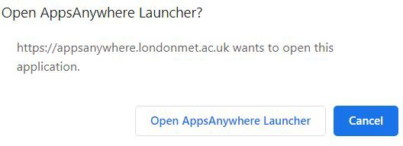

Then you will see a blue bar along the top of your screen prompting you to validate your device. When it turns green (and eventually disappears), you will be ready to launch apps.

Validation in progress screen

Validation successful screen

On the main page you will see a catalogue of apps available to you.

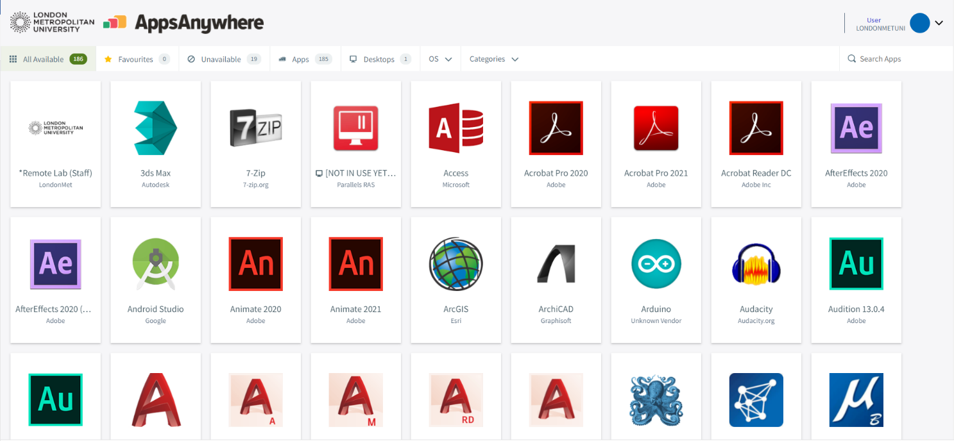

To launch an app from the portal, hover over an app tile and select ‘**Launch’**.

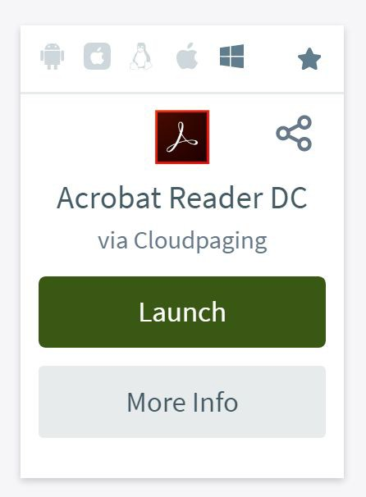

After you’ve launched the client, your device will be validated, and you can launch the applications. To do this, hover over the app you wish to use and click **Launch**.

A new window will open called **Cloudpaging Player**. This happens automatically when attempting to use an app and is not harmful to your computer.

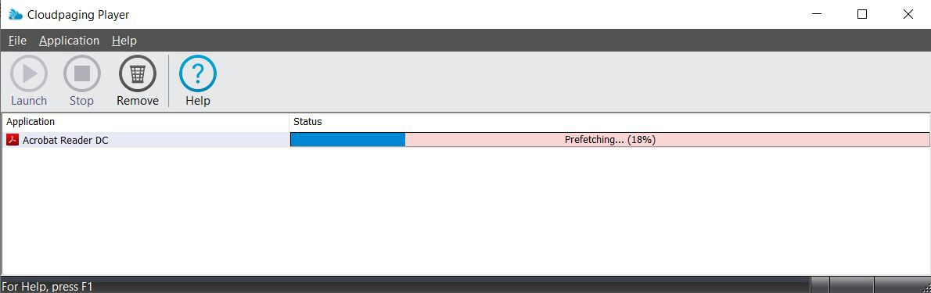

Once the program has been fetched, the **launch button** in the top left-hand corner will become green. **Press it** and the application will launch automatically.

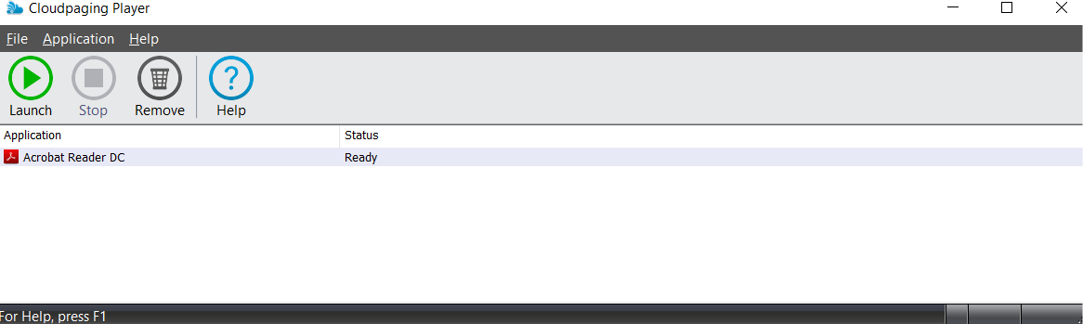

And that’s it! Because you’ve downloaded the client, any other available apps you want to use in the future will be that much easier to use.

The **Cloudpaging Player** will require an internet connection to check in periodically. However, there is a **Work Offline mode** which allows some applications to be used with no internet connect at all after the initial download and launch.