
Data Driven Decision Making (MN4081)

Pre-exam case study

2025-26
Instructions to students:

There are FOUR case studies and you are expected to complete the preparatory work for all of them and submit it on a single (ONE) WORD file.

You are required to start the preparatory work for each objective on a new page and clearly label your answers using the same structure on the brief. The word file for all three objectives should be uploaded on Turnitin using the link available on weblearn for this assessment. You should also print a copy of your answers and bring it with you to the exam.

You have only THREE submission attempts for this link, so make sure you upload your best and final version using the link. Your final submission will be marked.

The deadline for submitting this pre-exam answers is (Date to be announced). You are also asked to bring a copy with you to the exam.

Make sure you upload a draft copy of your work a week before the deadline so your tutor can give you some feedback. Any later than this, and you may not get that feedback.

Case study 1
Objective:
The management of a coffee shop, Netil, is anxious about the make-up of its customers’ demographic, decided to survey its customers regarding their perceptions of the shop and its services. They wanted to examine their level of satisfaction regarding 6 items of the coffee shop, namely service quality, ambiance, product quality, price fairness, location and whether they are happy to recommend the shop to others.
Instrument:
The survey was conducted via a questionnaire instrument containing TWO sections – Gender and Overall satisfaction.
Measures:
Each of the six levels of satisfaction items is measured on the Likert scale 1 to 5 (1=Not at all satisfied, 5=Very satisfied). The responses were split by males, females and those who prefer not to announce their gender.

The data of the survey, together with details of the questionnaire is recorded in an Excel file “Consumer perceptions.xlsx” available on Weblearn. The file has TWO worksheet – Questionnaire and Data.

Required
For this case study, you are expected to familiarise yourself with the objectives, the questionnaire and the collected data. You also need to carry out a data analysis in order to inform a strategic decision-making process for the business. The final decision will be based on your analysis here and your responses to further questions to be shared with you in a meeting in May.

Objectives for this analysis
- Improvement of the general satisfaction levels of customers
- Diversification of customers make-up

You need to produce the following analysis, as a minimum, before your May meeting. You may want to conduct “other” and additional analyses if you wish, in order to make better decisions.

For this first three requirements below, you need to concentrate on the overall satisfaction scores in the file “Consumer perceptions.xlsx”.

- Complete the frequency table for the categories below (or other categories) for overall satisfaction scores. This table should be named [Table 1].
Overall satisfaction | Frequency | Percent
<10
10-13
14-17
18-21
22-25
>26
Grand Total

Please note that you are allowed to choose categories for the satisfaction scores other than the ones shown above.

- Produce a percentage frequency table for the overall satisfaction scores but this time split by gender (Female, Male and Prefer not to say). This is [Table 2] and should look as below:

Satisfaction scores | Female | Male | Prefer not to say |  | Grand Total
<10
10-13
14-17
18-21
22-25
>26
Grand Total | 100% 100% |  |  | 100% | 100%

- Draw a full and well-labelled box and whisker plot of overall satisfaction split by gender.

For the next and final requirement, you need to concentrate on the individual rating for the “service quality” and “Location”

- Complete the two percentage frequency tables. One for the service quality rating split by gender and another one for the location rating split by gender. These tables [Table 3 and Table 4] should look like the following:
Service quality | Female | Male | Prefer not to say | Grand Total
1
2
3
4
5
Grand Total | 100% | 100% | 100% | 100%

Location | Female | Male | Prefer not to say | Grand Total
1
2
3
4
5
Grand Total | 100% | 100% | 100% | 100%

Guidance on Task A:
Students are expected to follow the structure of the requirements (1., 2., 3.) when presenting their answers. Students should only insert the answers (not the requirements). The box and whisker plot should include the descriptive statistics (see lecture notes).
Students are expected to use Excel and the datafile shared with them to produce all the answers/tables. Students are also expected to copy and paste their work from Excel to a WORD processor and not to use screenshots of their work.
Failure to follow this guidance may result in students not gaining full marks.

Case study 2

A small hotel situated in central London, DiveInn, has 8 rooms. Its unique selling point is its location at the heart of a big city, easy to reach and a very cheap breakfast considering its location.

Over the last 3 years, since the pandemic more precisely, customers have stopped coming in big numbers and this is evident by its occupancy rates. Indeed, the average occupancy rate for weekends (Friday and Saturday evenings), measured during this period, was estimated at 50%. This means that, on average, 4 out the 8 rooms are occupied during weekends. It goes without saying that few weekends are better than others.

Objective for this analysis:
The owner of the hotel has contacted you to seek your help with the following objectives:
- To investigate the occupancy rate, particularly at weekends.
- To restore the popularity of the hotel.

To do this, you are required to conduct an analysis of the situation based on the requirements below (as a minimum). It is predicted that the manager may have further questions for you in May 2026.

Required:

- Based on the size of the hotel and the assumption on weekend occupancy rate, produce the probability distribution using Excel – i.e. the set of probabilities that no room is occupied, 1 room is occupied, 2 rooms are occupied, …, 8 rooms are occupied. Please note that a hotel room is either occupied or not occupied. Present your results in a table like the one below.
N° of rooms occupied during weekends | Probability
0
1
2
3
4
5
6
7
8

The owner will be asking few questions about the above probability distribution in May.

- The owner of the hotel shared with you six reviews of previous guests left on the hotel portal. These are supposed to be genuine customers with typical views of the hotel. The reviews are shown from the next page.

What are the recurring themes from these 5 reviews? Present your answers in a table with the themes and the quotes as evidence.

Review 1: Lawrence M., 31, Solo Traveler
I stayed at DiveInn for two nights during a short business trip. I really appreciated how straightforward everything was—check-in was quick, the staff were polite, and the price was unbeatable for the area. However, the hygiene levels were disappointing. My room had dust in the corners, and the shower had visible mould around the edges. There was also litter near the stairwell that stayed there my entire stay. If they improved cleanliness, this place would be a hidden gem.

Review 2: Fatima R., 45, Family Visit
DiveInn offers a no-frills experience, which I actually liked. The staff were friendly and helpful, and the pricing was perfect for a short stay with my daughter. That said, the hygiene was below expectations. The bathroom had hair in the drain and the shower curtain smelled musty. We also noticed bits of trash outside the building and in the hallway. It’s a shame because the service was genuinely good. A bit more attention to cleanliness would make a big difference.

Review 3: Clyde T., 26, Weekend Getaway
I chose DiveInn for a quick weekend getaway because of the low price and easy booking process. The simplicity of the service was refreshing—no fuss, just what you need. The staff were lovely and even gave me tips on local places to eat. Unfortunately, the hygiene let the experience down. My room had a stale smell, the shower had grime buildup, and there was debris near the elevator that looked like it hadn’t been swept in days. I’d come back if they cleaned up their act—literally.

Review 4: Hannah B., 38, Business Traveler
I stayed at DiveInn for a quick business trip and was really impressed by how simple and efficient everything was. The check-in process was smooth, the staff were polite, and the price—especially with breakfast included—was excellent for central London. However, the hygiene left a lot to be desired. My room had dust on the shelves, and the shower had visible grime. What really disrupted my stay was the noise in the corridors—doors slamming and people talking loudly late at night. Great value, but not ideal for light sleepers or those expecting spotless rooms.

Review 5: Leila S., 26, Weekend Tourist
DiveInn is a great option if you're looking for a no-frills, budget-friendly stay in central London. The staff were friendly and helpful, and I liked the simplicity of the service. Breakfast was basic but decent, and included in the price, which was a big plus. Unfortunately, the room wasn’t very clean—there were stains on the carpet and the bathroom smelled musty. I also found it hard to sleep because of the constant noise in the hallways. It’s a good deal, but they really need to improve the hygiene and soundproofing.

Guidance:
All probability values should be rounded correct to 6 decimal places.
You need to setup the Excel worksheet and the formulae we have used in the lecture.
Alternative methods, such as AI tools may not be awarded the full marks if the working is not clear.

Case study 3

A builder contacted you as a project management to plan a medium scale building work. He has shared all the different activities of the building work, their average durations and their precedence. This information is presented on the table below.

Activity | Duration | Preceding activities
R | 1 | None
S | 2 | None
T | 3 | R and S
U | 4 | T
V | 4 | R
W | 8 | V
X | 3 | U
Y | 2 | T
Z | 1 | U and Y
Table 1 - Durations are in weeks
Required:
The builder wants you to conduct a network data analysis before the meeting in May 2026. This analysis includes the following requirements.

- Complete the network diagram below by conducting the forward and backward pass for the project stated above. Your network diagram should look like the one below. You may need to use a blank Excel file to build the same network and complete it.

The builder is asking to bring a copy of this completed diagram with you to the meeting in May. He may have further questions to ask you about the findings.

Case study 4

The manager of the coffee shop in case study 1 surveyed 20 of the customers and recorded the number of complaints made about the coffee shop in the survey during the year 2024 together with their overall satisfaction scores. They shared with you the following output of their results.

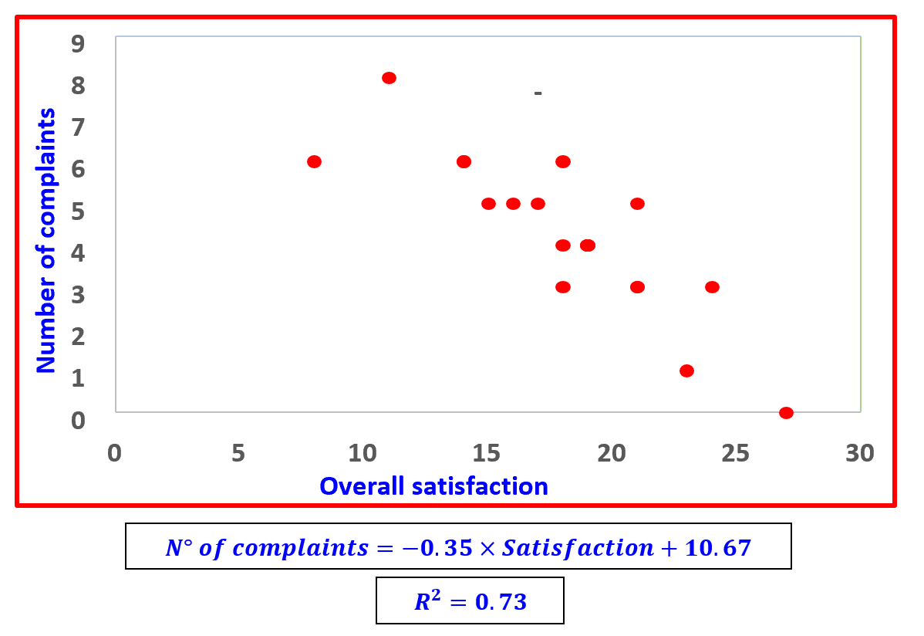

Objective:
The manager wants you to investigate if there is any impact of overall satisfaction scores of the customers on the number of complaints made by them about the shop. The manager is not a data analyst and wants to meet you in May for further questions about the findings.

Required:
- Familiarise yourself with this case study and the data represented on the scatter diagram.

- Copy and paste the scatter diagram on the word file for your pre-exam answers.

- Prepare yourself for further questions in relation to the objective.

Guidance:
You are allowed to prepare answers to all possible questions related to this case study and its objective. You can also annotate and take to the meeting in May any possible pieces of evidence you may need. The point of the exercise is to prepare yourself for any eventuality.

End of the case studies

