INDIVIDUAL EXAMS REQUEST (IEA) PROCESS FOR STUDENTS

- Using any browser go to: evision.londonmet.ac.uk.

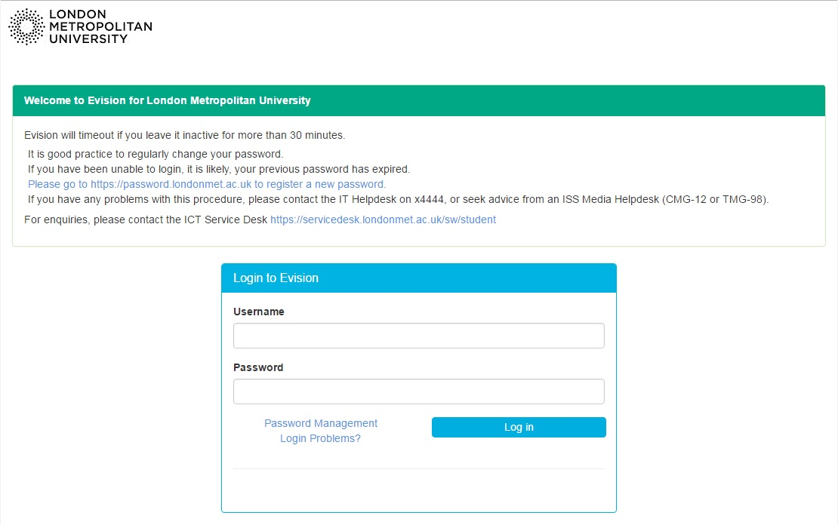
- Enter in your username and password, this is the same as your standard username and password you use to log into your PC. Then click ‘Log in’

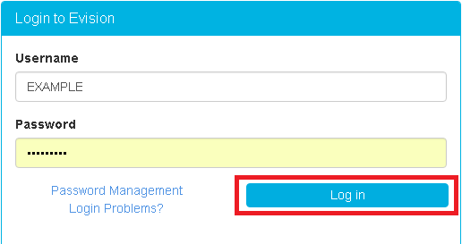
- You will then need to click on the button below

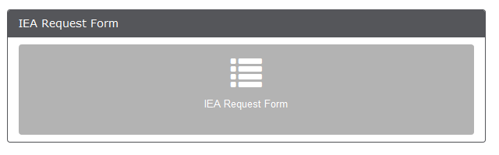

- You will then be taken to the declaration page. Please read this through carefully and tick to confirm. Then click the next button.

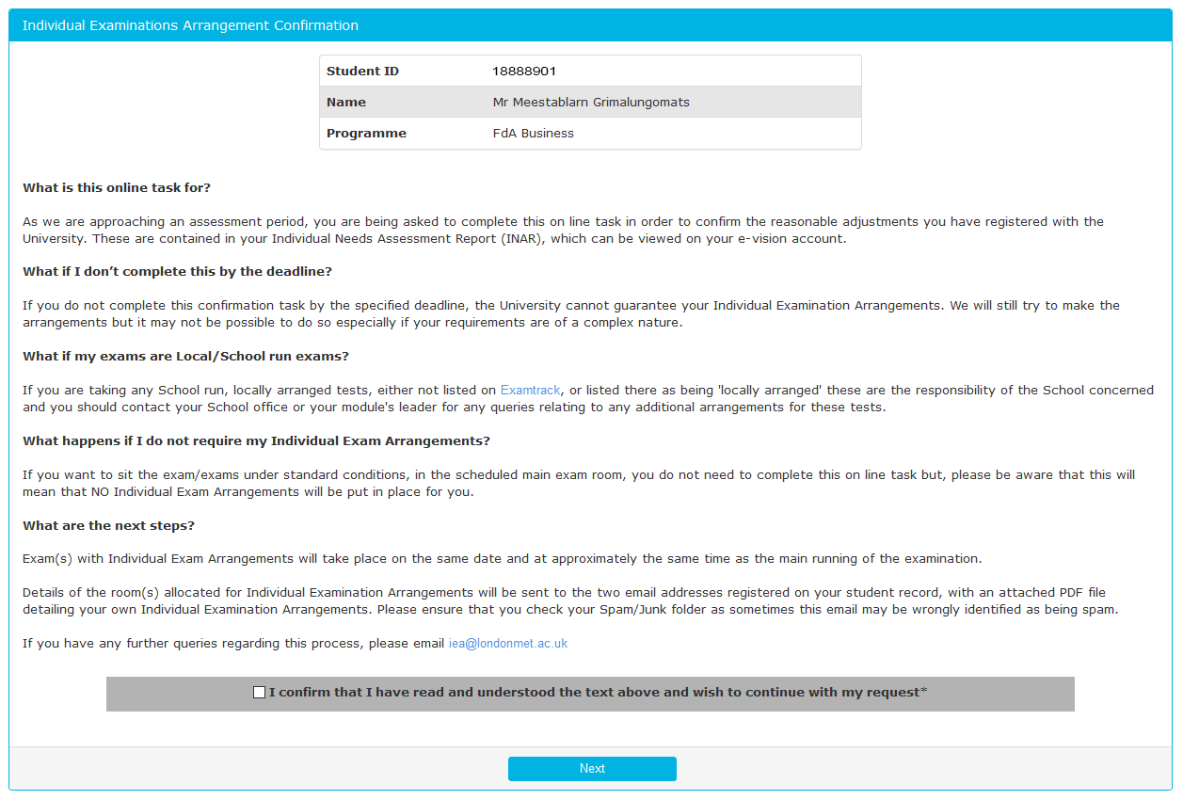
- You will then be taken to a page which will display all your available assessments for the upcoming exams period. Click on the submit request button

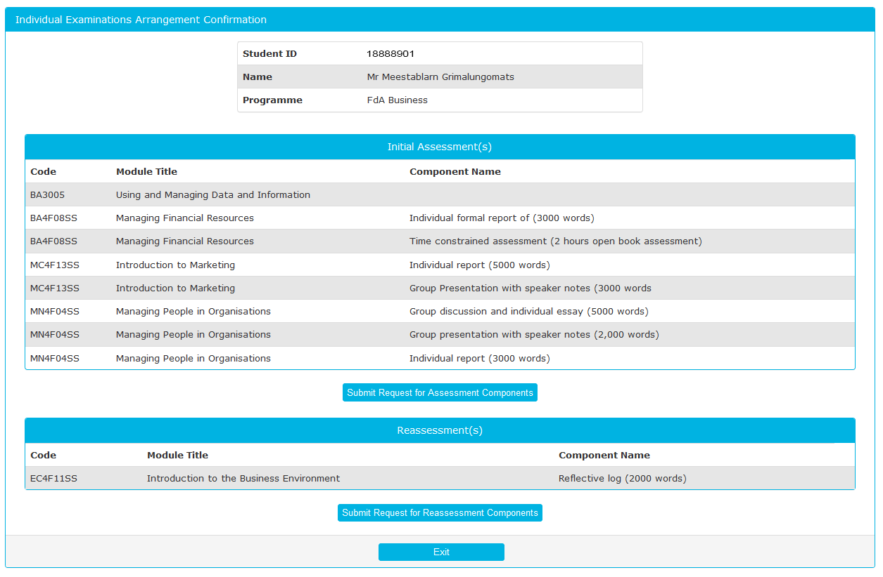

- Please then select the assessments that you wish to apply your individual exam arrangements to as shown below.

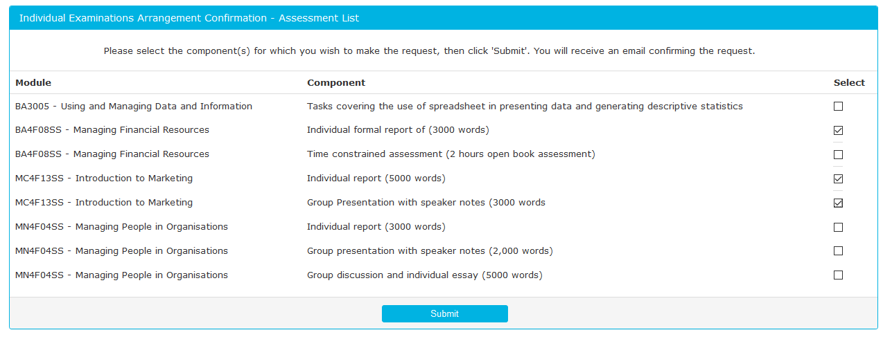
- After this you will then see the confirmation screen which confirms which upcoming exams you have selected to have individual exam arrangements for.

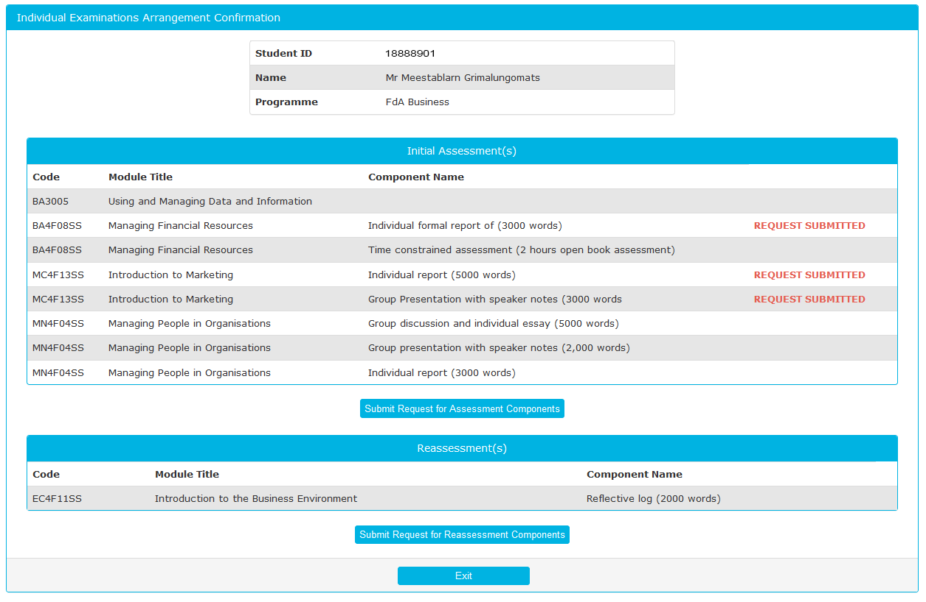

- You will also receive a confirmation email to your University email account of the request that you have submitted.
