Appeal Mitigating Circumstances - Evision Process Guidance
Please log into your Evision Account:
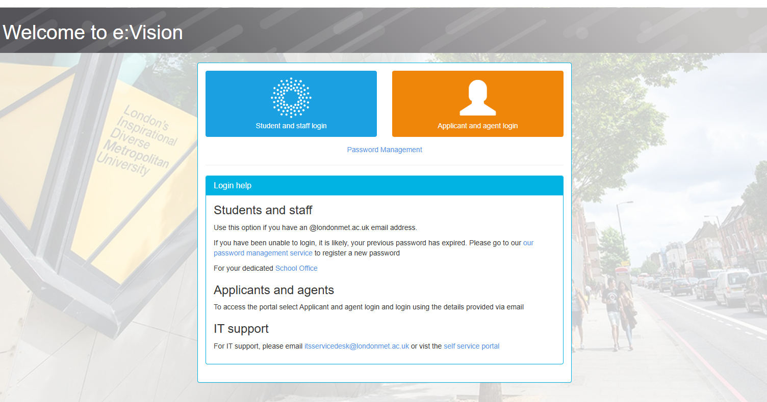

Once logged in it will take you to the page below. Click on “My Modules”:
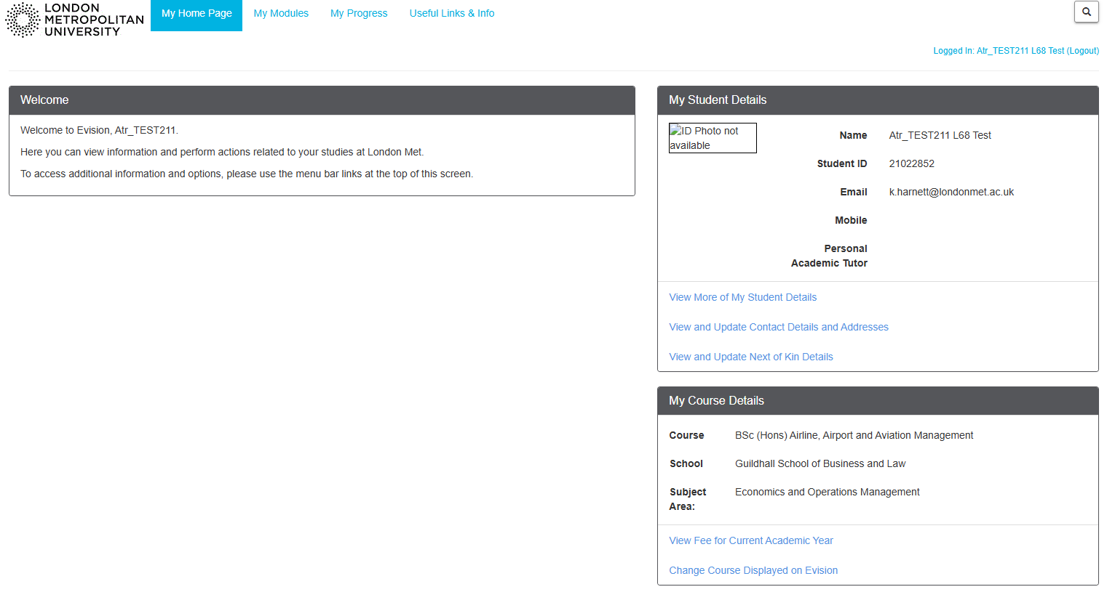

It will take you to the page below. Click on “Submit a Mitigating Circumstances Claim/Appeal or Upload Evidence”:

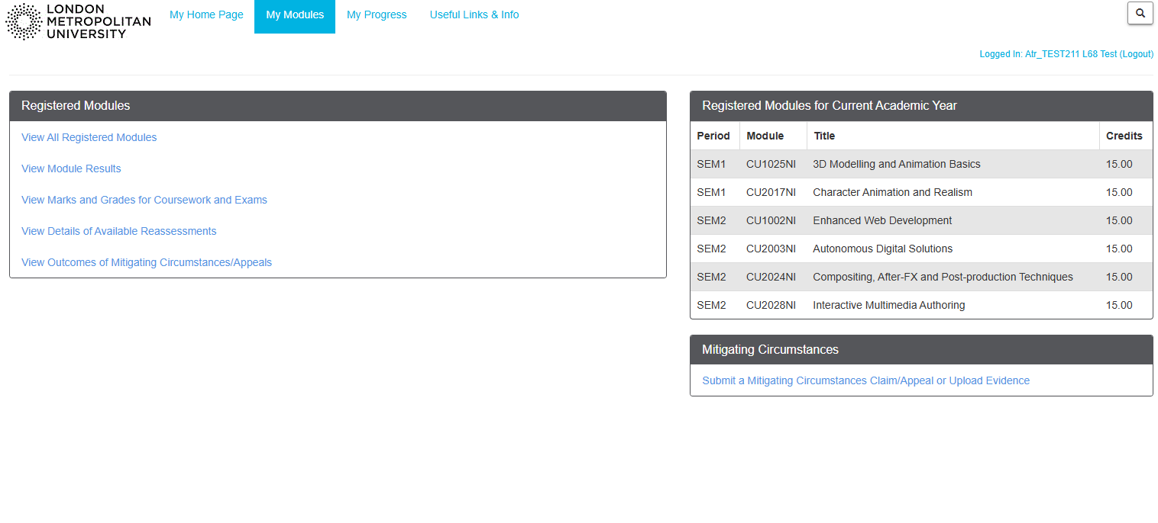

It will take you to the page below. Please read carefully and tick the box to confirm and click “Continue” to proceed:

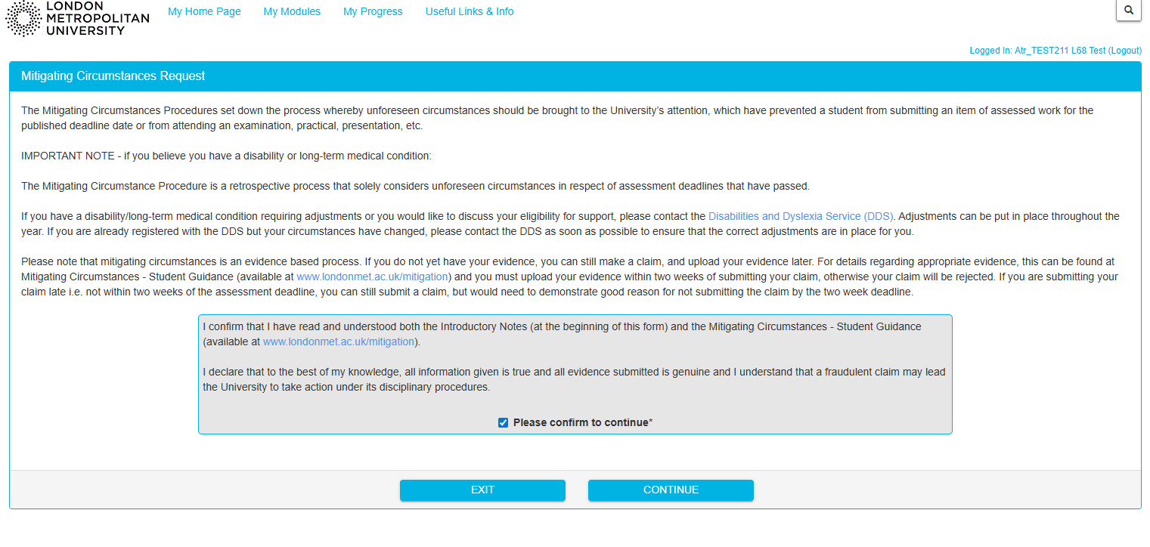

It will take you to the page shown below:
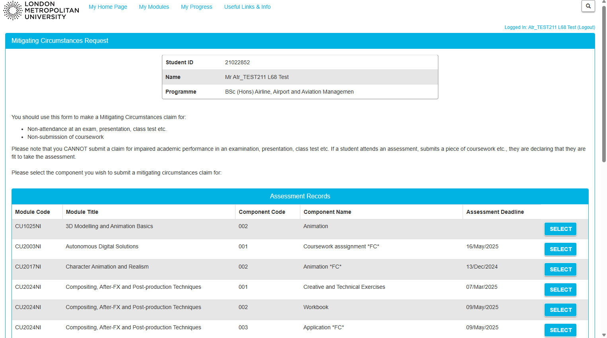

Scroll down this page until you come to the Appeal section below. Click the “Select” option to choose which Module component you wish to submit an appeal for. Please note the option to Select will not be available if you have not submitted a Mitigating Circumstances Claim:

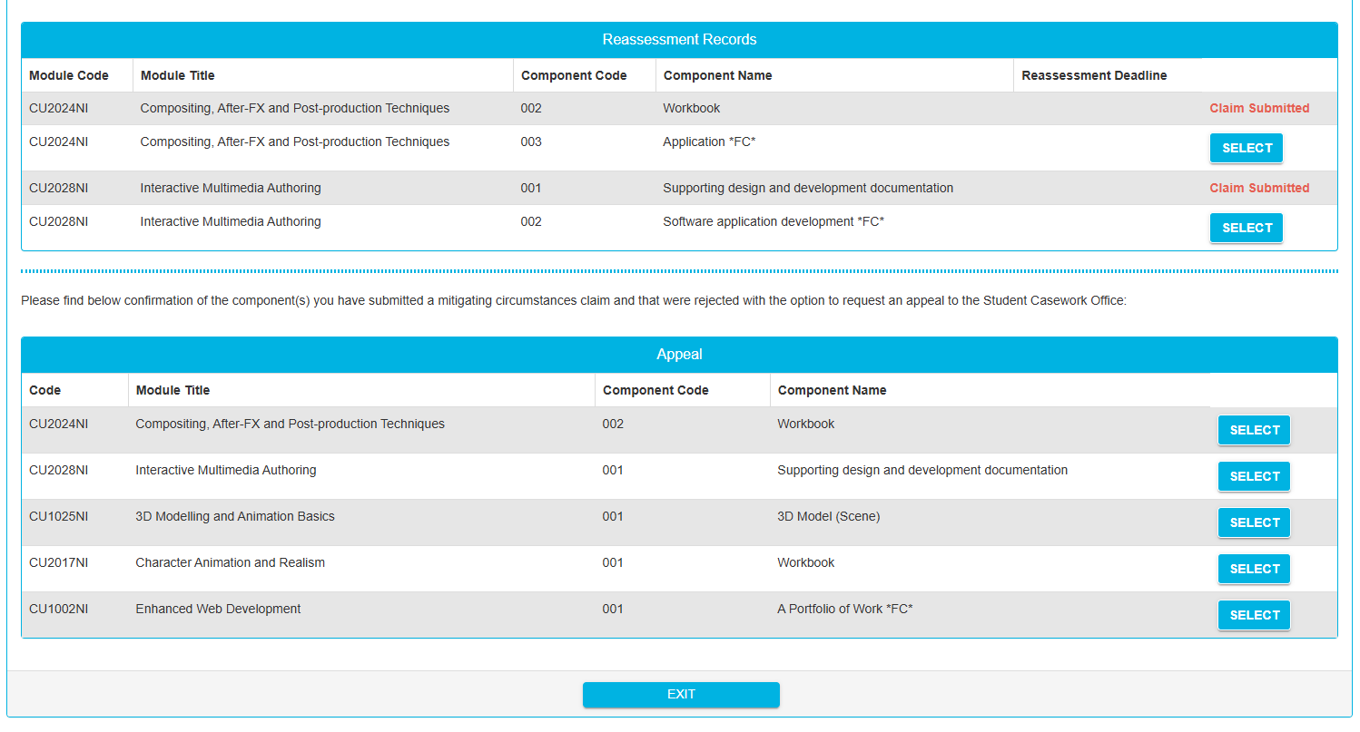

Once you have clicked Select it will take you to the page below where you can complete the sections that will be considered by the Student Casework team. If applicable, please complete the Disability section shown below:

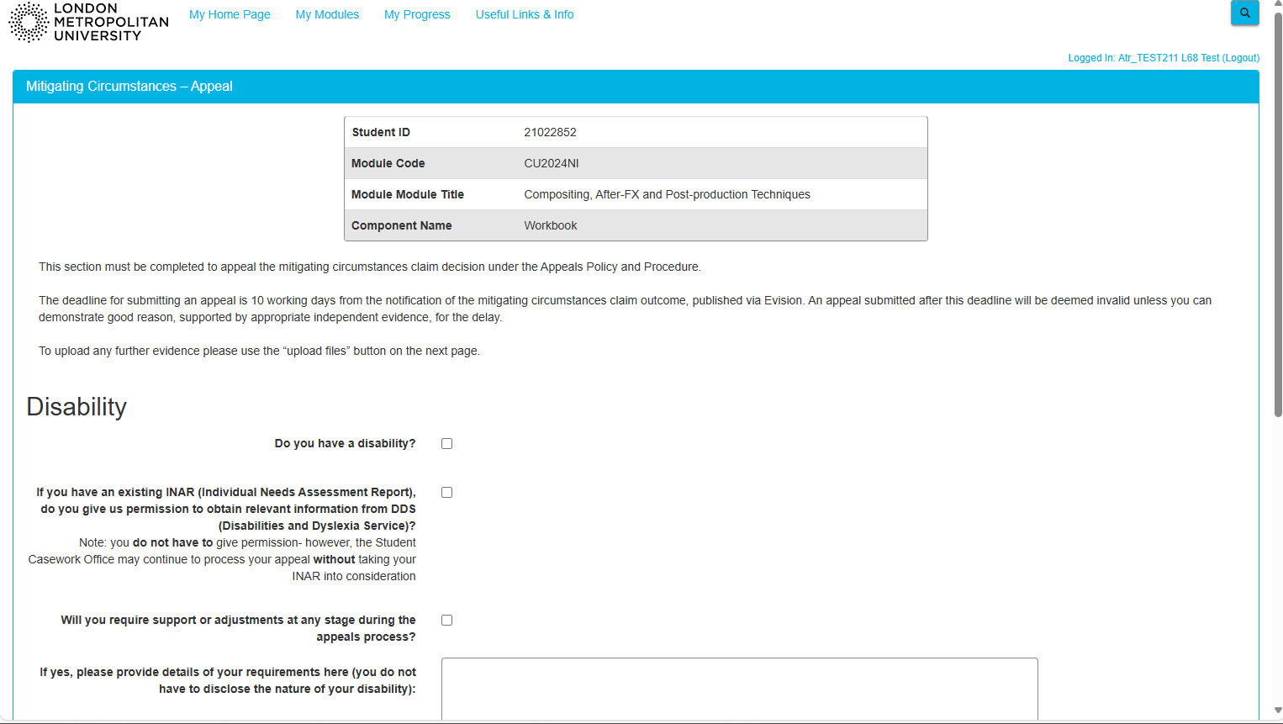

Scroll down to the Grounds section and click on the grounds that apply to your appeal (to view the Appeals Policy and Procedure, click on the link to visit our web page):

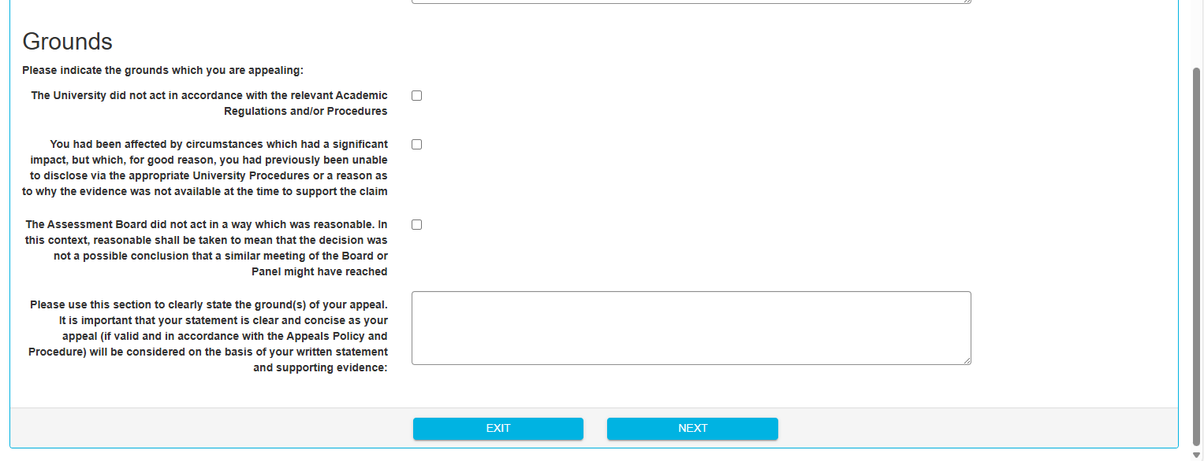
Advice – if you intend to request an appeal for multiple components you may want to draft this in a separate document, so it can be cut and pasted again as you will be asked to complete this section again for each component you request an appeal for:
Below are some examples of what might be entered in this page:

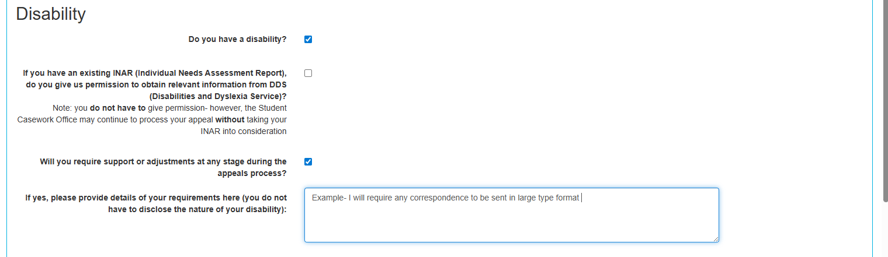

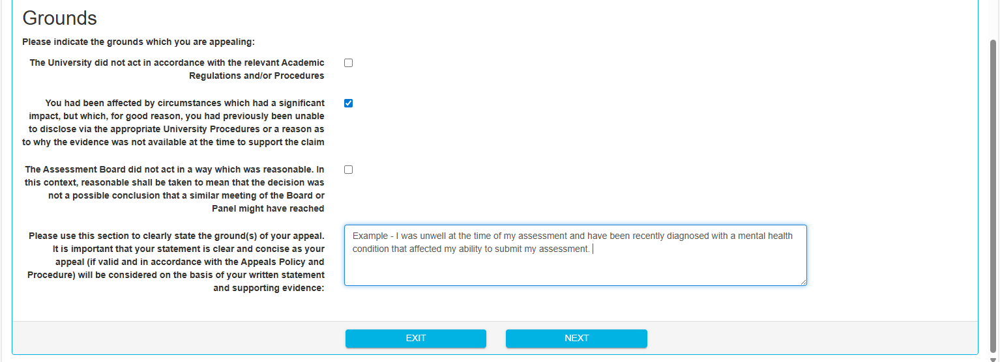

Note - This may include details of a health diagnosis, bereavement, difficult personal circumstances, procedural irregularity and include details that where possible can be supported with evidence.
Once you have completed the sections, click “Next” to proceed.

Once you have clicked Next it will take you to the page shown below where you will be asked to upload any supporting documents by clicking “Browse My Computer”:

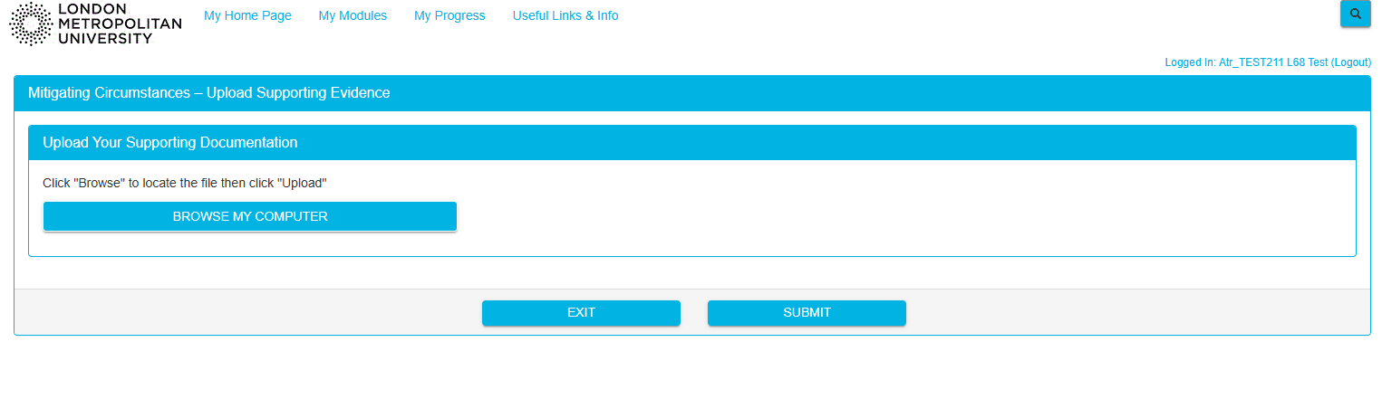
Note – You should scan/photograph and save any documents you wish to attach as evidence to your computer or device so that you can easily locate and upload them.
Once uploaded successfully they will appear underneath as presented below. Once you have uploaded everything you would like to be considered, please click “Submit”

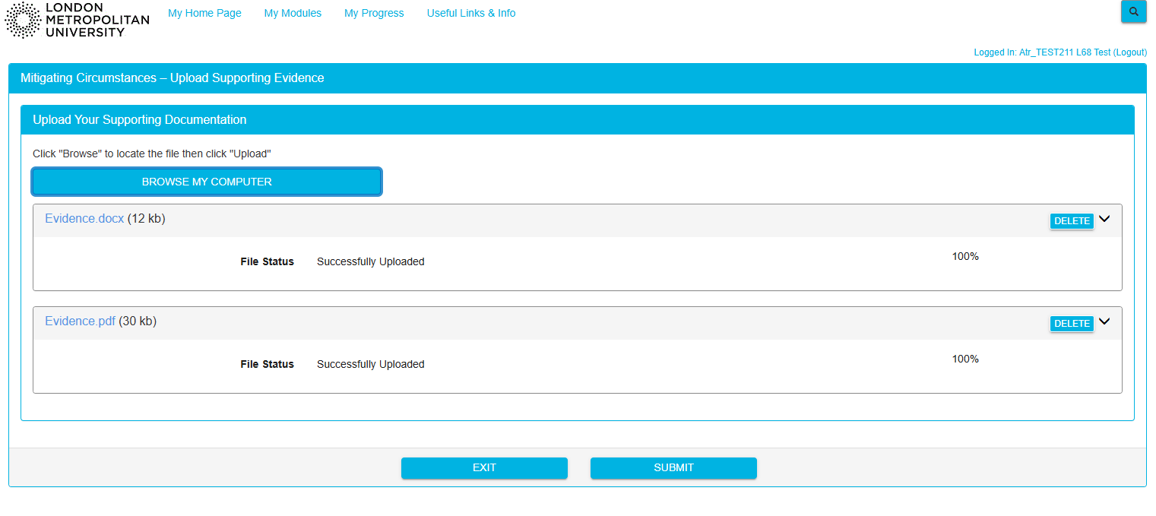

Once you have clicked submit it will take you to the page below where you will be able to select further components that have already been considered and rejected at the Mitigating Circumstances Claim stage. To select, please click on the “Please Select” drop down menu:

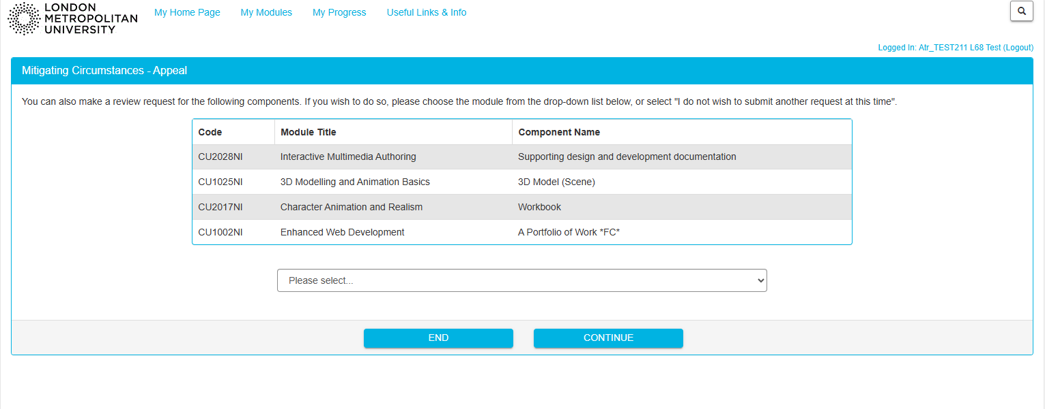

Select the component or if you do not intend to request an Appeal for any other components click “I do not wish to submit another appeal at this time”:

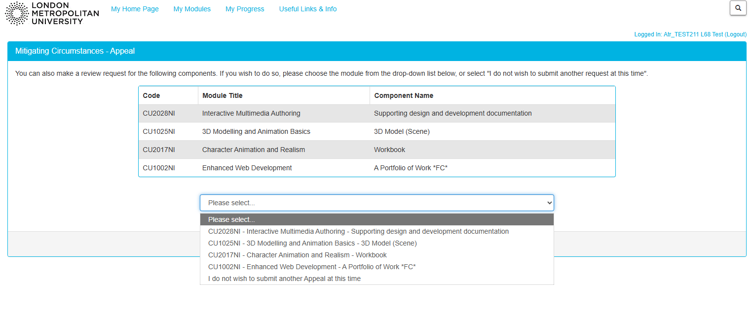

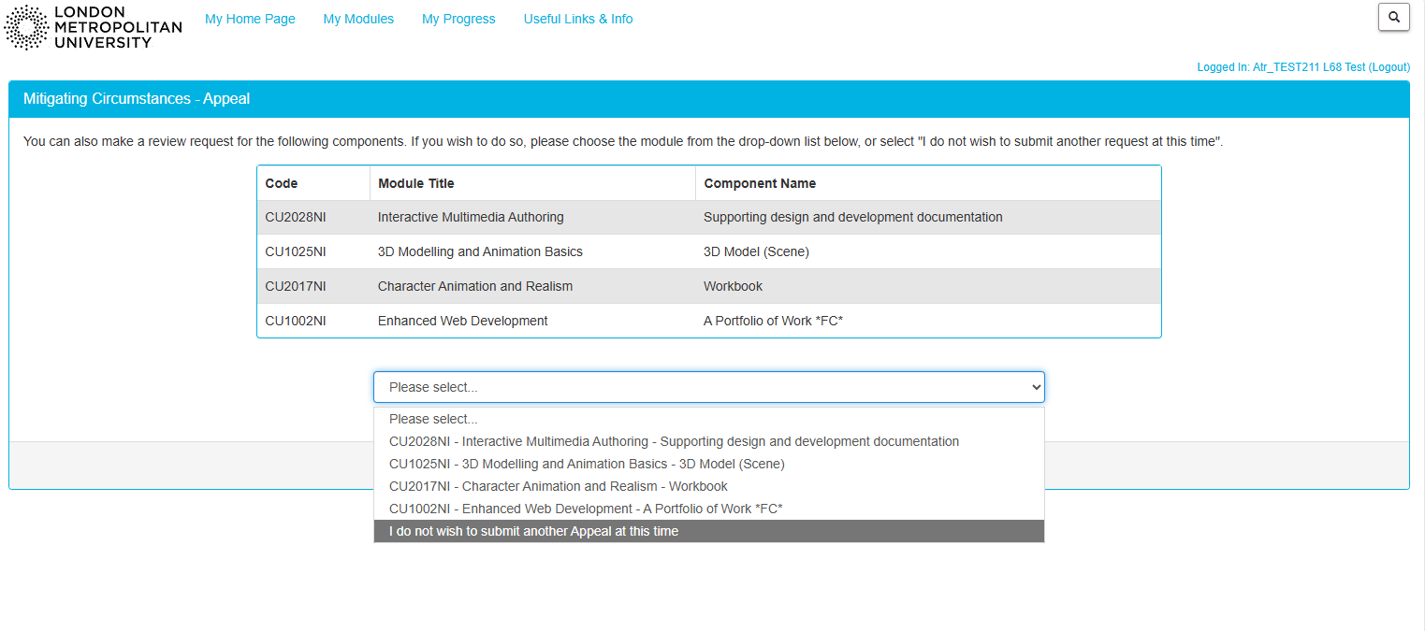

Once selected click “Continue”:
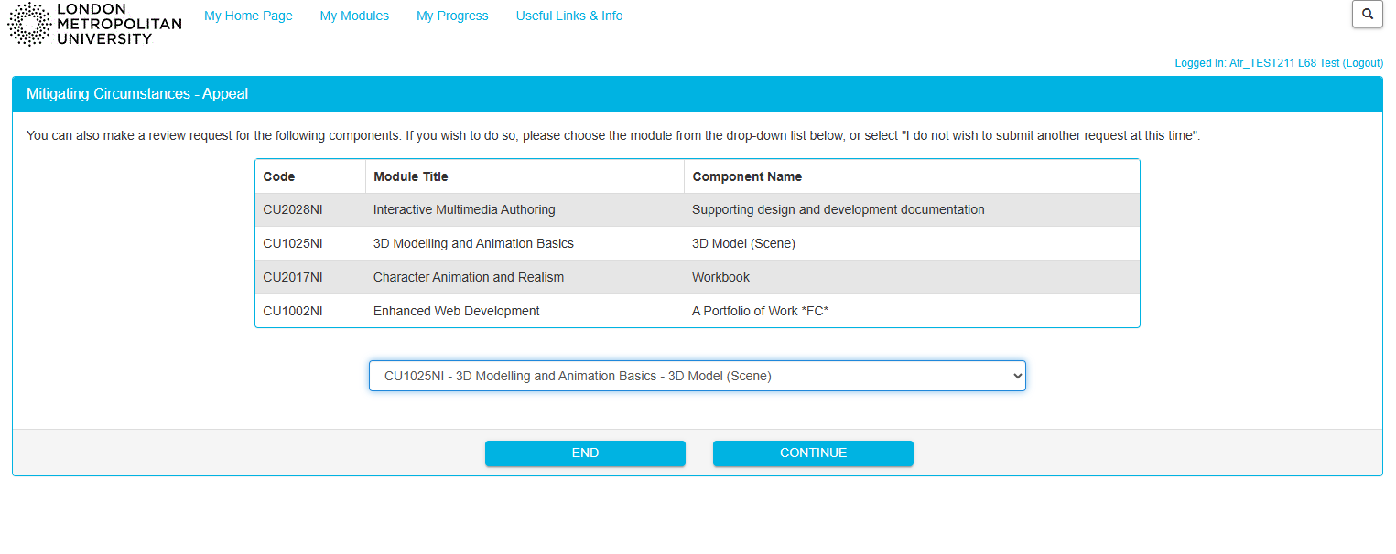

Once you have selected Continue it will take you to the page below where you can complete the sections that will be considered by the Student Casework team.
Note - This must be completed for each component you are requesting an appeal for, once completed please click “Next”:

Once you click Next it will take you to the page again where you uploaded evidence and will list any evidence you have submitted so far. Here you can upload any further evidence related to the claim for this further component or if this is the evidence you wish to rely on, you can continue by clicking “Submit”:

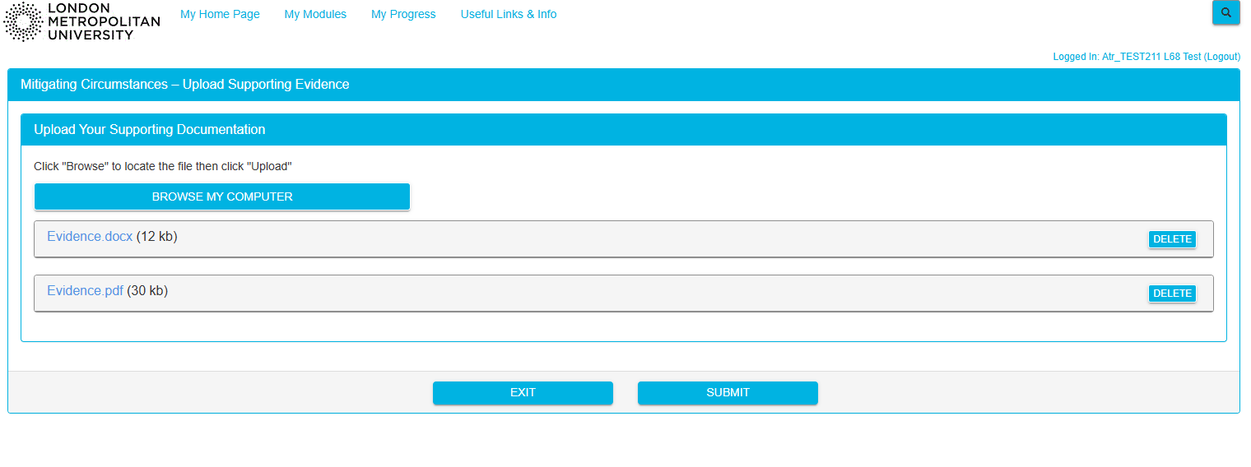
Once you have clicked Submit it will take you to the page below where you can again select another component you would like to request an appeal for and this will again take you back to the Appeal section where you can enter any information you wish to rely on and after this the Evidence section to submit any further evidence and submit. Once you have submitted your appeal for all the components you wish to, you can choose “I do not wish to submit another appeal at this time” and click “Continue”:

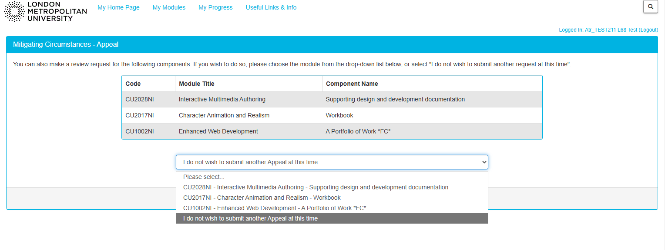

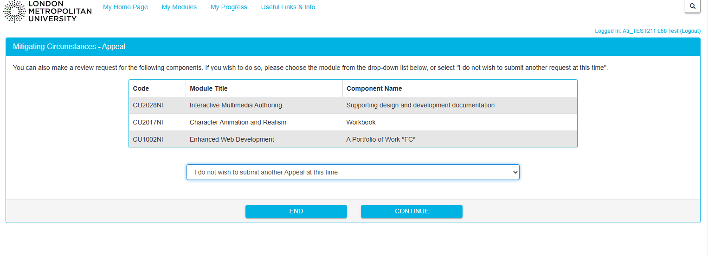

Once you have clicked Continue and completed the appeal request it will take you to the page shown below, where it will provide a breakdown of the module components you have requested an Appeal for, the information and evidence provided. If you still want to request an appeal for any further components, you can click “Appeal Other” otherwise you can click “End” to submit your Appeal:

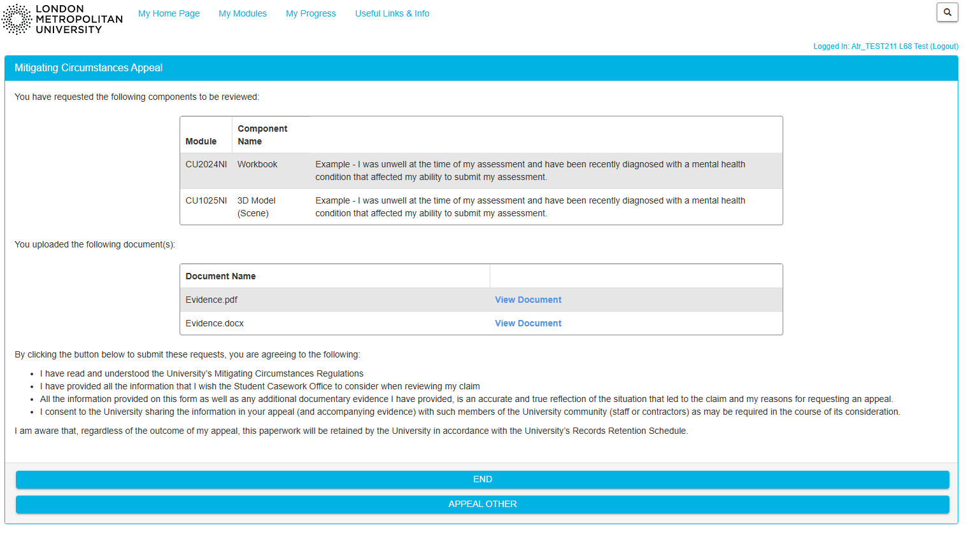

If you follow the instructions as set out in pages 1-4 it will take you to the page shown below and you will be able to see which components, you have submitted an appeal for:
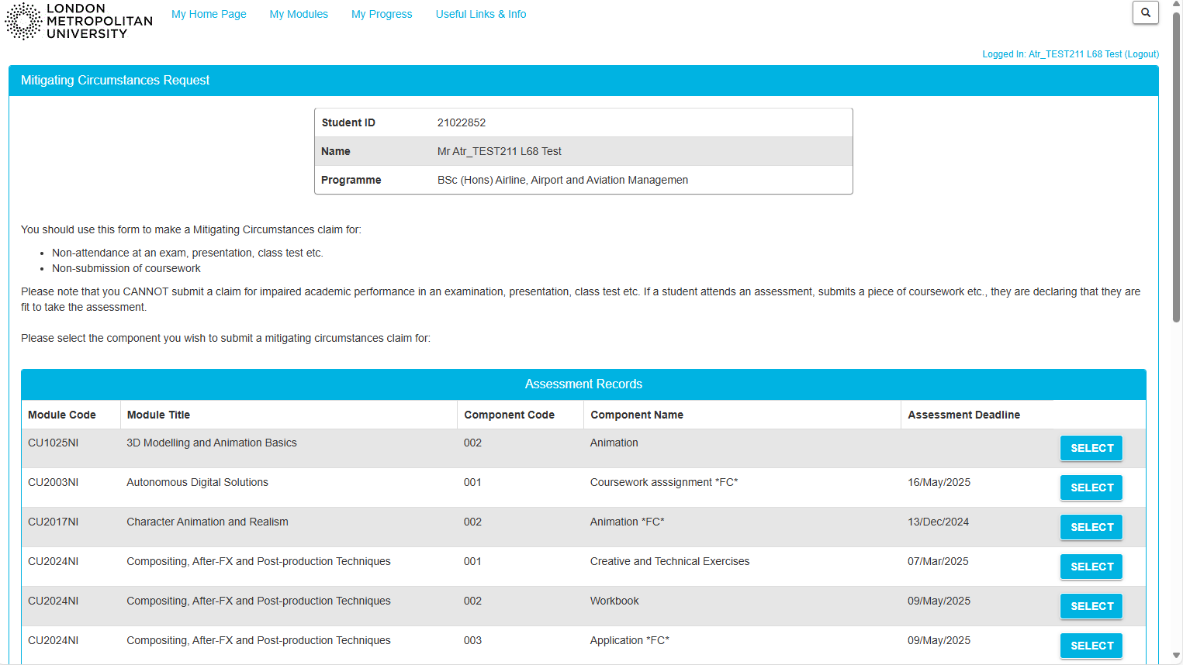
Scroll down to the Appeal section to see this:

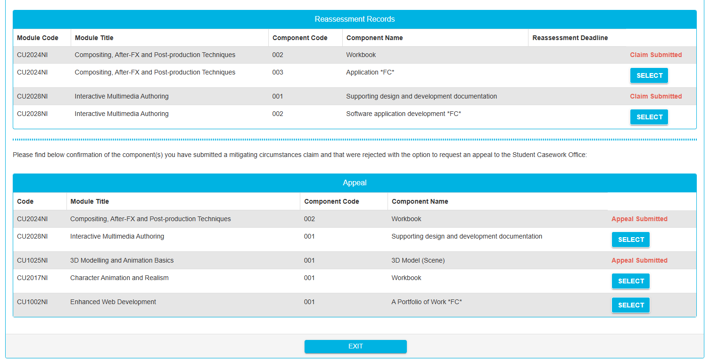

Once you have submitted your appeals you will receive an email as shown below which will state the components and the date the Appeal was submitted. The student Casework Office will also receive an email to alert us that you have submitted an appeal and the components it has been submitted for.
Note – The University regulatory timeframe for considering an appeal and providing an outcome is 25 working days from the date that the appeal is received:
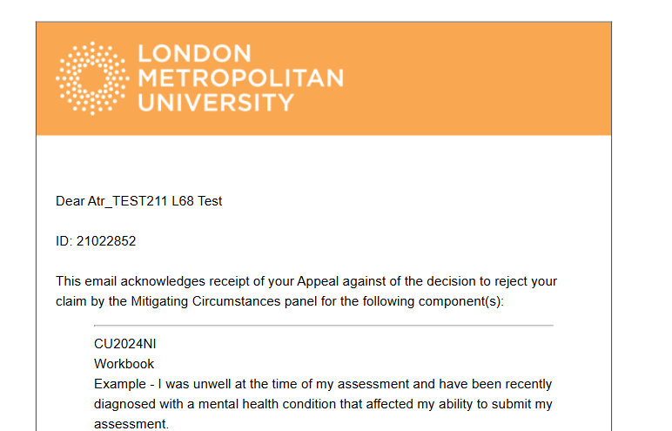

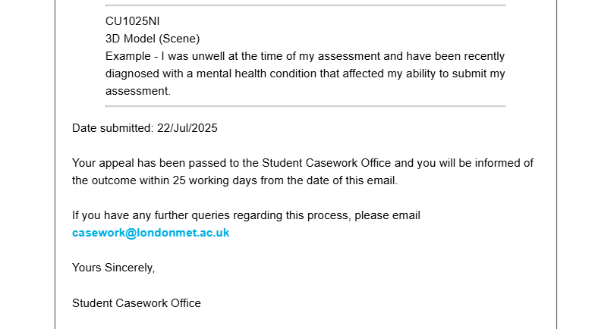

Once the Student Casework Office has considered your appeal you will receive an email confirming the outcome of the appeal.
If it is successful it will look like this:

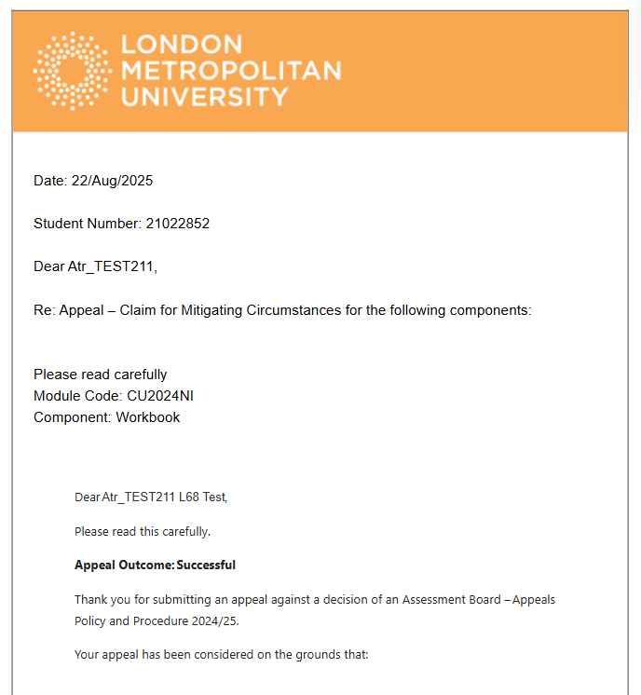

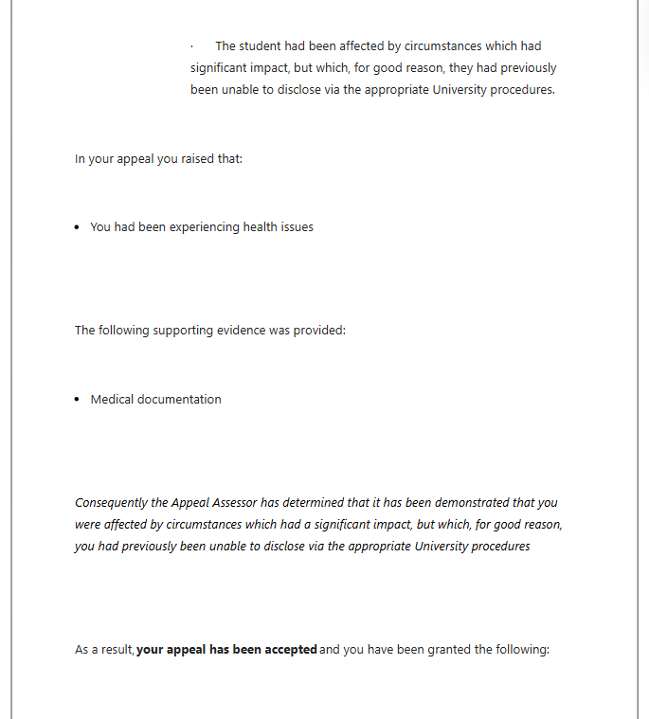
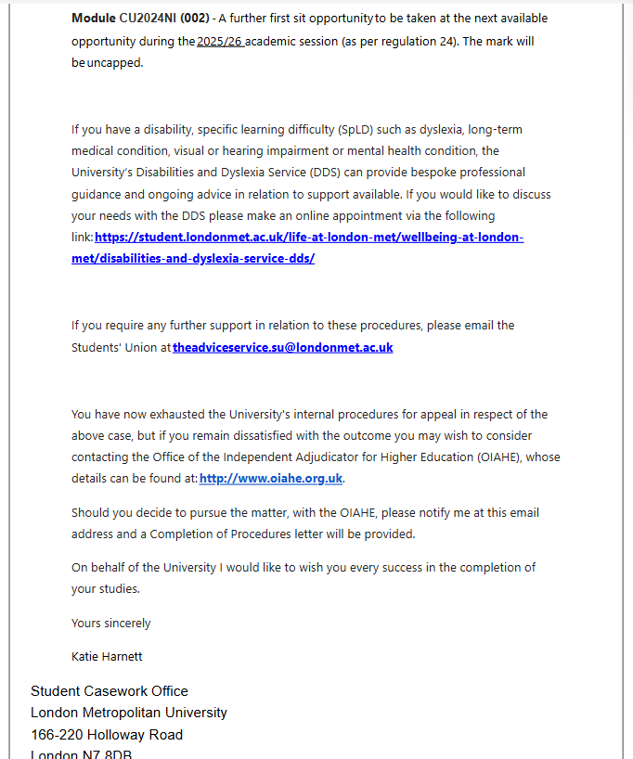

Should your Appeal be unsuccessful you will receive an email that looks like this:

