Activating Google Live Captions

Android Devices (including Chromebooks)
If you have a device which is running the Android operating system (which includes Chromebooks), you will already be able to access live captions when using Collaborate. To do this you will need to active live captions using the steps noted in this Google Help article.

PC with Windows operating system and Google Chrome
It is also possible to activate live captions in Collaborate using a PC. You will need to use Google Chrome as your internet browser and take the steps noted below.

Note: You should ensure that your Google Chrome internet browser is up to date. For more information on updating see this Google Chrome webpage.

Activate Live Captions

- Open Google Chrome and type chrome://flags/#enable-accessibility-live-captions into the address bar (or copy and paste from this document).

- On the webpage that opens, ensure that ‘Live Captions’ is Enabled (see the red arrow below).

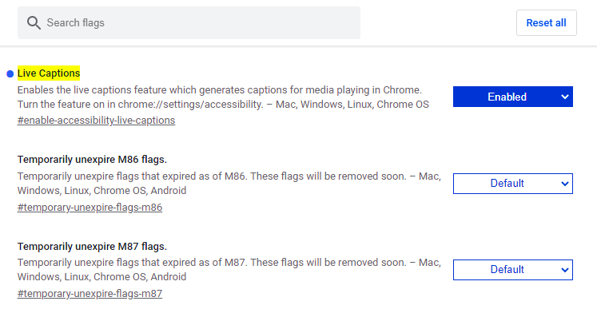

- Shut down your Google Chrome browser.

- Restart your Google Chrome browser.

- Open Google Chrome settings:

- Method 1: Type chrome://settings into the browser address bar.

- Method 2: Click on the three small dots in the top right-hand corner of your browser window (green arrow), then select ‘Settings’ (red arrow) – see image below.

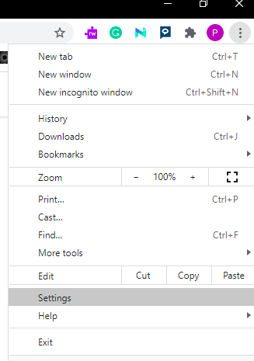

- Select ‘Advanced’ (green arrow) and then ‘Accessibility’ (red arrow).

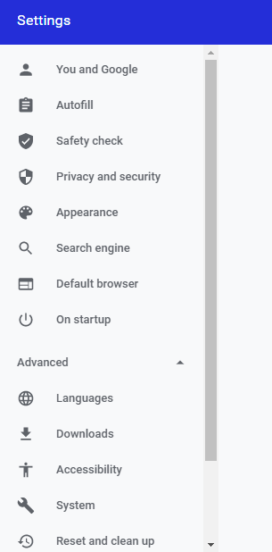

- Turn on Live Captions (toggle the slider control to on – see red arrow below).

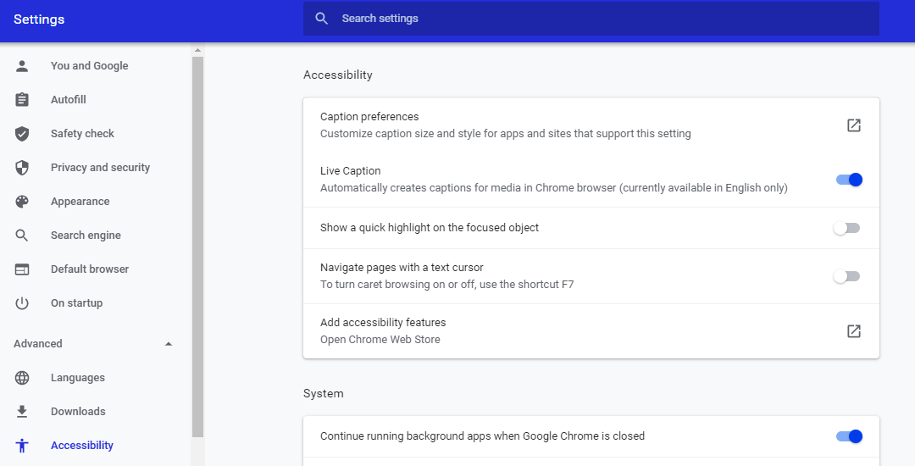

- Close the settings tab. Live captions should now appear when you use Collaborate.

Turning off live captions
To turn off live captions return to the Google Chrome settings page (see step 5 above) and toggle the ‘Live Captions’ control to off.

A note on accuracy
Please note that the accuracy of live captions may reduce if the audio quality of the speaker is poor.

