Sources for the research of race relations and BAME workers in the TUC Library Collections
The TUC Library Collections transferred to the London Metropolitan University in 1996. The holdings include a full collection of all the publications produced by the TUC and its affiliate unions since its foundation in 1868. The collection predominately covers the UK but also includes sizeable international collections, in particular from the former British colonies. Material also includes campaigns and policy areas with which the TUC and its affiliated unions have been involved. Visit us to view original material that documents the history of:
- Immigration and race relations in the UK
- Equality and anti-discrimination campaigns and legislation
- Significant strikes that have involved BAME workers, such as the 1976 Grunwick dispute
- Race and diversity issues within unions
- Statistics on BAME participation in the labour market

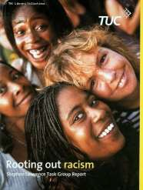

The TUC Library Collections are accessible in the university’s Special Collections Reading Room. The collections are available by appointment only for external visitors. See Access details on the Special Collections page of the University website for details.

TUC Library Collections, London Metropolitan University, The Wash Houses, Old Castle Street, London E1 7NT (entrance via 16 Goulston St).
Tel: 020 7320 3516 // Email: tuclib@londonmet.ac.uk

TUC Library Collections web page www.londonmet.ac.uk/libraries/tuc
The Union Makes Us Strong : TUC History Online at www.unionhistory.info
The Workers War: Home Front Recalled at www.unionhistory.info/workerswar
Winning Equal Pay: The Value of Women’s Work at www.unionhistory.info/equalpay
April 2018

