Sources for the study of women and gender issues in the TUC collections
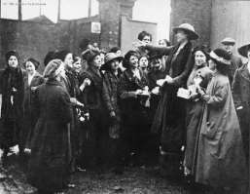

The TUC Library Collections, established in 1922, transferred to the London Metropolitan University in 1996. The Library has large holdings of books, pamphlets, periodicals and visual material, produced by unions, government, international and other organisations, relating to women at work from the 1870s to the current day. These have been collected to support the policy-making and campaigning work of the Women’s Trade Union League [merged with the TUC in 1921], the TUC Women’s Committee, and the TUC Lesbian, Gay, Bisexual and Transgender Rights Committee.

The Collections hold the printed publications of the TUC and affiliated unions, including the Women's Trade Union League, National Federation of Women Workers, National Union of Domestic Workers, Association of Women Clerks & Secretaries, Health Visitors’ Association and Society of Women Welders. There are large pamphlet collections from the Labour Party, Communist Party and other relevant political groups and campaigns, plus publications of other organisations concerned with working women such as the National Institute of Houseworkers, National Union of Women Workers, Women’s Cooperative Guild and the Equal Opportunities Commission. The Library holds documents from international women’s organisations, e.g. the International Federation of Working Women and the Women’s International League for Peace and Freedom, as well as relevant material from international organisations, such as the International Labour Organisation, ICFTU and European TUC, and overseas unions.

We continue to acquire recent publications on issues such as
- equal pay and hours
- parental leave and childcare
- discrimination at work and employment rights
- older women
- women in unions
- health
- black and ethnic minority women.

Recent acquisitions can be seen on the online catalogue, but the majority of older documents are only accessible via a card catalogue in the Library.

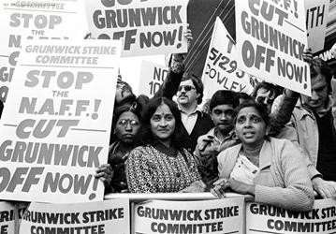

The press cuttings collection includes files on individuals, organisations and industries and is an invaluable source. For example, a search on the online cuttings database on the (see below) for women reveals 40 folders of cuttings 1913 -1979 covering strikes, equal pay and the marriage bar.

Special Collections deposited in the Library include the records of the Workers’ Educational Association, including its Women’s Advisory Committee, the Labour Research Department, with documents written by women activists such as Margaret Cole, Barbara Drake and Ellen Wilkinson, and the Mary Macarthur Holiday Trust which provided holidays and rest-breaks for working women. The Library also holds the papers of individuals e.g. Gertrude Tuckwell 1861-1951, Margaret Bondfield 1873-1953, Marjorie Nicholson 1914- 1999, Dorothy Elliott 1895-1980, Yvonne Kapp 1903-1999 and Mary Macarthur 1880-1921. The Tuckwell Collection includes printed and manuscript documents from 1890-1921 covering issues relating to women’s political and employment rights, anti-sweating campaigns, union organisation, health and safety, suffrage campaigns and issues relating to women and World War 1. The Bondfield papers include her diary of a visit to Russia in 1920 and documents relating to the International Congress of Working Women 1921 and the International Federation of Working Women 1922-1925. Catalogues of the WEA, LRD, Tuckwell and Nicholson collections can be searched online from Collections webpage.

Online resources include:
- Winning Equal Pay on the Union History website equal pay pages show filmed interviews with women who fought for and won equal pay, hundreds of digitised images and documents, plus contributions from historians and other experts.
- The Union Makes Us Strong on the Union History website info page provides digitised photographs and documents relating to women’s history in its Timeline and has a fully searchable database of the Trades Union Congress Annual Reports 1868-1968. The website also has a whole section dedicated to the famous 1888 strike of women match workers in London.
- The Workers War on the Union History website workers war page
- Britain at Work: voices from the workplace 1945-1995 on the Union History website Britain at Work page present images and documents, as well as oral testimony from women who worked on the Home Front during the Second World War and later in the period of Reconstruction.
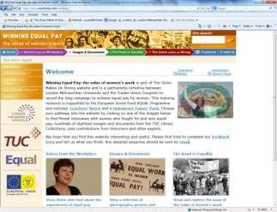
Visitors should note that the TUC Archive, including correspondence files and committee minutes has been deposited in the Modern Records Centre at the University of Warwick
The TUC Library Collections are accessible in the university’s Special Collections Reading Room. The collections are available by appointment only for external visitors. See Access details on the Special Collections page of the University website for details.

TUC Library Collections, London Metropolitan University, The Wash Houses, Old Castle Street, London E1 7NT (entrance via 16 Goulston St).
Tel: 020 7320 3516 // Email: tuclib@londonmet.ac.uk
TUC Library Collections web page
The Union Makes Us Strong : TUC History Online
The Workers War: Home Front Recalled
Winning Equal Pay: The Value of Women’s Work

July 2019

