Some resources relating to the Equality and Social Justice framework in the TUC (Trades Union Congress) library, part of the special collections at London Metropolitan University.

Access/ Location
Some of the following collections are online resources but most are available for reference from London Metropolitan University Special Collections Reading Room, Wash Houses, Aldgate Campus. Individual research or group sessions can be arranged. Some digital versions are available. Contact j.howarth@londonmet.ac.uk or specialcollections@londonmet.ac.uk for more information.

Collection:

Federation of Worker Writers and Community Publishers (FWWCP)

Brief Description:

FWWCP was a network of hundreds of working-class writing groups exploring various identities during a period of great social change in the UK from 1976 to 2007. Collection consists of over a thousand booklets of testimony, poetry and prose, with some graphic novels.
Examples:
Black Eye Perception by Multiple authors, 1980
FWWCP/08 L 02
In this anthology, young Black writers use their poetry to express their emotions of anger, hopelessness, and determination to overcome labelling. Writers describe the racism they face, feeling like strangers within the culture they were born into. Another common theme in this anthology is identity. Writers describe their journeys in seeking their identity and a sense of belonging, outside of European culture.
Keywords: Black writers/culture/identity/oppression/racism

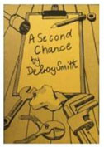
A Second Chance by Delroy Smith, 1981
FWWCP/08 L04
This short story is about overcoming obstacles to literacy, education and labour. This topic of discussion is accessibility to education, especially for immigrants. Delroy left Jamaica, where he failed to get an education, when he was fourteen years old to come to England and re-join his parents. This short testimony depicts the like of working-class immigrants.
Keywords: education/Jamaican student/labour/literacy/working-class
This is the largest collection of publications in the UK from the network of writing groups that stretched across the UK between 1976 and 2007 that met to allow working class people to share and discuss their writing and facilitate community self-publication. It thrived during a period of significant social, economic and political change in the UK and represented a significant counter-cultural movement. Through the medium of poetry, prose, fiction, biography, autobiography and local history, they document the changing experience of working-class people over the course of the second half of the twentieth century, and much like oral history, they contain testimony about cultural history and working lives. They also reveal an emerging identity politics focused on issues of local community, immigration, race/ethnicity, gender, mental health and sexuality, with groups setting up to discuss, publish and represent those identities.

Guides available include:
- Race
- Disability
- Gender
- Jewish culture
- LGBTQ+
- Mental Health

Student Research and Classroom Activities
The Federation of Worker Writers and Community Publishers Collection provides a pool of testimony of people’s experiences that can be used for research and project work. There were at least eleven writing groups in London for example, many of which recorded and explored individual BAME lives and communities.

Students have found the diversity and depth of this collection exciting, and workshops (organised through contact with the TUC Library) can provide an opportunity for students to get their hands on the publications. Activities can help Students see themselves reflected in the narratives, and students may be encouraged in their own writing through their appreciation of the very short distance between a discursive, creative process and community publication. Some of the writing groups themselves, such as Centerprise in Hackney, were models of community solidarity, acting as a publisher, café, legal advice centre and creche. Others such as Queens Park in Brighton were born out of community action.

A few of the writing groups themselves still exist and the TUC Library might be able to act as a bridge to any project work for staff and students.

Collection:

Marjorie Nicholson Collection

Brief Description:
A large collection of resources (many primary) relating to the development of trade union movement, democracy and the fight for independence in countries formerly under colonial control.

Examples:

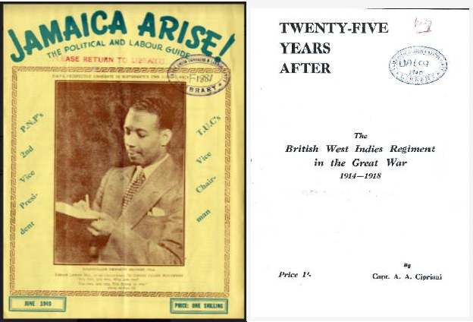

Jamaica Arise! (left) issue published in 1949 by the People’s National Party is a magazine from our collection of political journals and relates to the independence movement in Jamaica.

We have the only known copy of this report (right) about West Indian soldiers fighting in the First World War (published 1940).

Guides: An index is available

Student Research and Classroom Activities
Selections from the Marjorie Nicholson Collection can be made available (hard-copy and digital) for classes wishing to explore themes such as race, colonialism and liberation from empire, and how democratic platforms such as trade unions helped in the fight for independence.

Collection:

Oral History Collections

Brief Description:
A small but significant collection of interviews (primary sources) relating to the experience of BAME people, some of whom migrated to Britain in the second half of the 20th Century.
Examples:

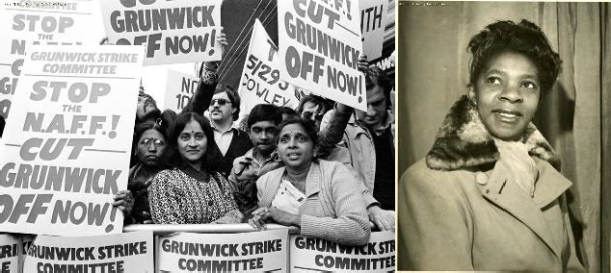

Urmilaben Patel (left) talks about her experience of the famous Grunwick strike on the Union History website where a predominantly BAME staff went on strike against exploitative working conditions.

Lilly Crawford (right) describes her experience of a recruitment drive in Jamaica and arriving in the UK in1951. Read and hear more on the Union History website.

Guides: Interviews and other resources available from
The Union History Britain at Work website

Student Research and Classroom Activities

A section on our Britain at Work website deals specifically with BAME communities in Britain in the second half of the Twentieth Century, and their testimony (audio and transcription) is available for research by students. Each interview is a potential case study into their experiences, often confronting discrimination in the working world either independently or through communities of solidarity and resistance. The interviews are accompanied by a short learning narrative by TUC Equality Officer Wilf Sullivan, and images and documents from anti-racist campaigns and organisations selected to provide
context.

