Sources for Caribbean Studies in the TUC Library Collections.
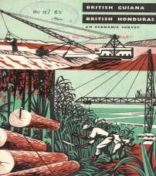
The TUC Library Collections, established in 1922, transferred to London Metropolitan University in 1996. The holdings include reference and historical works on the trade union movement, documents relating to working conditions and industrial relations in various industries and countries, and material collected from all the campaigns and policy areas in which the TUC (Trades Union Congress) has been involved since its foundation in 1868. The library also holds publications from overseas. Most of the Caribbean collection relates to the former ‘British West Indies’ - primarily Jamaica, Trinidad & Tobago, Guyana, St. Lucia, Barbados and Antigua, although there is material from other countries such as Cuba and the Dominican Re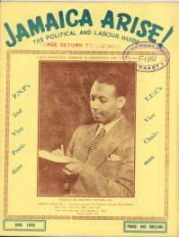

The largest part of the collection relates to trade unions and other labour issues in the West Indies (before and after independence) such as union newsletters and publications (including some rare titles), official papers, employment law and collective agreements. Campaign literature and official reports on strikes and disturbances demonstrate significant labour unrest and strong political movements on some islands. The sugar industry was of particular interest to the British government and a collection spanning over 30 years includes policy documents, reports and press cuttings on disputes, plus agreements between unions and sugar industry employers. In particular, there are significant files on Trinidad & Tobago where there was a strong labour movement. Also held are the publications of various international organisations such as the International Labour Organisation, the International Trade Union Confederation and their regional organisations for the Caribbean Area.

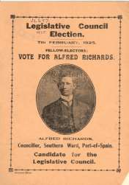
The library also holds publications from Caribbean political parties and pressure groups. In particular, there is interesting material from the People’s Progressive Party in Guyana, and its leader Dr. Cheddi Jagan, from the 1950s up to the late 1980s. There are documents by or about other prominent individuals in Caribbean history such as Alexander Bustamante, C.L.R James, A. A. Cipriani and Norman Manley. Files on the region’s constitutional history include legislation, reports from the West India Royal Commission, conferences to discuss independence, and documents relating to the formation of the British Caribbean Federation. The Library also holds relevant publications from British political organisations, such as the Labour Party (including the British Commonwealth Labour Conferences from 1925), Communist Party and other relevant groups and campaigns e.g. the Fabian Colonial Bureau and the League against Imperialism.
Other themes covered include the broader economic and social history of the islands, the West Indies contribution to the Second World War effort, plus a substantial collection on West Indian migration to the UK and settlement. More recent material includes plans for welfare and economic development, including tourism, in the Caribbean area and globalisation issues.

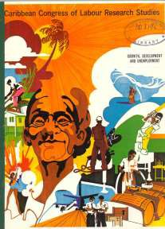
Also held are the papers belonging to the late Marjorie Nicholson, author of The TUC Overseas: the roots of policy (1986), who worked in the Fabian Colonial Bureau and the TUC International Department to develop the trade union movement in many countries, including the West Indies. There are reports from her visits to the Caribbean and on the trade union movements on different islands. She also gave lectures and wrote academic papers on the West Indies, as well as keeping papers by other academics. The collection has a personal feel with handwritten notes, press cuttings and receipts from her visits. A catalogue of her papers can be searched online from the Collections web page (see below).

Access/Location
The TUC Library Collections are accessible in the university’s Special Collections Reading Room. The collections are available by appointment only for external visitors. See Access details on the Special Collections page of the University website for details
The TUC Library Collections, London Metropolitan University, The Wash Houses, Old Castle Street, London E1 7NT (entrance via 16 Goulston Street)
Telephone 0207 320 3516 or Email tuclib@londonmet.ac.uk

Useful links
TUC Library Collections web page
The Union Makes Us Strong: TUC History Online
The Workers War: Home Front Recalled
Winning Equal Pay: The Value of Women’s Work

