PaperCut Printing Guide

Print Services

Version: 1
Date: September 2022

Table of Contents

What is PaperCut 3
1. Print from managed laptops 3
Windows Devices 3
macOS Devices 6
2. Mobility print (BYOD) 7
Print from Windows Devices 7
Print from macOS 10
Print from Chrome OS 12
Print from Apple iOS 14
Print from Android OS 17
3. Create a guest user account 20
4. Top up your print credit 22

What is PaperCut
PaperCut is a powerful print management software that allows you to track, manage and secure your printing, copying, and scanning, including adding print credit balance. As long as you are connected to the University network, you will be able to print directly from any University or personal device. Once you have sent your materials to print, you can then simply use any of the printers on campus to release your printing.

1. Print from managed laptops
Devices that are managed by London Metropolitan University have PaperCut software automatically deployed.

Windows Devices
When you access the PaperCut software for the first time you need to follow the instructions below:
1. Click on the printer icon
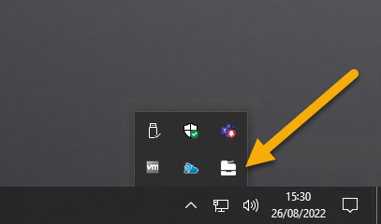

2. Click on the Sign in to Install button
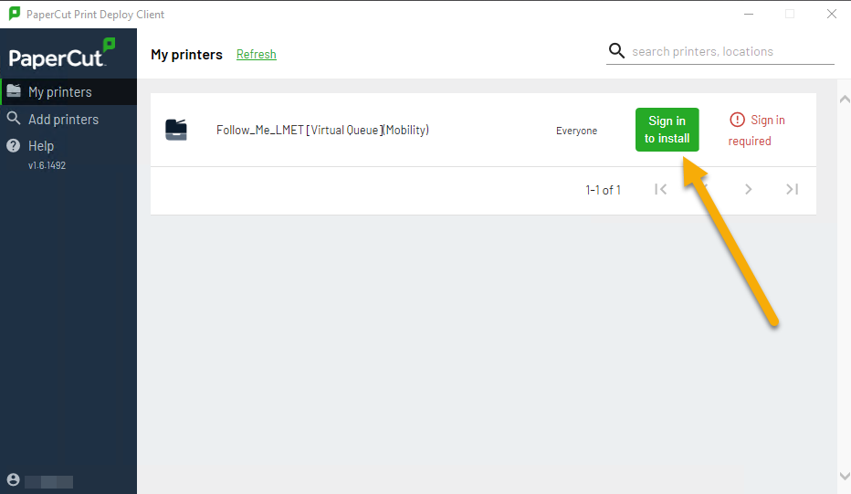
3. Enter Username and Password and Click Sign in and Install
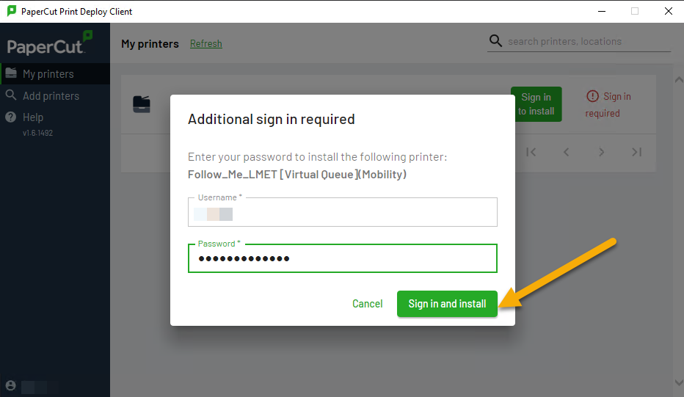
4. Printer will start installing, see the image below:
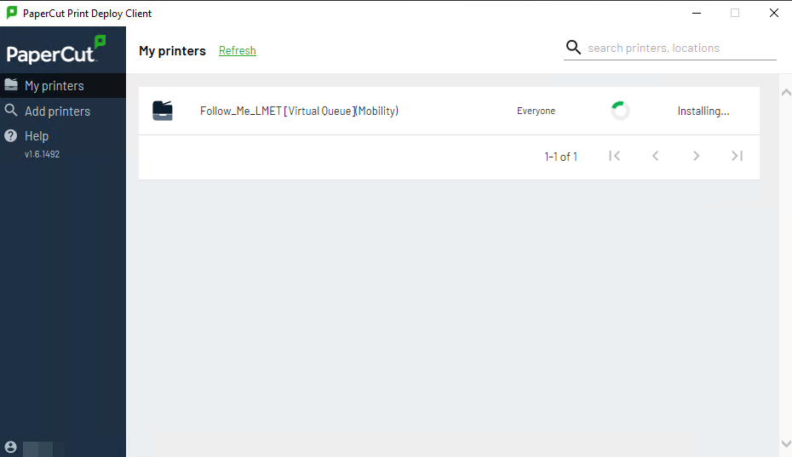
5. When the printer is successfully installed, you will see the message below: “Follow_Me_LMET [Virtual Queue](Mobility) was installed”
How to Print
- Open the document that you wish to print.
- Click Printer from the drop-down and choose Follow_Me_LMET [Virtual Queue](Mobility)
- Choose the number of copies, color, and other print options.
- If prompted, enter your username and password.
- Locate and log in to any Sharp printer to release your print job.

macOS Devices
macOS devices have already been deployed, to check that go to Settings > System Preferences then select Printers & Scanners
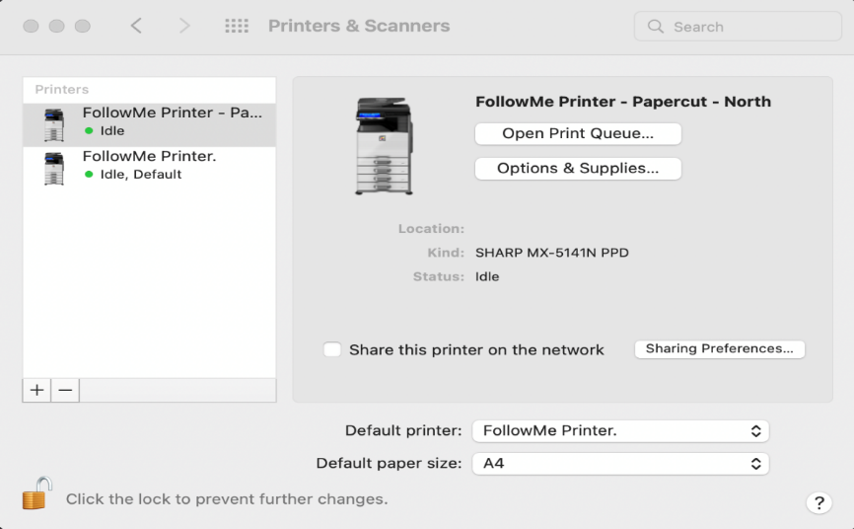
How to Print
- Open the document that you wish to print.
- Click Printer from the drop-down and choose Follow_Me_LMET [Virtual Queue](Mobility)
- Choose the number of copies, color, and other print options.
- If prompted, enter your username and password.
- Locate and log in to any Sharp printer to release your print job.

2. Mobility print (BYOD)
Is simple to install the new managed print service on your device Windows, Macs, Chromebooks, iOS, or Android.

Print from Windows Devices
You Will Need
- Computer running Microsoft Windows 8, 10 or the latest
- Network connection wireless eduroam or LondonMet Guest
- A Desktop Services account for authentication

1. Visit print.londonmet.ac.uk login with your username and password.
2. Choose from the software menu (left-hand side) the campus BYOD that you are located in (Holloway or Aldgate).
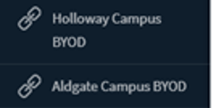
3. Download and Run the Mobility Print installer to install your printers
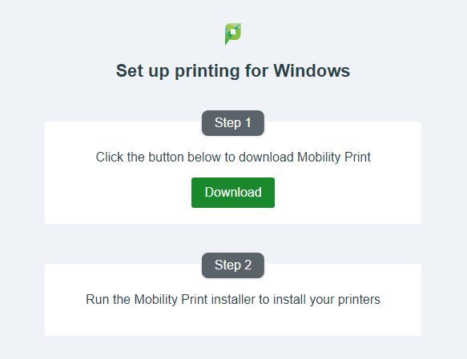
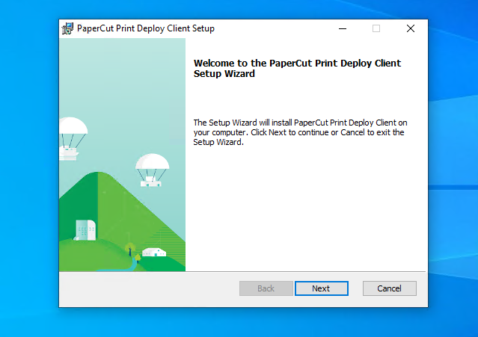
4. Once your software is installed, enter your regular Username and Password

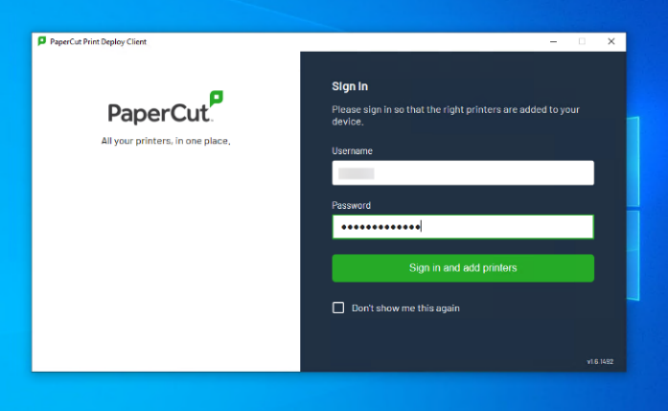

5. Click on the printer icon
6. Click on the Sign in to Install
7. Enter Username and Password and Click Sign in and Install
8. Printer successfully installed, please see the message below: “Follow_Me_LMET [Virtual Queue](Mobility) was installed”
How to Print
- Open the document that you wish to print.
- Click Printer from the drop-down and choose Follow_Me_LMET [Virtual Queue](Mobility)
- Choose the number of copies, color, and other print options.
- If prompted, enter your username and password.
- Locate and log in to any Sharp printer to release your print job.

Print from macOS
You will need
- MacBook macOS 10.7 or later
- Administrative rights to Install Print Service on the computer
- Desktop Services account for authentication
- Network connection ( eduroam or LondonMet Guest).
1. Visit print.londonmet.ac.uk and log in with your username and password.
2. Choose from the software menu (left-hand side) the campus BYOD that you are located in (Holloway or Aldgate).
3. Download and Install Mobility Print and follow the on-screen instructions.
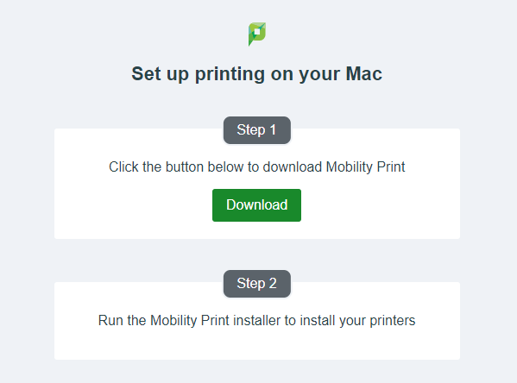
4. Once both setup steps are completed, you’re ready to start printing.
5. When prompted sign in by entering your username and password.
How to Print
- Open the document that you wish to print.
- Click Printer from the drop-down and choose Follow_Me_LMET [Virtual Queue](Mobility)
- Choose the number of copies, color, and other print options.
- If prompted, enter your username and password.
- Locate and log in to any Sharp printer to release your print job.

Print from Chrome OS
You will need
- A device running Chrome OS
- Network connection wireless eduroam or LondonMet Guest
- A Desktop Services account for authentication
1. Visit print.londonmet.ac.uk login with your username and password.
2. Choose from the software menu (left-hand side) the campus BYOD that you are located (Holloway or Aldgate)
3. Install Mobility Print and follow the on-screen instructions.
4. After Mobility Print has been installed you’re ready to use Cloud Print
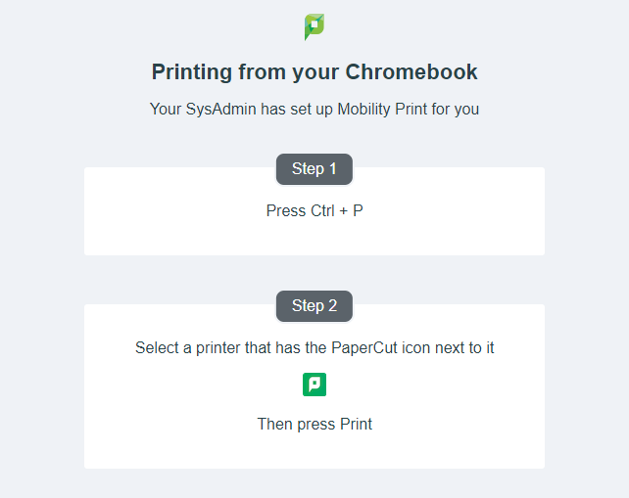
How to Print
- Open the document that you wish to print.
- Click Printer from the drop-down and choose Follow_Me_LMET [Virtual Queue](Mobility)
- Choose the number of copies, color, and other print options.
- If prompted, enter your username and password.
- Locate and log in to any Sharp printer to release your print job.

Print from Apple iOS
You will need
- An Apple iPhone or iPad iOS 12 or later
- Safari mobile web browser
- A connection to either eduroam or LondonMet guest
- A Desktop Services account for authentication
You must complete both steps of these instructions.
Step One – Downloading the profile
- Visit print.londonmet.ac.uk login with your username and password.
- Once logged, tap View in Desktop mode
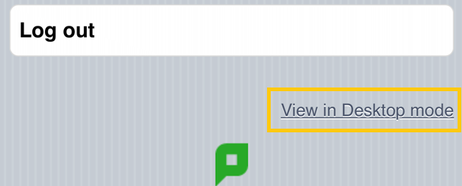
- Choose from the software menu (left-hand side) the campus BYOD that you are located (Holloway or Aldgate)
- Open Safari – it will not work in other mobile browsers.
- Download the Mobility Print profile.
- Select Allow when prompted.
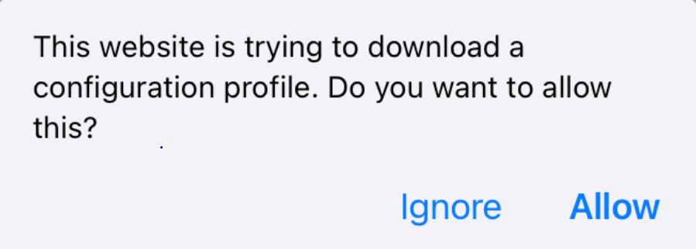
Step Two – Installing the profile
- Open Settings
- Select Profile Downloaded
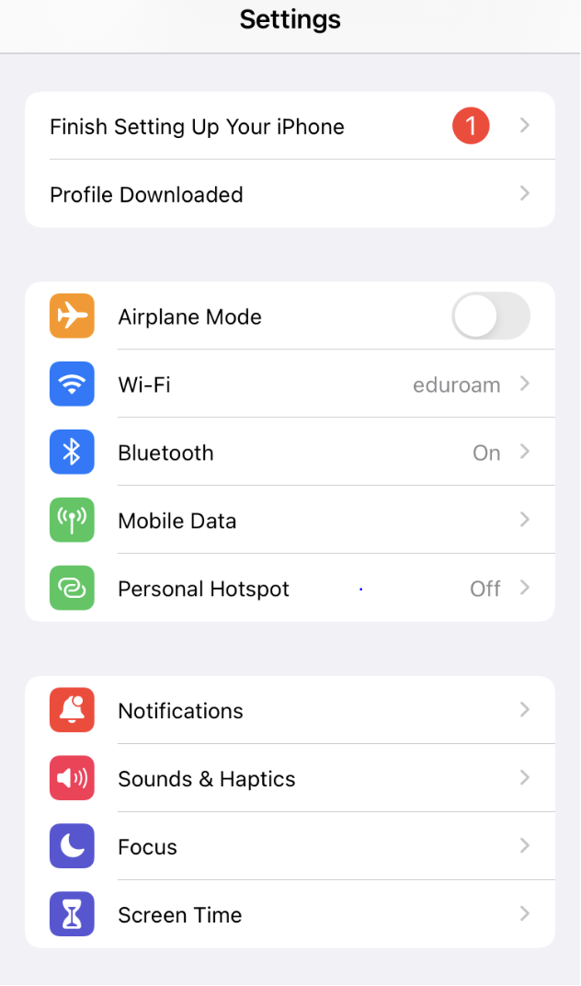
- Select Install at the next couple of prompts.
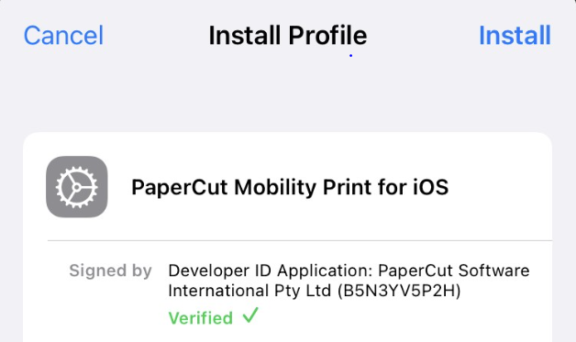

How to Print
- Open the app you want to print from.
- Select print from the app’s share icon or in the app’s menu - if you can’t find the print option, check the app’s help section. Not all apps support printing.
- Select Printer and choose FollowMe
- Choose the number of copies, color, and other print options.
- If prompted, enter your username and password.
- Locate and log in to any Sharp printer to release your print job.

Print from Android OS
You will need
- An Android phone or tablet using Android 7.0 or later
- A connection to either eduroam or LondonMet guest
- A Desktop Services account for authentication
You must complete both steps of these instructions.
Step One – Downloading and installing the app
- Visit print.londonmet.ac.uk login with your username and password.
- Once logged, tap View in Desktop mode
- Choose from the software menu (left-hand side) the campus BYOD that you are located (Holloway or Aldgate)
- You must install the Mobility Print app from the Google Play
- Select Install
Step Two – Ensuring Mobility Print is on
- After installing the app select Tap here and check the Mobility Print Service on

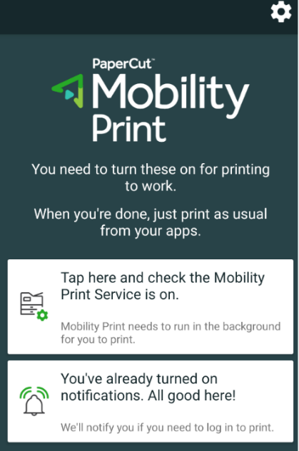
- Ensure Mobility Print is On

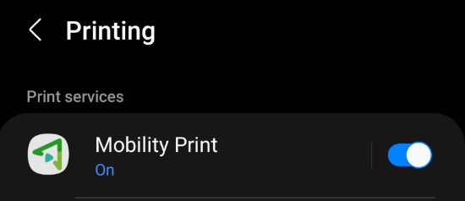

- Tap on the Mobility Print and check if FollowMe is available.

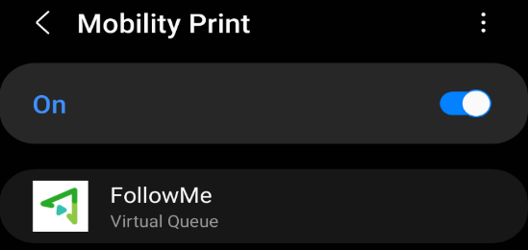

Tip: If you select the Remember me check box, your Android device will remember your login details for 30 days.

How to Print:
- Open the app you want to print from.
- Select print from the app’s share icon or in the app’s menu - if you can’t find the print option, check the app’s help section. Not all apps support printing.
- Select Printer and choose FollowMe
- Choose the number of copies, color, and other print options.
- Look out for Notifications, select the Notification when authentication is required.
- Locate and log in to any Sharp printer to release your print job.

3. Create a guest user account
Guests can use the university print service by creating a papercut account following the steps below:
1. Visit print.londonmet.ac.uk
2. Click on Register as a New User
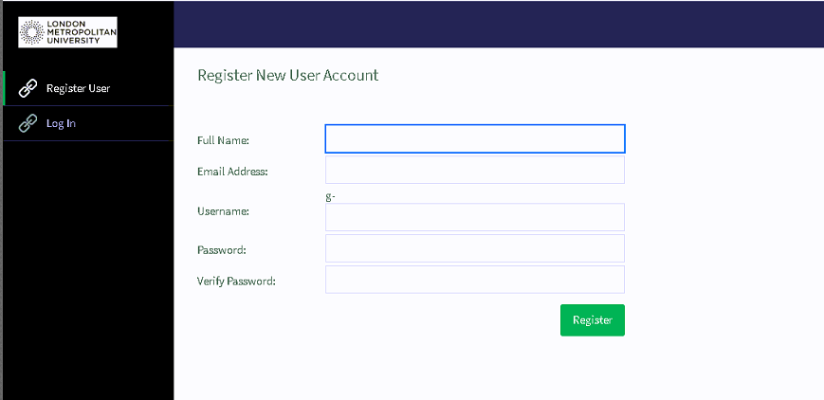
3. Type in your Full Name – Personal Email Address – Username – Password – Verify Password
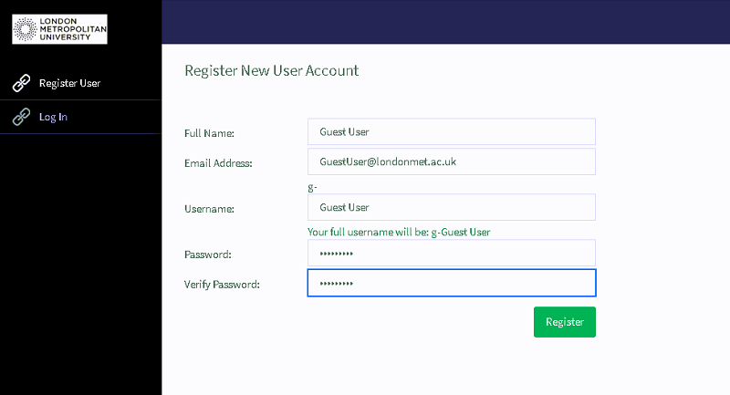

4. Click on Register to complete Registration, Click Login upon Successful Registration
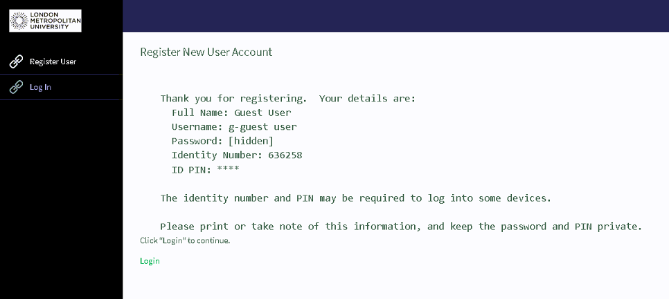
5. Enter the registered Username and Password and click Login
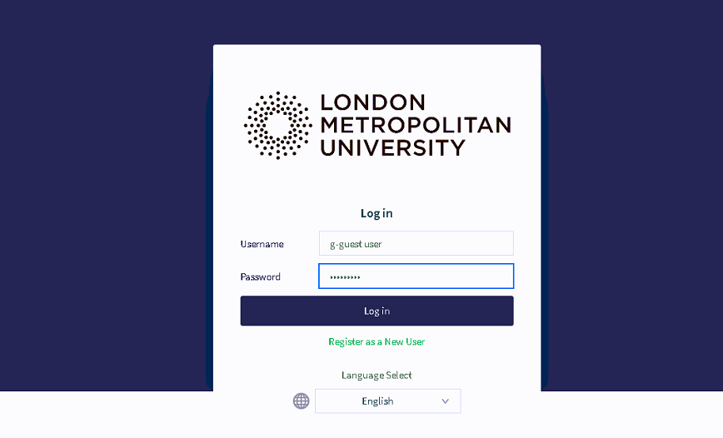

4. Top up your print credit
1.Visit print.londonmet.ac.uk
2. Enter your username and password then click login.
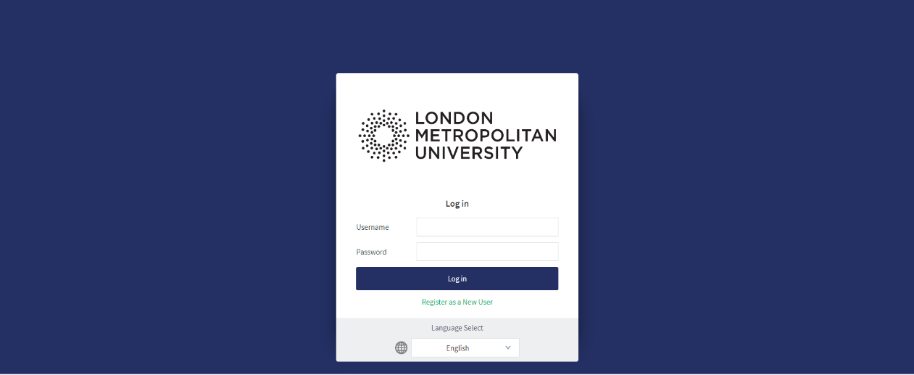
3. Once logged, the screen will display a summary of your printing account. Select the “Add Credit” option from the left-hand menu.
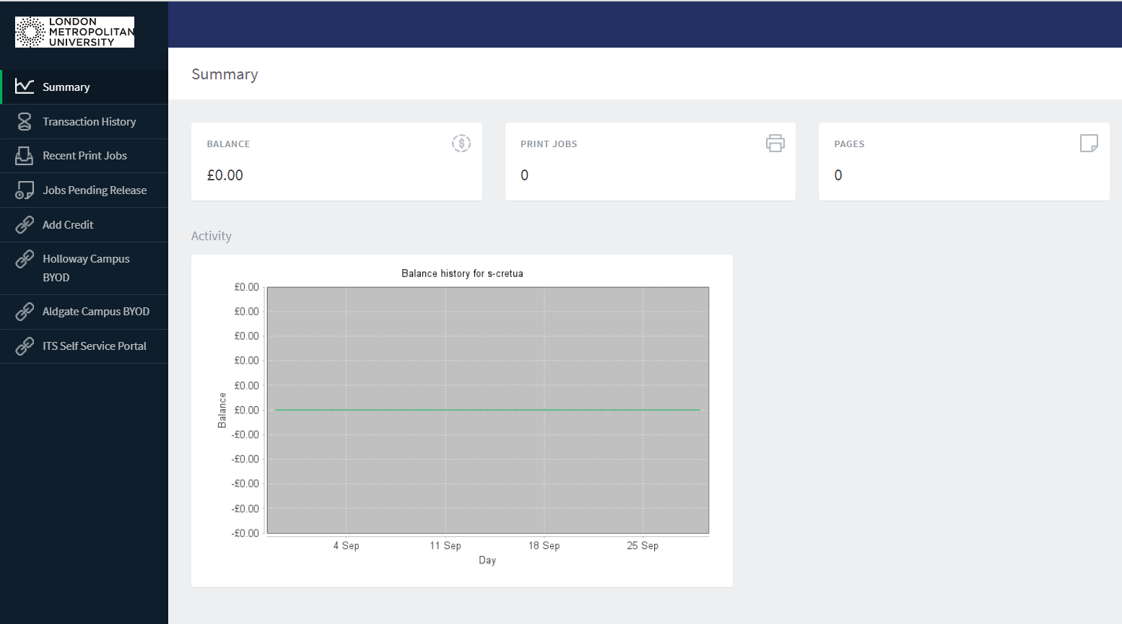
4. On the “Add Credit” screen, select from the drop-down button choose the amount you wish to add to your print credit account (£1, £2, £5,£10, £20, or £50).

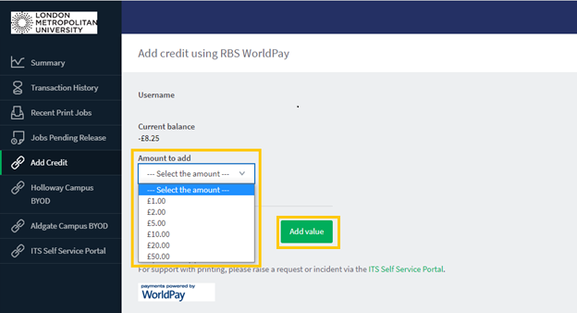

5. Once you have selected the amount, press the “Add value” button.
6. Fill in your card details on the payment form and click “Pay Now”. You may then need to authenticate the payment with your bank.
7. After completing payment, a message will be displayed confirming that your printing credit has been added to your account.

