IT Self-Service
User Guide

Author: Elaine Dimon
Version: 1
Date: 12 September 2018
+44 (0)20 7133 4562

Contents
Change History 3
Introduction 4
Self Help 5
Access from Student Zone 5
Access from Staff Zone 6
Access from Portal 7
Home Page 8
Logging a Request 9
Logging In 9
Selecting a Service 9
Issue or Request 12
Completing Information Required 12
Adding Attachments 14
Add Attachments to New Request 15
Add Attachments to Existing Request 16
Asset Number 17
Find, View and Update a Request 18
Update Profile 21

Change History

Date | Amended By | Change/Update
12 September 2018 | Elaine Dimon | Document Released

Introduction

As the IT Service Desk is no longer operational after 21 September 2018, it will not be possible to log IT requests by telephone or email.

Information regarding IT services and resources is available in the Student and Staff Zones. If the relevant information to resolve a query or issue cannot be found, then a request should be raised in the IT and Estates Self-Service Portal.

The IT and Estates Self-Service Portal, as the title suggests, is a platform that is used by both the IT and Estates departments. However, this guide relates to IT services only. It provides instructions for students and staff to raise and manage requests to report that something is broken or not working correctly or to ask for something new. Customers (students and staff), and IT analysts add and check updates within the Portal. All of the information is stored in one place from the initial request to closure. The system generates email notifications when actions such as opening, updating and closing a request take place, but any responses required must be added in the Portal.

The portal can be used on desktops and laptops, tablets and mobile devices. For mobiles, we recommend using landscape orientation. If you find the portal does not function as described, please try a different browser on your device.

The Portal is likely to be updated from time to time, so it is possible that some of the content will be different on subsequent visits.

Self Help
Information relating to IT services and resources and guidance on using the IT and Estates Self Service Portal is available in the Student and Staff Zones.

Access from Student Zone
- Select IT resources, then IT resources home.
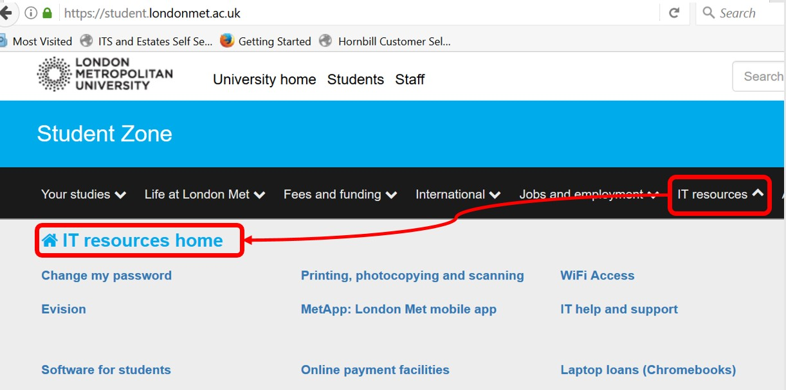

Navigation to IT self help information - students

- Guidance on using the Self Service Portal and links to other pages with detailed information relating to IT services are available.
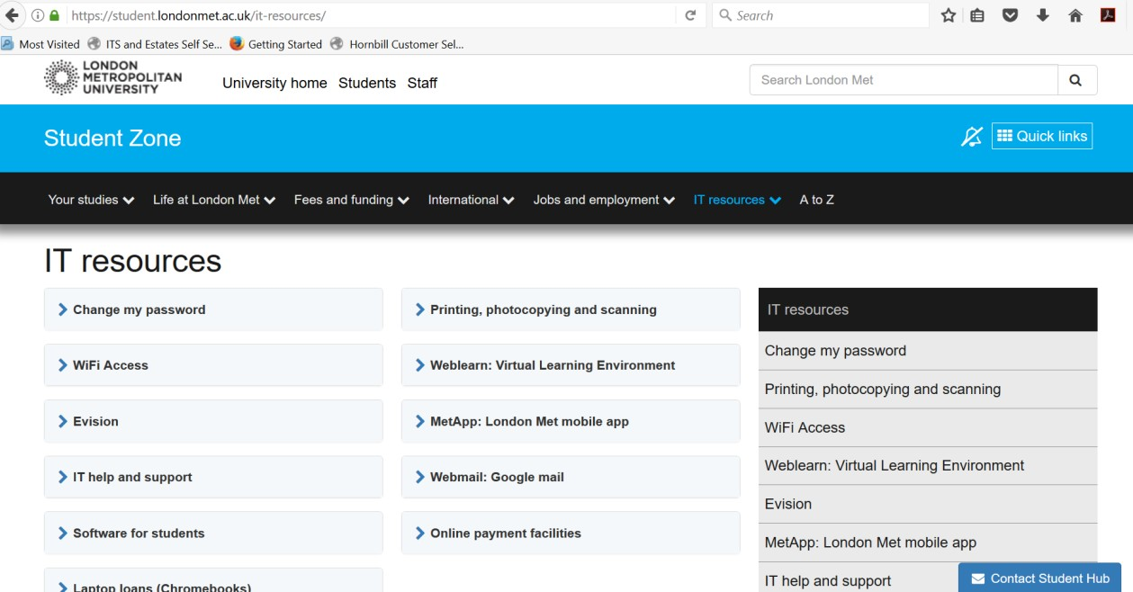

Links to detailed information - students

Access from Staff Zone
- Select Support services, then Support services home.
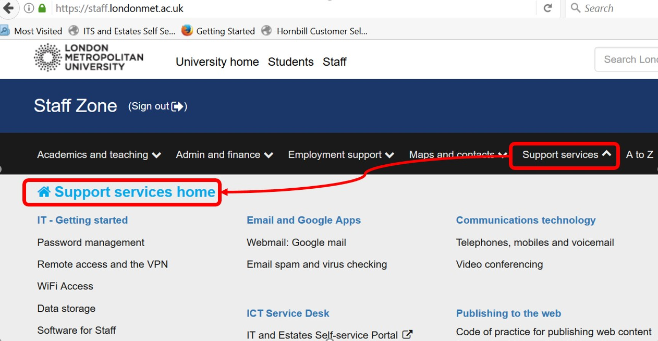

Navigation to IT self help information - staff

- Guidance on using the Self Service Portal and links to other pages with detailed information relating to IT services are available.
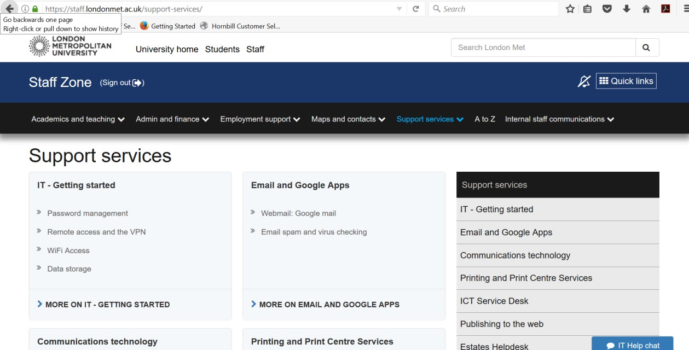

Links to detailed information - staff

Access from Portal
1. There are also links to the resources and support pages in the Self-Service Portal on the Login page, the Home page and at the top of the list under Log IT Request.
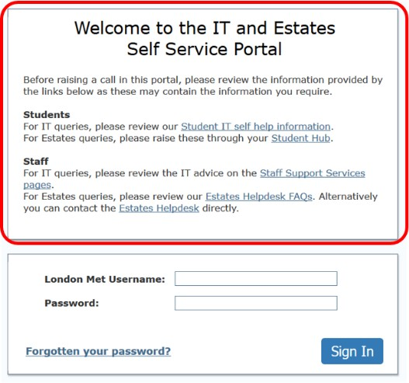
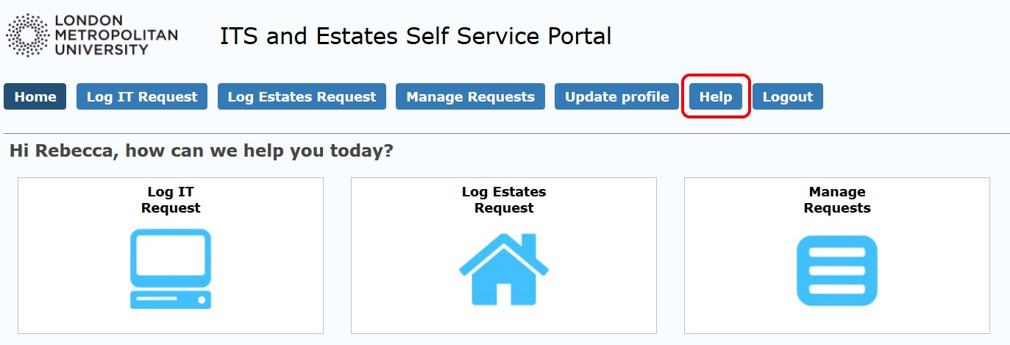
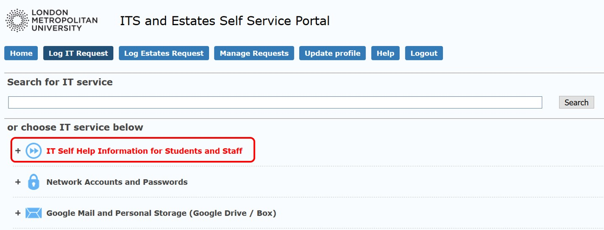

Links to detailed information – in the Portal

Home Page
The Home page provides quick and easy navigation to all areas of the Portal.
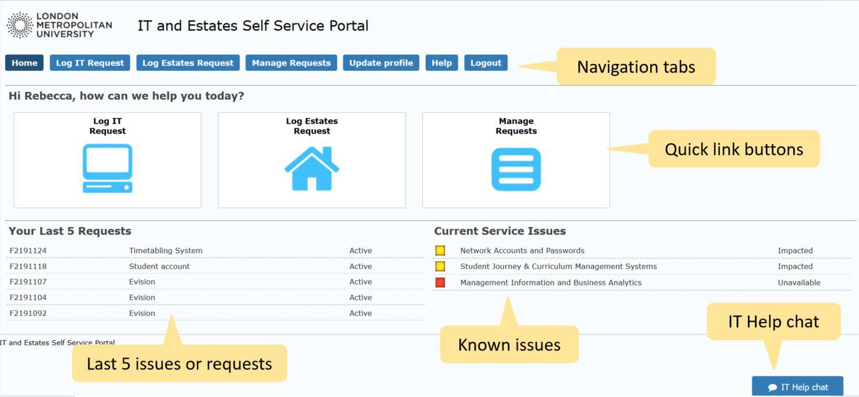

Home page

Navigation tabs – See information relating to each tab within the instructions in this document.

Quick link buttons – Alternative routes to some of the pages.

Your Last 5 Requests – Quick access to the last 5 requests that you have raised.
Requests can be updated while they are active.

Current Service Issues – This is a list of known issues with IT systems and services.
Check here before raising a request.

Help chat – Use this to chat online if you have difficulty using the Portal.

Logging a Request

Logging In
- The Self Service Portal can be accessed from Quick Links in the Student Zone and Staff Zone
(IT & Estates Self Service).

- Log in using your London Met ID and password.
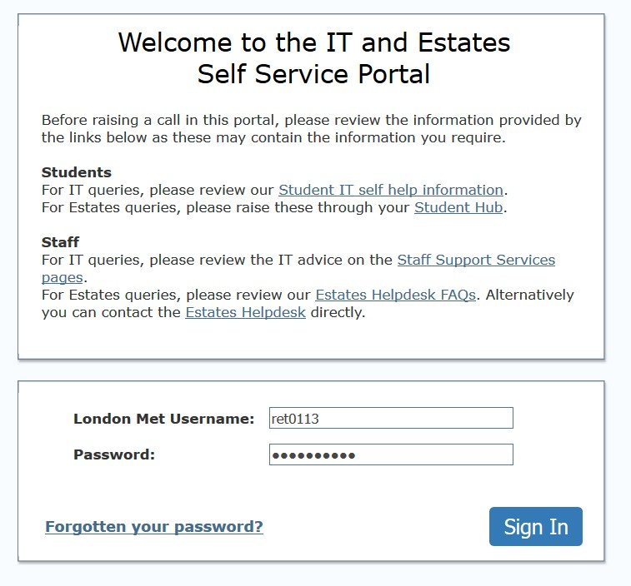

Login page

Selecting a Service
- From the Home page, select Log IT Request.
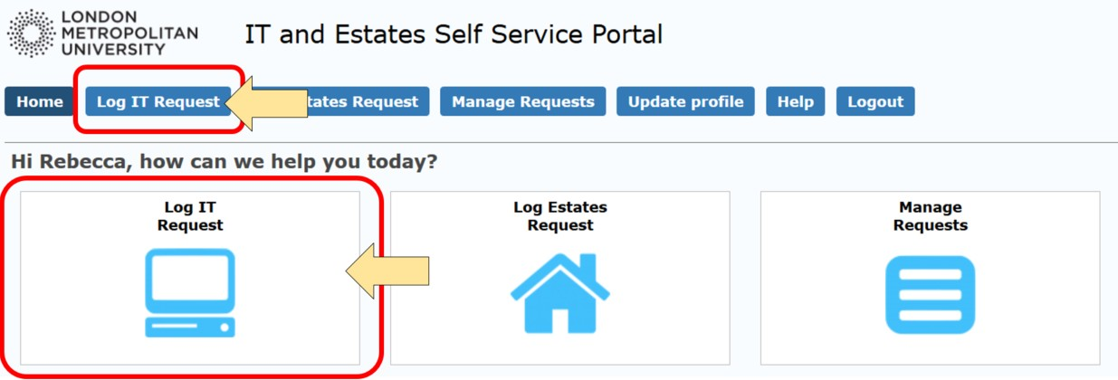

Log IT Request

- Find the service or resource relating to your issue or request from the high-level categories that are listed below the search box.
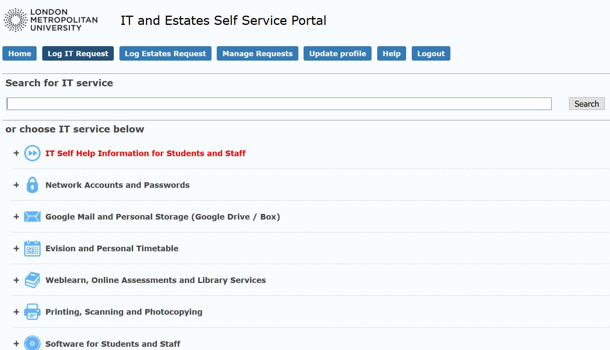

List of services

- Select the ‘+’ next to a category to view more detail about the associated services and systems.
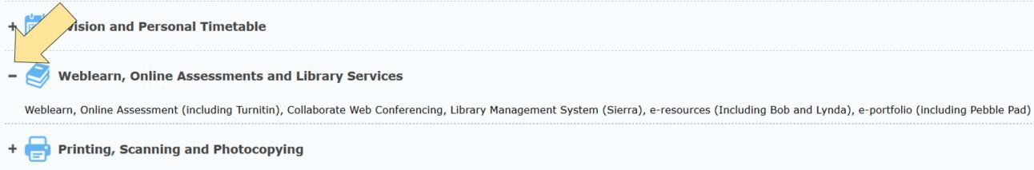

Expand to view details

- Select the relevant category.
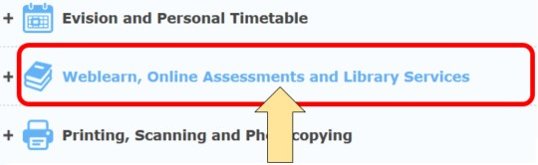

Select category

- You can search for the service you require by entering a keyword or a system name.
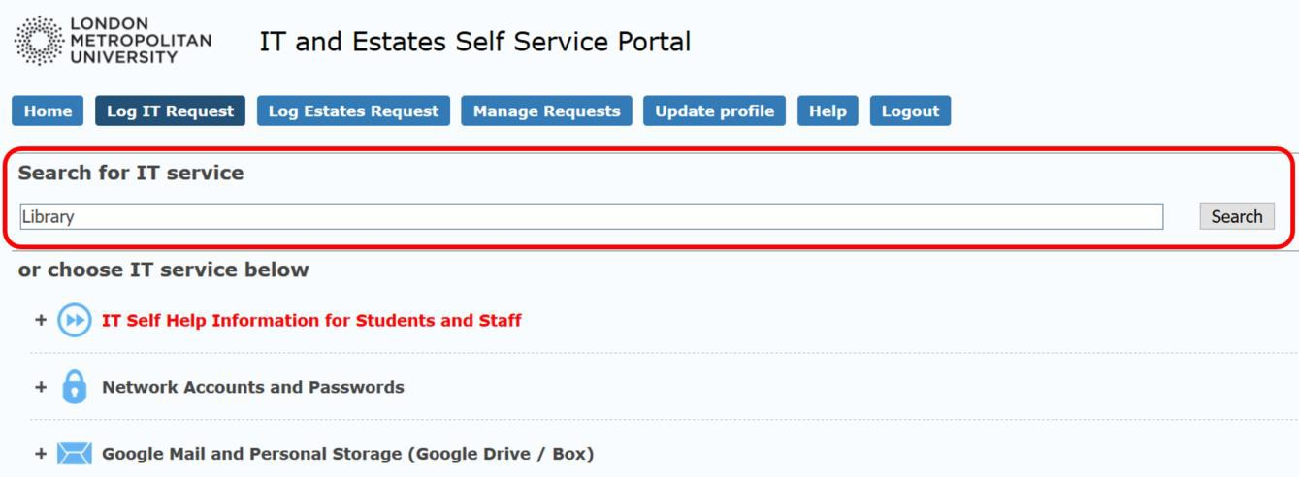
Search

- Select the row that relates to your issue or request.
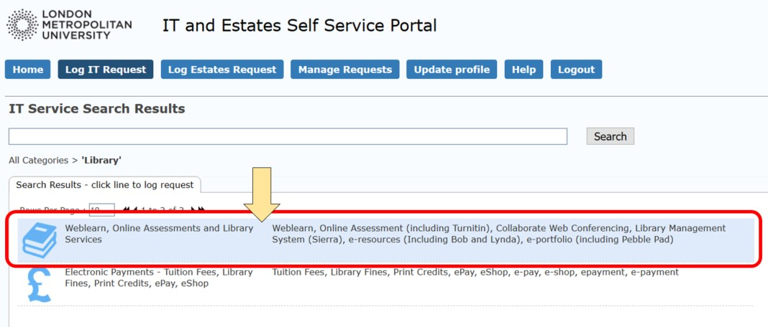

Search results

Issue or Request
In order to ensure that existing systems and services are operational for as much time as possible, issues are usually prioritised over requests for something new. Therefore, in most cases, you must indicate whether you are logging an issue or a request.
1. Select the relevant option and click on Next to continue.
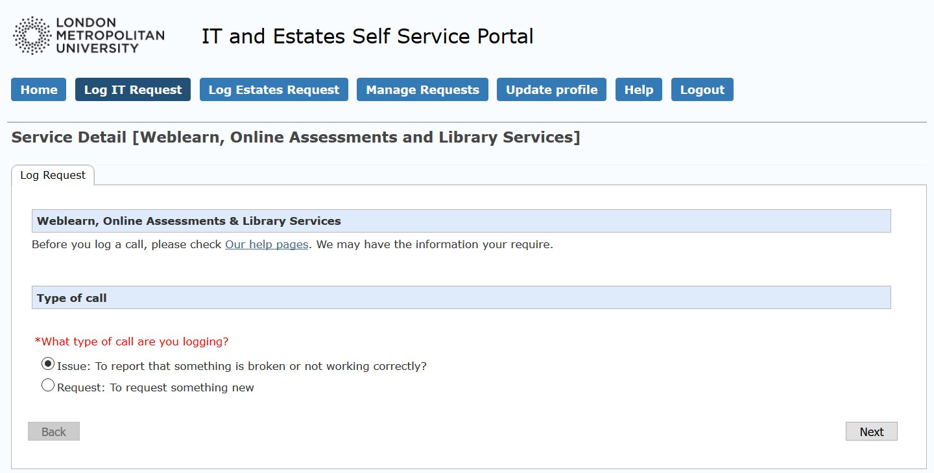

Select Issue or Request

Completing Information Required

- Enter the details requested in the wizard. Questions or information required that are in red font with an asterisk (*) are mandatory fields.
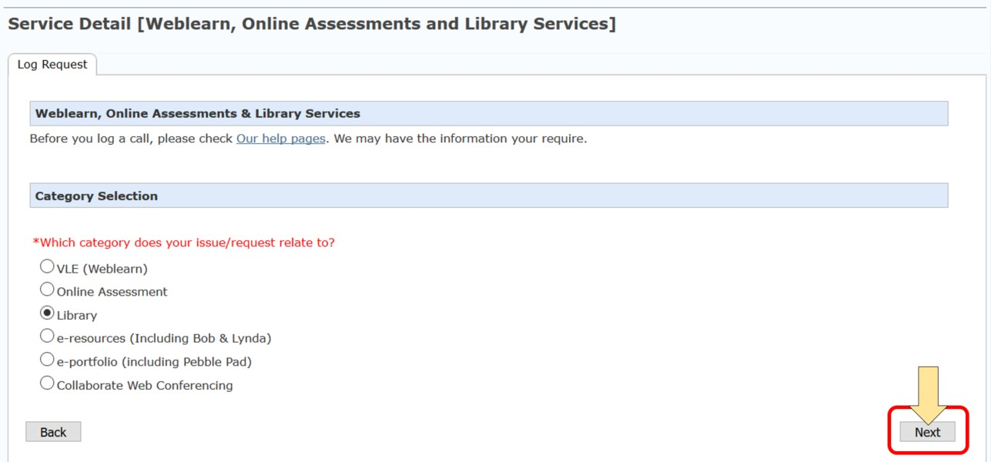

Wizard questions

- If appropriate, select the Next button to continue.

- On the final page of the wizard (which is also the first page in many cases), select the Submit button
when all required information has been entered.
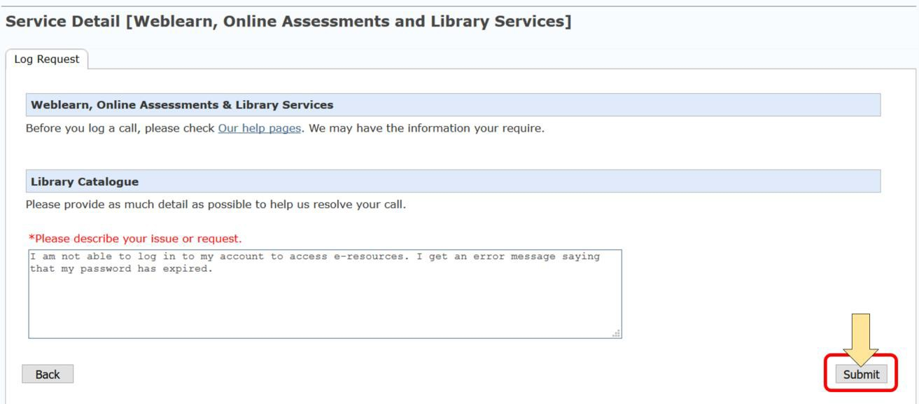

Submit

- The system displays confirmation of the request with the unique ticket reference number.
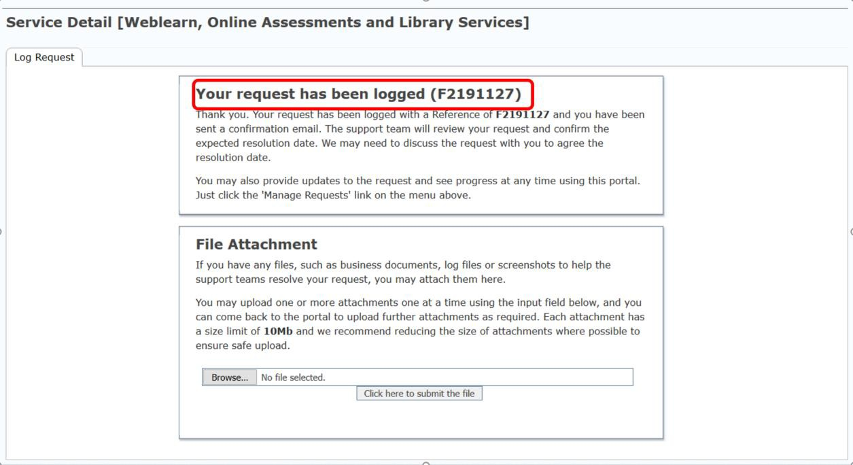

Confirmation and ticket reference

- If you are a student or staff, the system will generate an email to your London Met email account. If you are an applicant, the system will send the email to your personal email account. Do not respond to the email from your mailbox. If you need to send information relating to your request to the IT team, it must be through the Portal. (See Find, View and Update a Request).

Adding Attachments
You can add attachments at the time of submission on the confirmation page when you have submitted the ticket.

Save screen shots in an appropriate image file (e.g. png, JPEG) or in a Word document in order to add as an attachment.

Upload multiple file attachments one at a time. There is a size limit of 10Mb for each file.
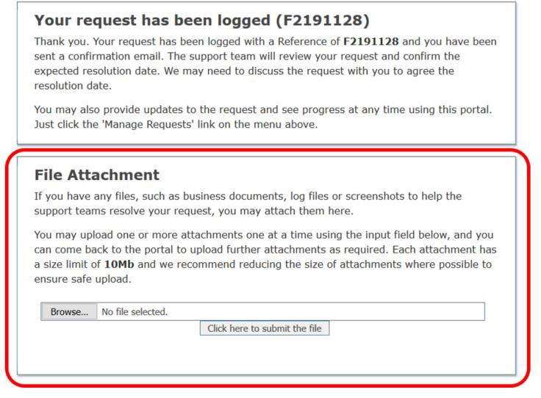

File Attachment

Note: If you attempt to upload a file that is significantly larger than 10Mb and the network is busy, you may see a message relating to an unrecoverable error. If this happens, close the window and navigate to the request from the Home page. Alternatively, you can log out & back in again.

If you try to upload a file that does not exist in Chrome (if the file name has changed or you have moved the file before submission), you may get an error message or a grey panel (see image below). If this happens, close the window and re-upload the file.
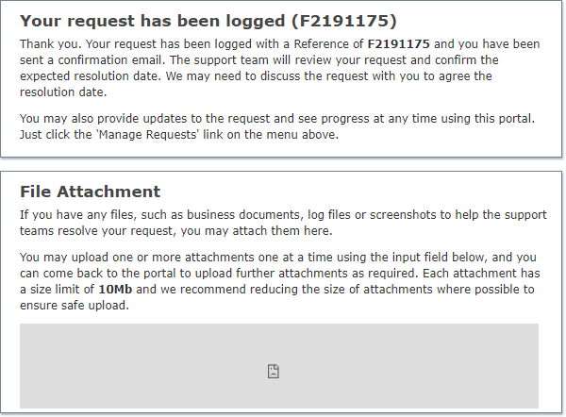

File does not exist – Chrome only

Add Attachments to New Request
- Browse to the file location on your computer and select the appropriate document.
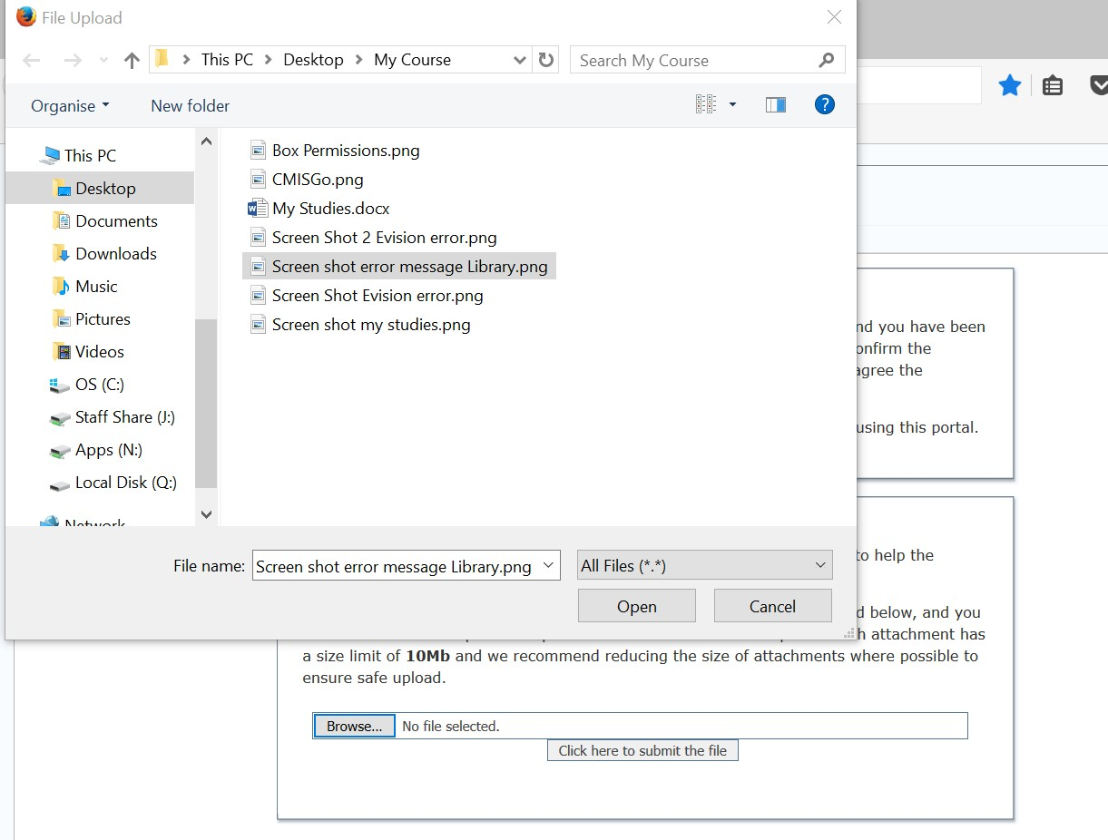

Browse to document

- Select Click here to submit the file.
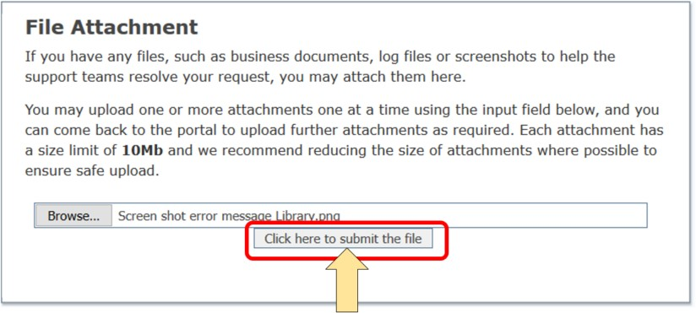

Submit the file

- Repeat steps 1 and 2 to add more attachments if required.

Add Attachments to Existing Request
You can add attachments to your request at any time while it is still active.

- Navigate to Your Last 5 Requests on the Home page or to Manage Requests if you have raised five or more since the relevant request was raised and select the ticket from the list.
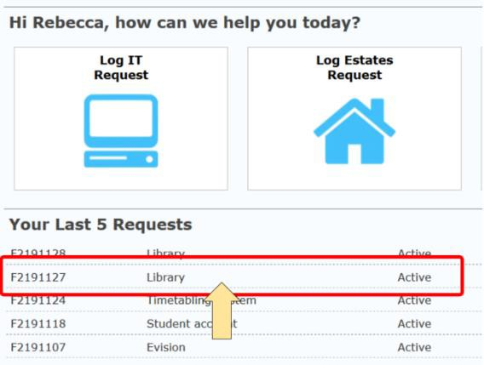
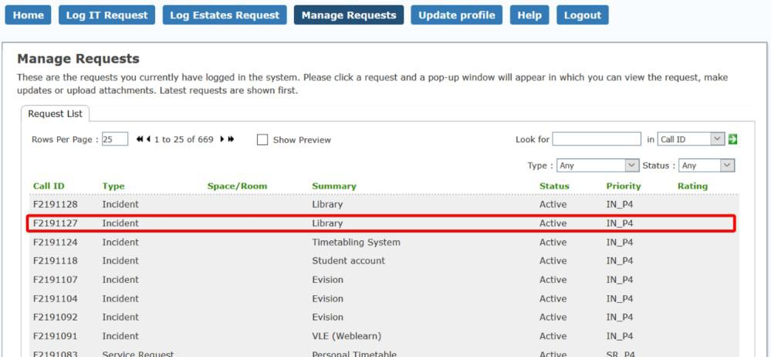

Select the ticket from the list

- Add a message as appropriate, browse to the file location upload the attachment and select Click here to submit this update.
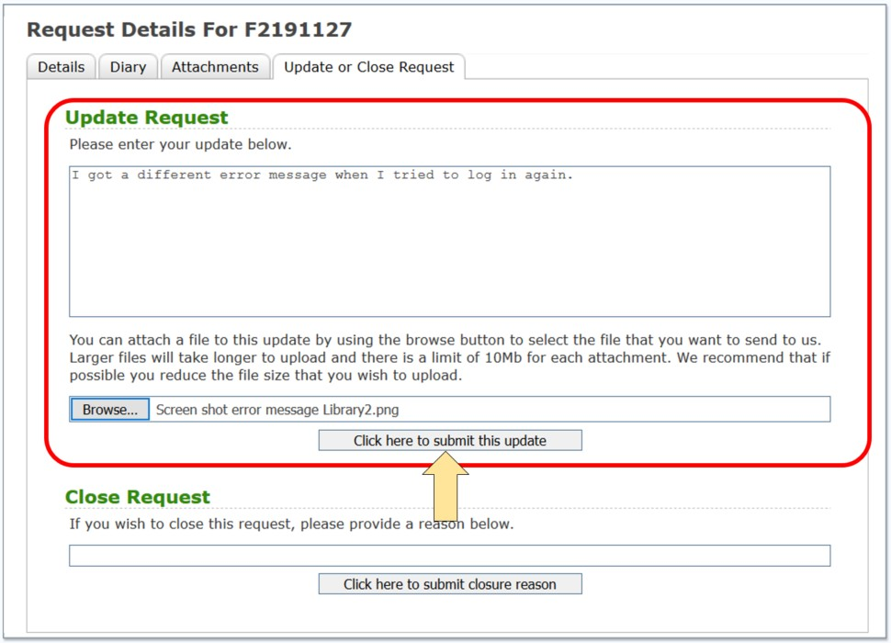

Browse to file and submit

- To view attachments that relating to the request, open the Attachments tab.

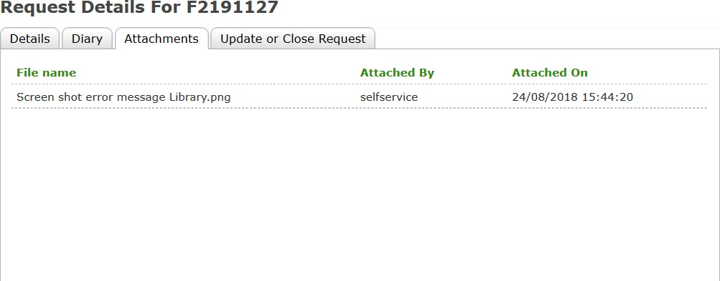

View attachments

- Double click on an attachment to open or save the file on your computer.

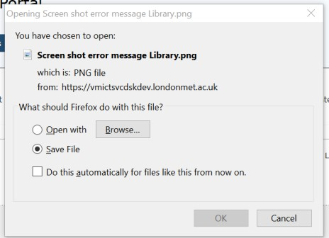

Open or save attachment

Note: Any attachments added by IT analysts will also be available to view or download.

Asset Number

All University devices are registered with an asset number. You can find the six-digit asset number on a sticker somewhere on the device. The asset number for Sharp printers, (Machine reference number), is displayed on a label on the front of the machine.
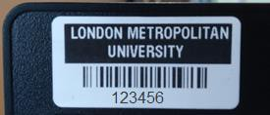

Asset number

Find, View and Update a Request
If you have previously logged a request, you can view the status or submit additional information in the Self-Service Portal.

- The last five requests that you have raised are displayed on the Home page. Click on the relevant row to select. If you need to view or update an earlier request, navigate to Manage Requests.
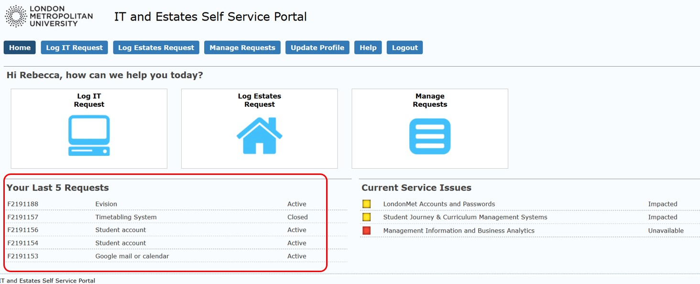

Last five requests
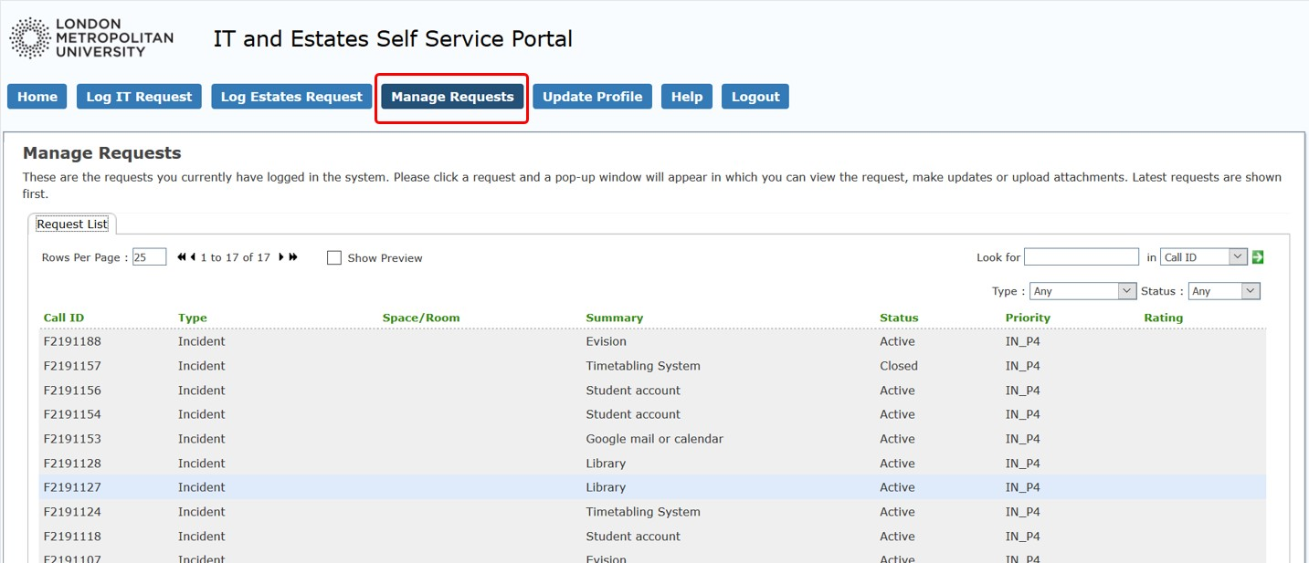

Manage Requests

- A new window opens displaying summary details and service level information relating to the request. The summary only displays the first 250 characters. Select the Diary tab and double click on the text area to view the full content.
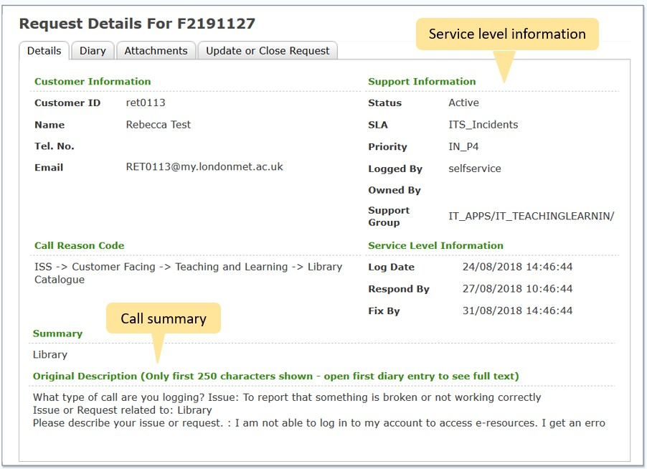

Summary details
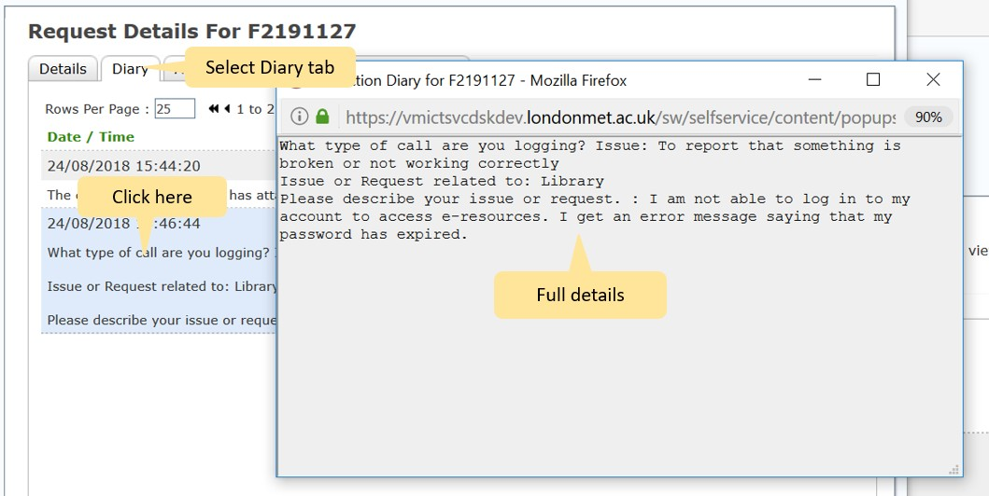

View full details

- Details of information and actions relating to the request are listed in the diary tab. This includes updates from the IT department. Click on any row to view the full content as for the initial request summary.

- Select the Attachments tab to view files that have been added to the request. This will include attachments that you have added and those added by IT staff. Select an attachment to open or download.
(See Add Attachments to Existing Request for more details).
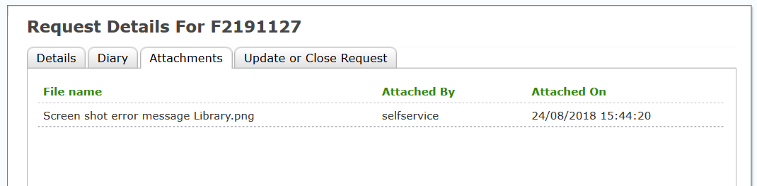

View attachments

- Select the Update or Close Request tab to respond to information added by IT staff, add extra information and/or attachments or to request closure of the request if it has been resolved.
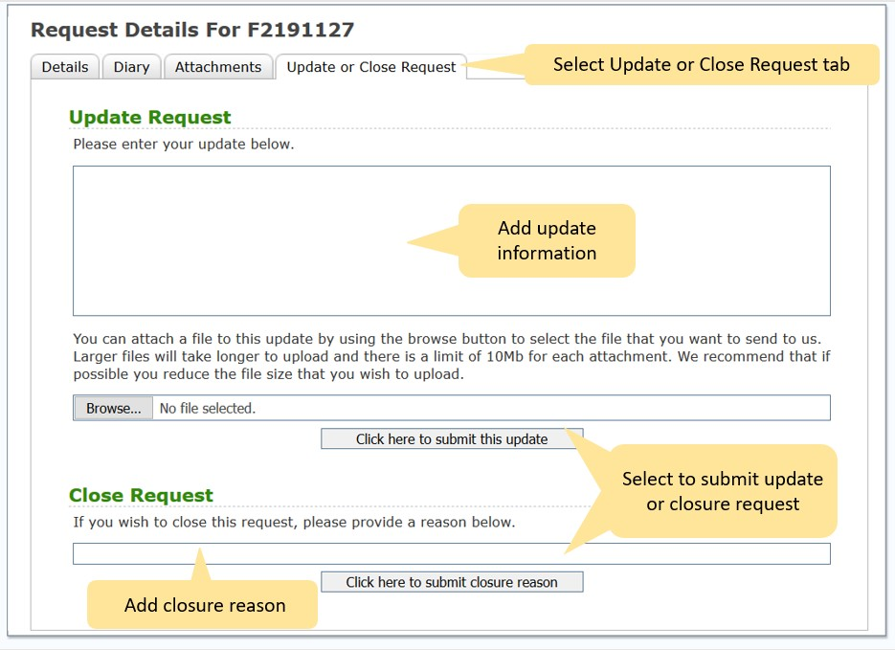

Update request or request closure

Update Profile
You can only update telephone numbers in the Portal. Other information is controlled by central ID management. If any of your other details need to be changed, students should contact the Hub and staff should contact HR.
1. To change or add telephone numbers, select the Update Profile tab, add or change the details and select Update Profile in the bottom right hand corner.
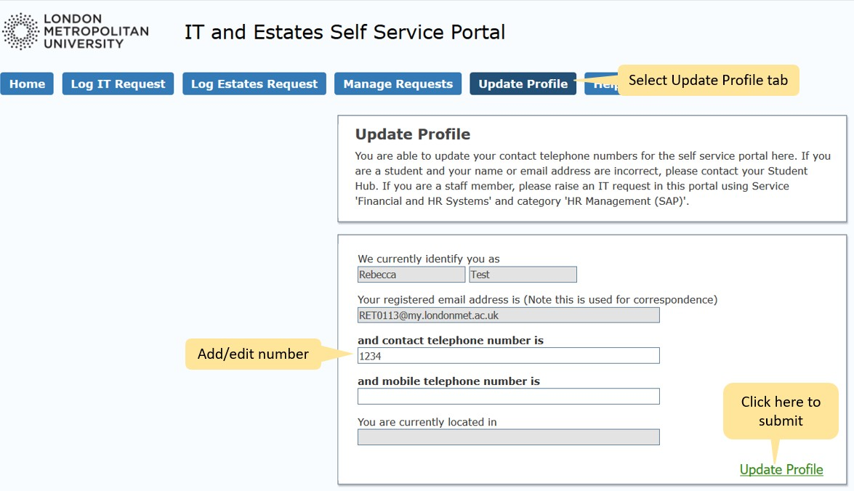

Update profile

