HOW TO CONNECT TO YOUR HOME NETWORK (WIRELESS) ON A CHROMEBOOK

This guide will walk you through how to connect your Chromebook to the home wireless network.
- To begin, open your Chromebook and power it on. You should be presented with a screen like this one:
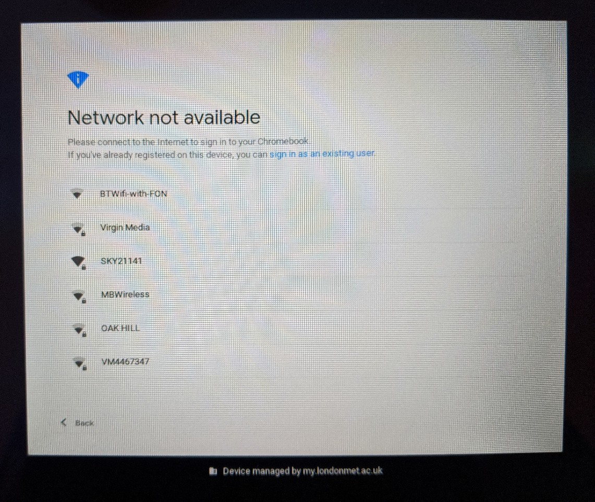
- Click on your network. In my case it is ‘MBwireless’ and you should then be asked to type in your password:
(NB: if you see ‘@my.londonmet.ac.uk’ on the right then click the ‘Back’ button once or twice until it refreshes to show ‘@staff.londonmet.ac.uk’ – if it does not refresh, type in your full email address)

- Now enter your password in the box on this screen and click Next:

- Sign into your Chromebook
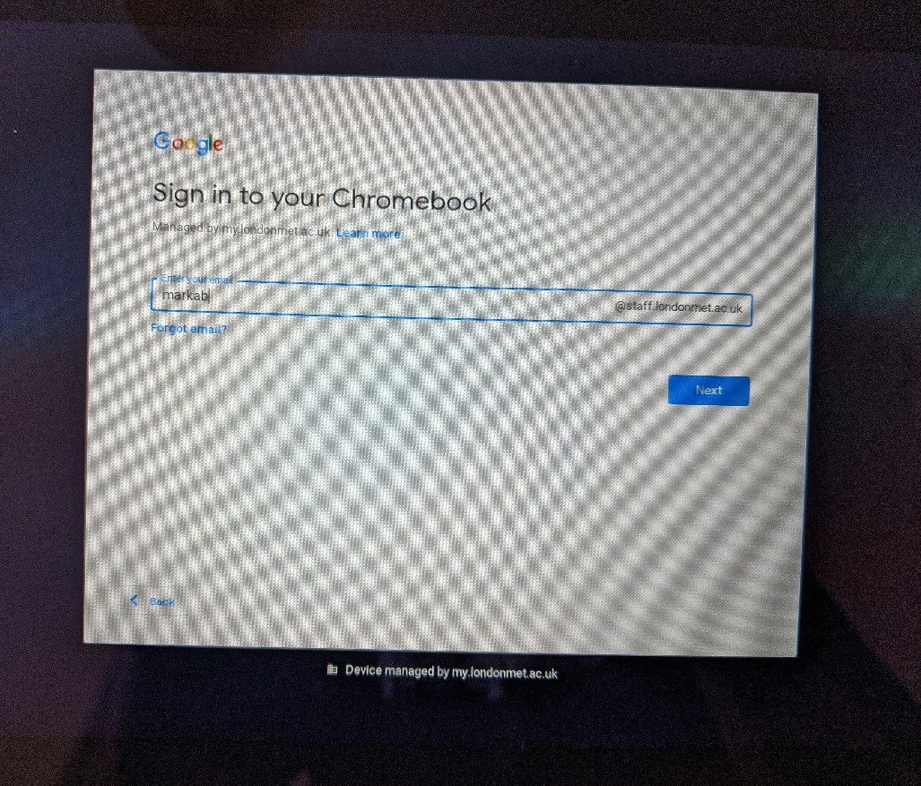
- Choose an account- Select G Suite account
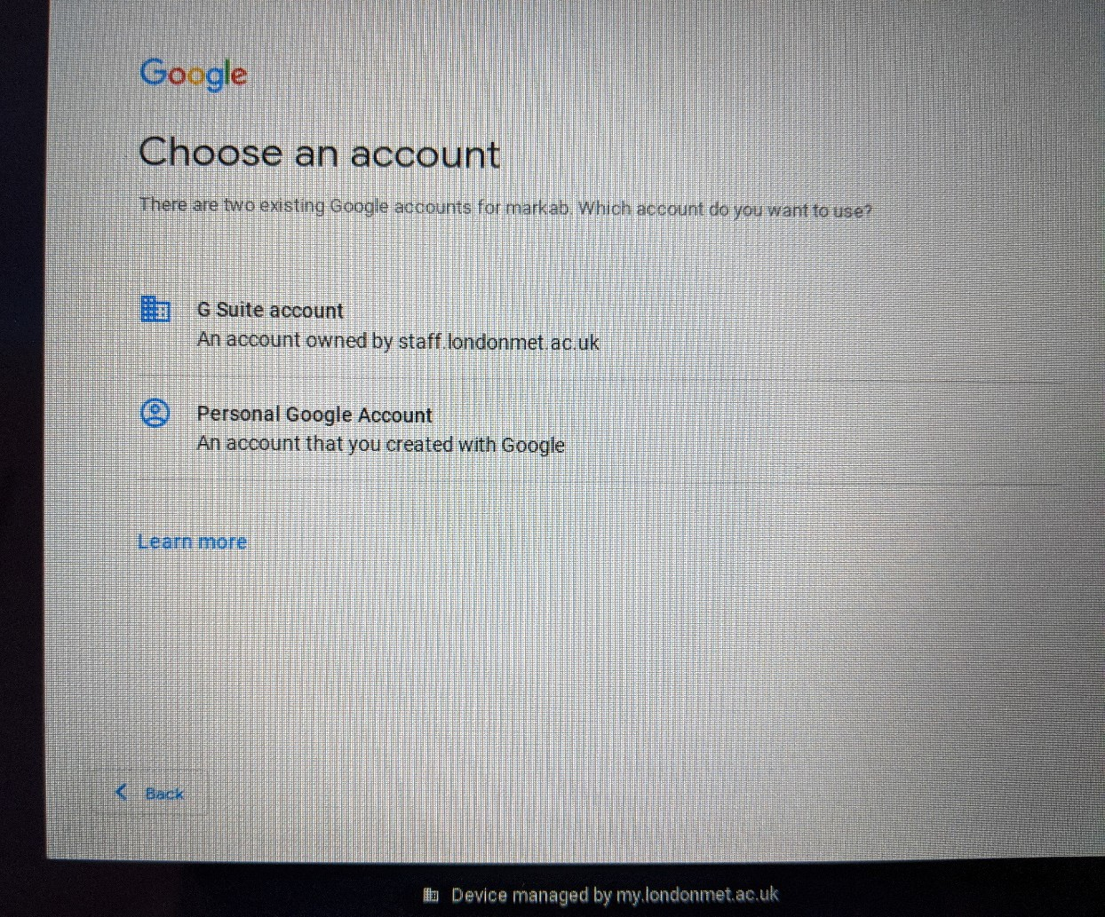

- Enter your standard university password

- The next screen should confirm that you’re signed in and simply click on ‘Accept and continue’:
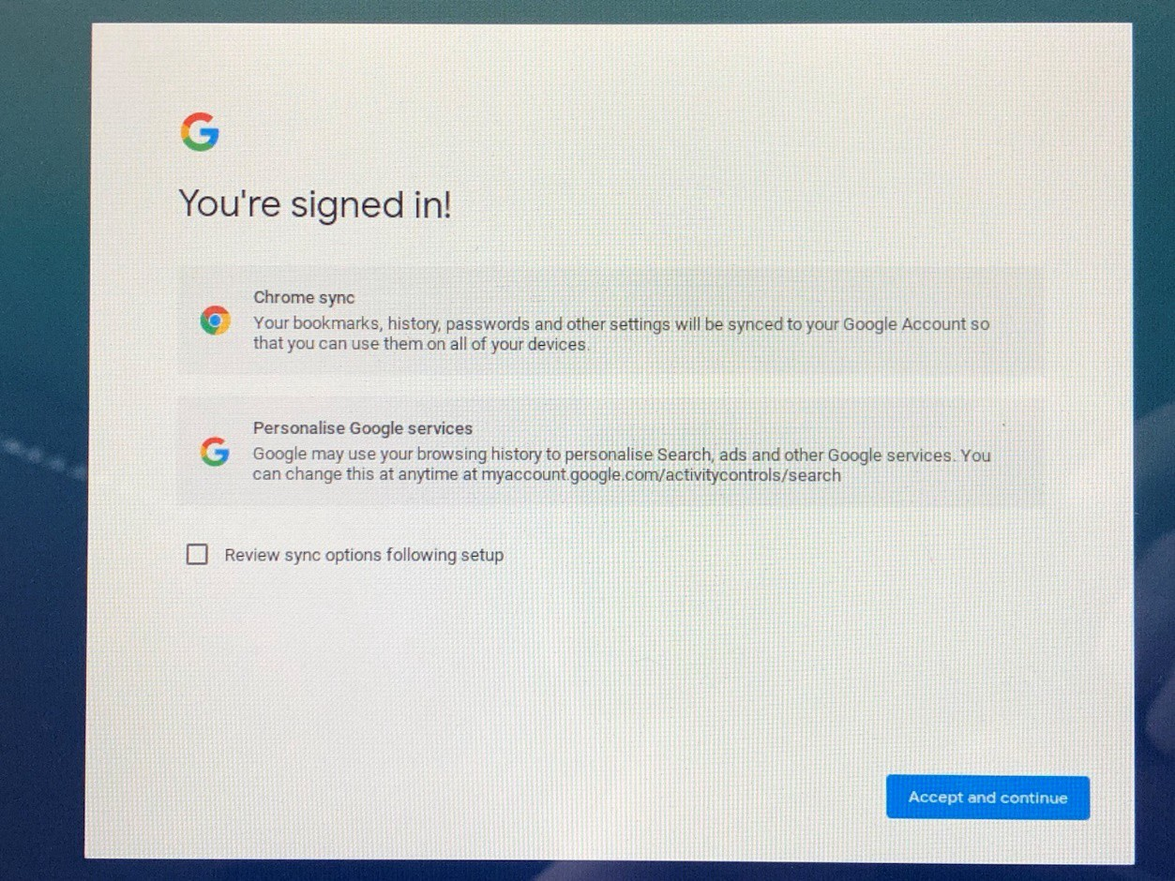
- On this next screen, untick the box to backup to Google Drive as follows and then click on ‘More’:

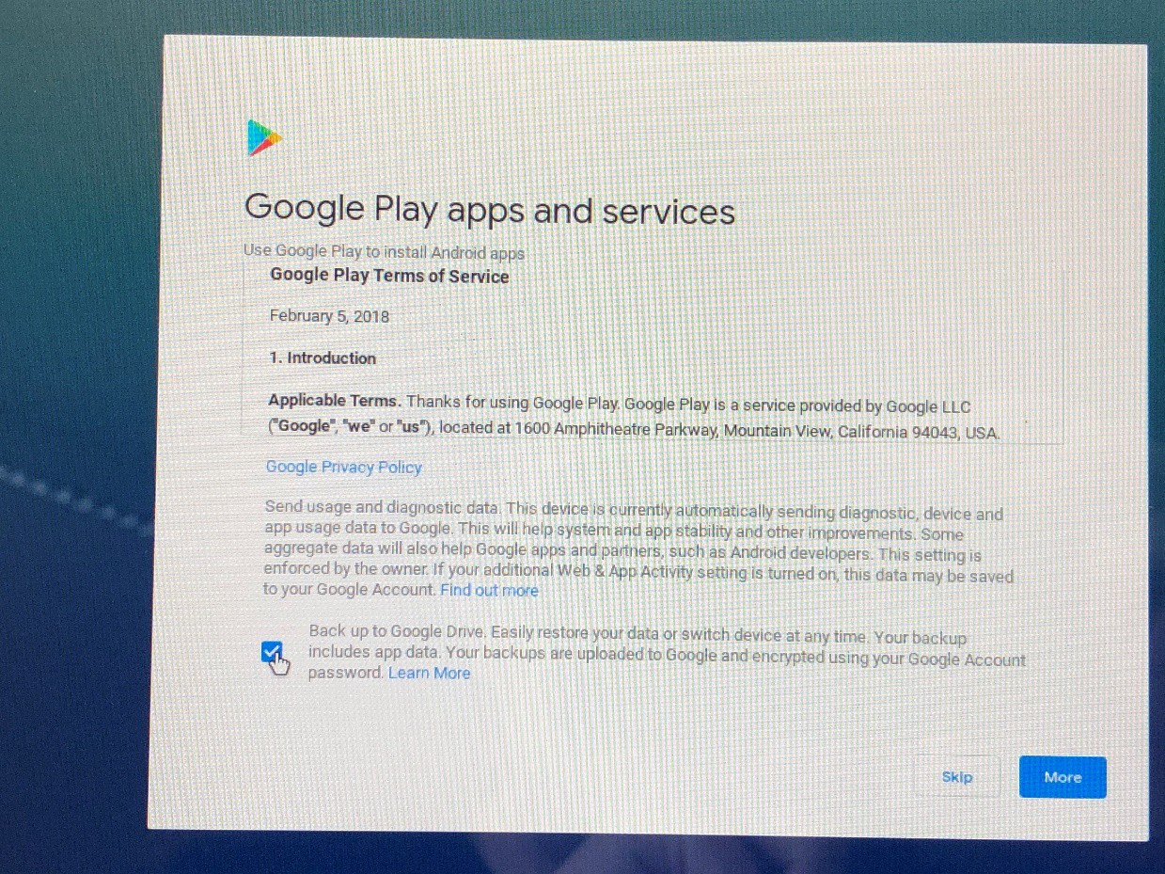
- Scroll to the bottom on the final screen and click ‘Accept’:
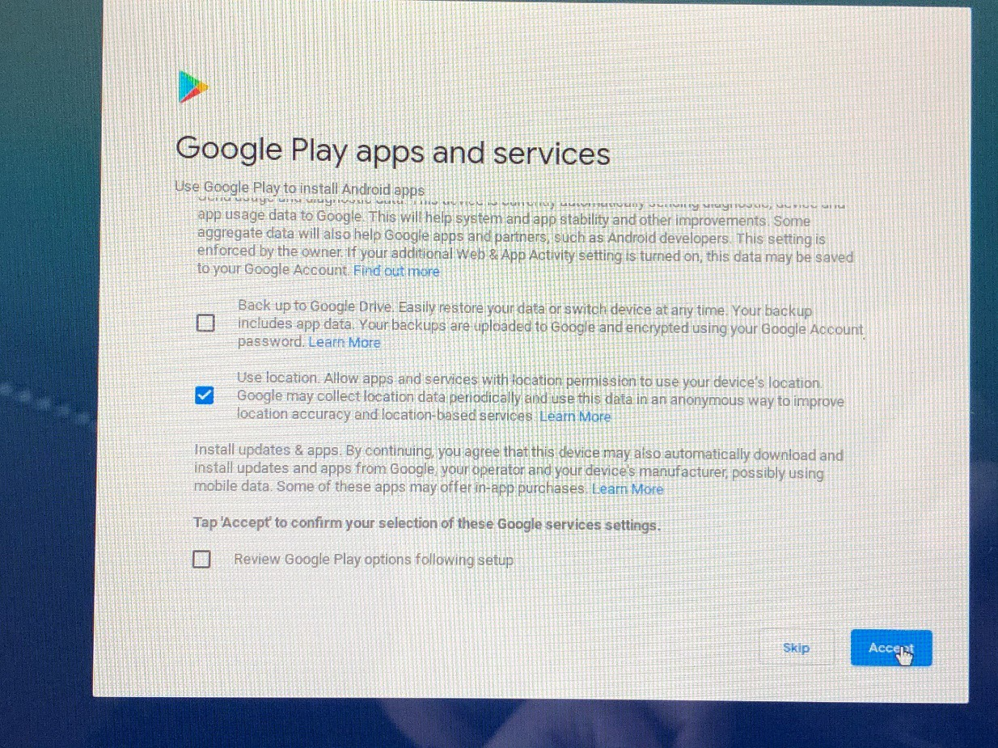
At this point you should now be signed into home network and into your Chromebook laptop.

