How to connect to Remote Access Service
AppsAnywhere can be accessed via the “AppsAnywhere” shortcut found on all the university computers or by navigating to the following address in your web browser: appsanywhere.londonmet.ac.uk This is applicable for Windows, MAC, and Chromebook Operating Systems
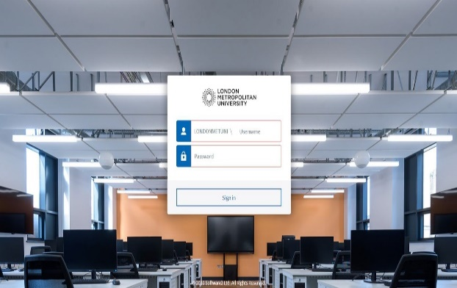

Remote Access Service can be found within AppsAnywhere list, or you can search for it, using the search bar at the top. Alternatively, click the Desktops tab from the menu.
Hover over the application, and you should see the Launch button appear to access it.
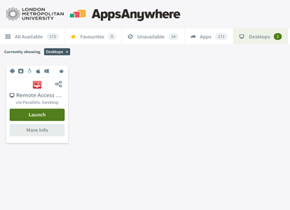
Upon clicking the app should appear after a few moments.
Once you finished with your session, make sure to Sign out from your remote session.
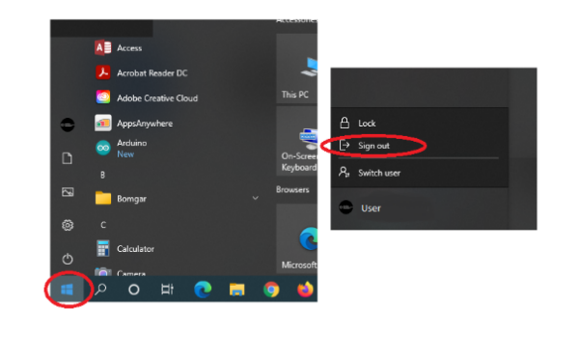
To do this select the Windows start button and select the LondonMet logo icon and then select Sign out.

